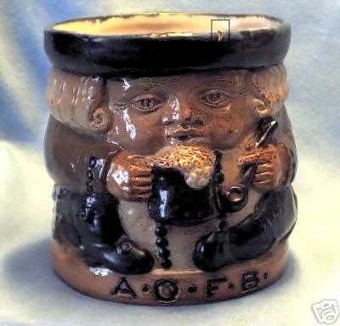
Winter 2008
F. O. F. B.

Crazy Collectors NEWSLETTER NO. 9

Hidden in the pottery section of ebay Side-by-side, the third extra of beer and froth
were two apparently A.O.F.B. arte- can be appreciated – ‘Oh, to be a Blaster!’
facts not recognised by Bert. The
above toby-type Doulton Lambeth The Temple Connection
pot with a figure in relief blowing When I was writing ‘Of Fripp and Froth
froth off his beer was fought over by Blowers’, about four years ago, my chapter
two collectors and realised nearly on Bert Temple was particularly short on the
£2,000 (v.s.). facts of his life. Since its completion, Ian
Not quite so ‘crazy’ was the figure Brown’s indefatigable research has unearthed
of around £160 for an 1890 silver details I could only guess at. I hope to publish
match-holder with A.O.F.B. inscribed a more professional version of the story when
on its side – by a 1920’s Blower who I can afford it – sooner rather than later, it is
was happy to deface the family silver, to be hoped.
presumably (v.i.). However, that I have not rushed into print
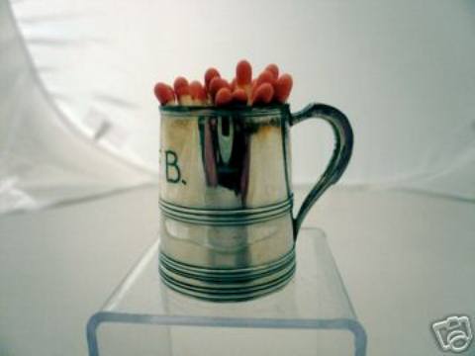 may turn out to be a wise move, even if in-
voluntary: a few weeks ago Bert Temple’s
great-nephew contacted Ian through the web-
site. He was delighted to have found the site
and is even now digging out family material
for our perusal. We, apparently, filled in
many gaps in his knowledge and he will, no
doubt, be able to do the same for us. At least
we know that our research is substantively
correct. If all goes according to plan – and to
fit in with my hospital visits – Ian and I hope
Since then, I have bought an Ashtead to meet up with Richard in the near future.
‘Blaster’ tankard, the capacity of In a heart-warming hand-written letter to me
which seems designed to reflect both one paragraph refers to Bert’s office address:
the importance of its owner and the “It is my belief that the offices at Cheapside
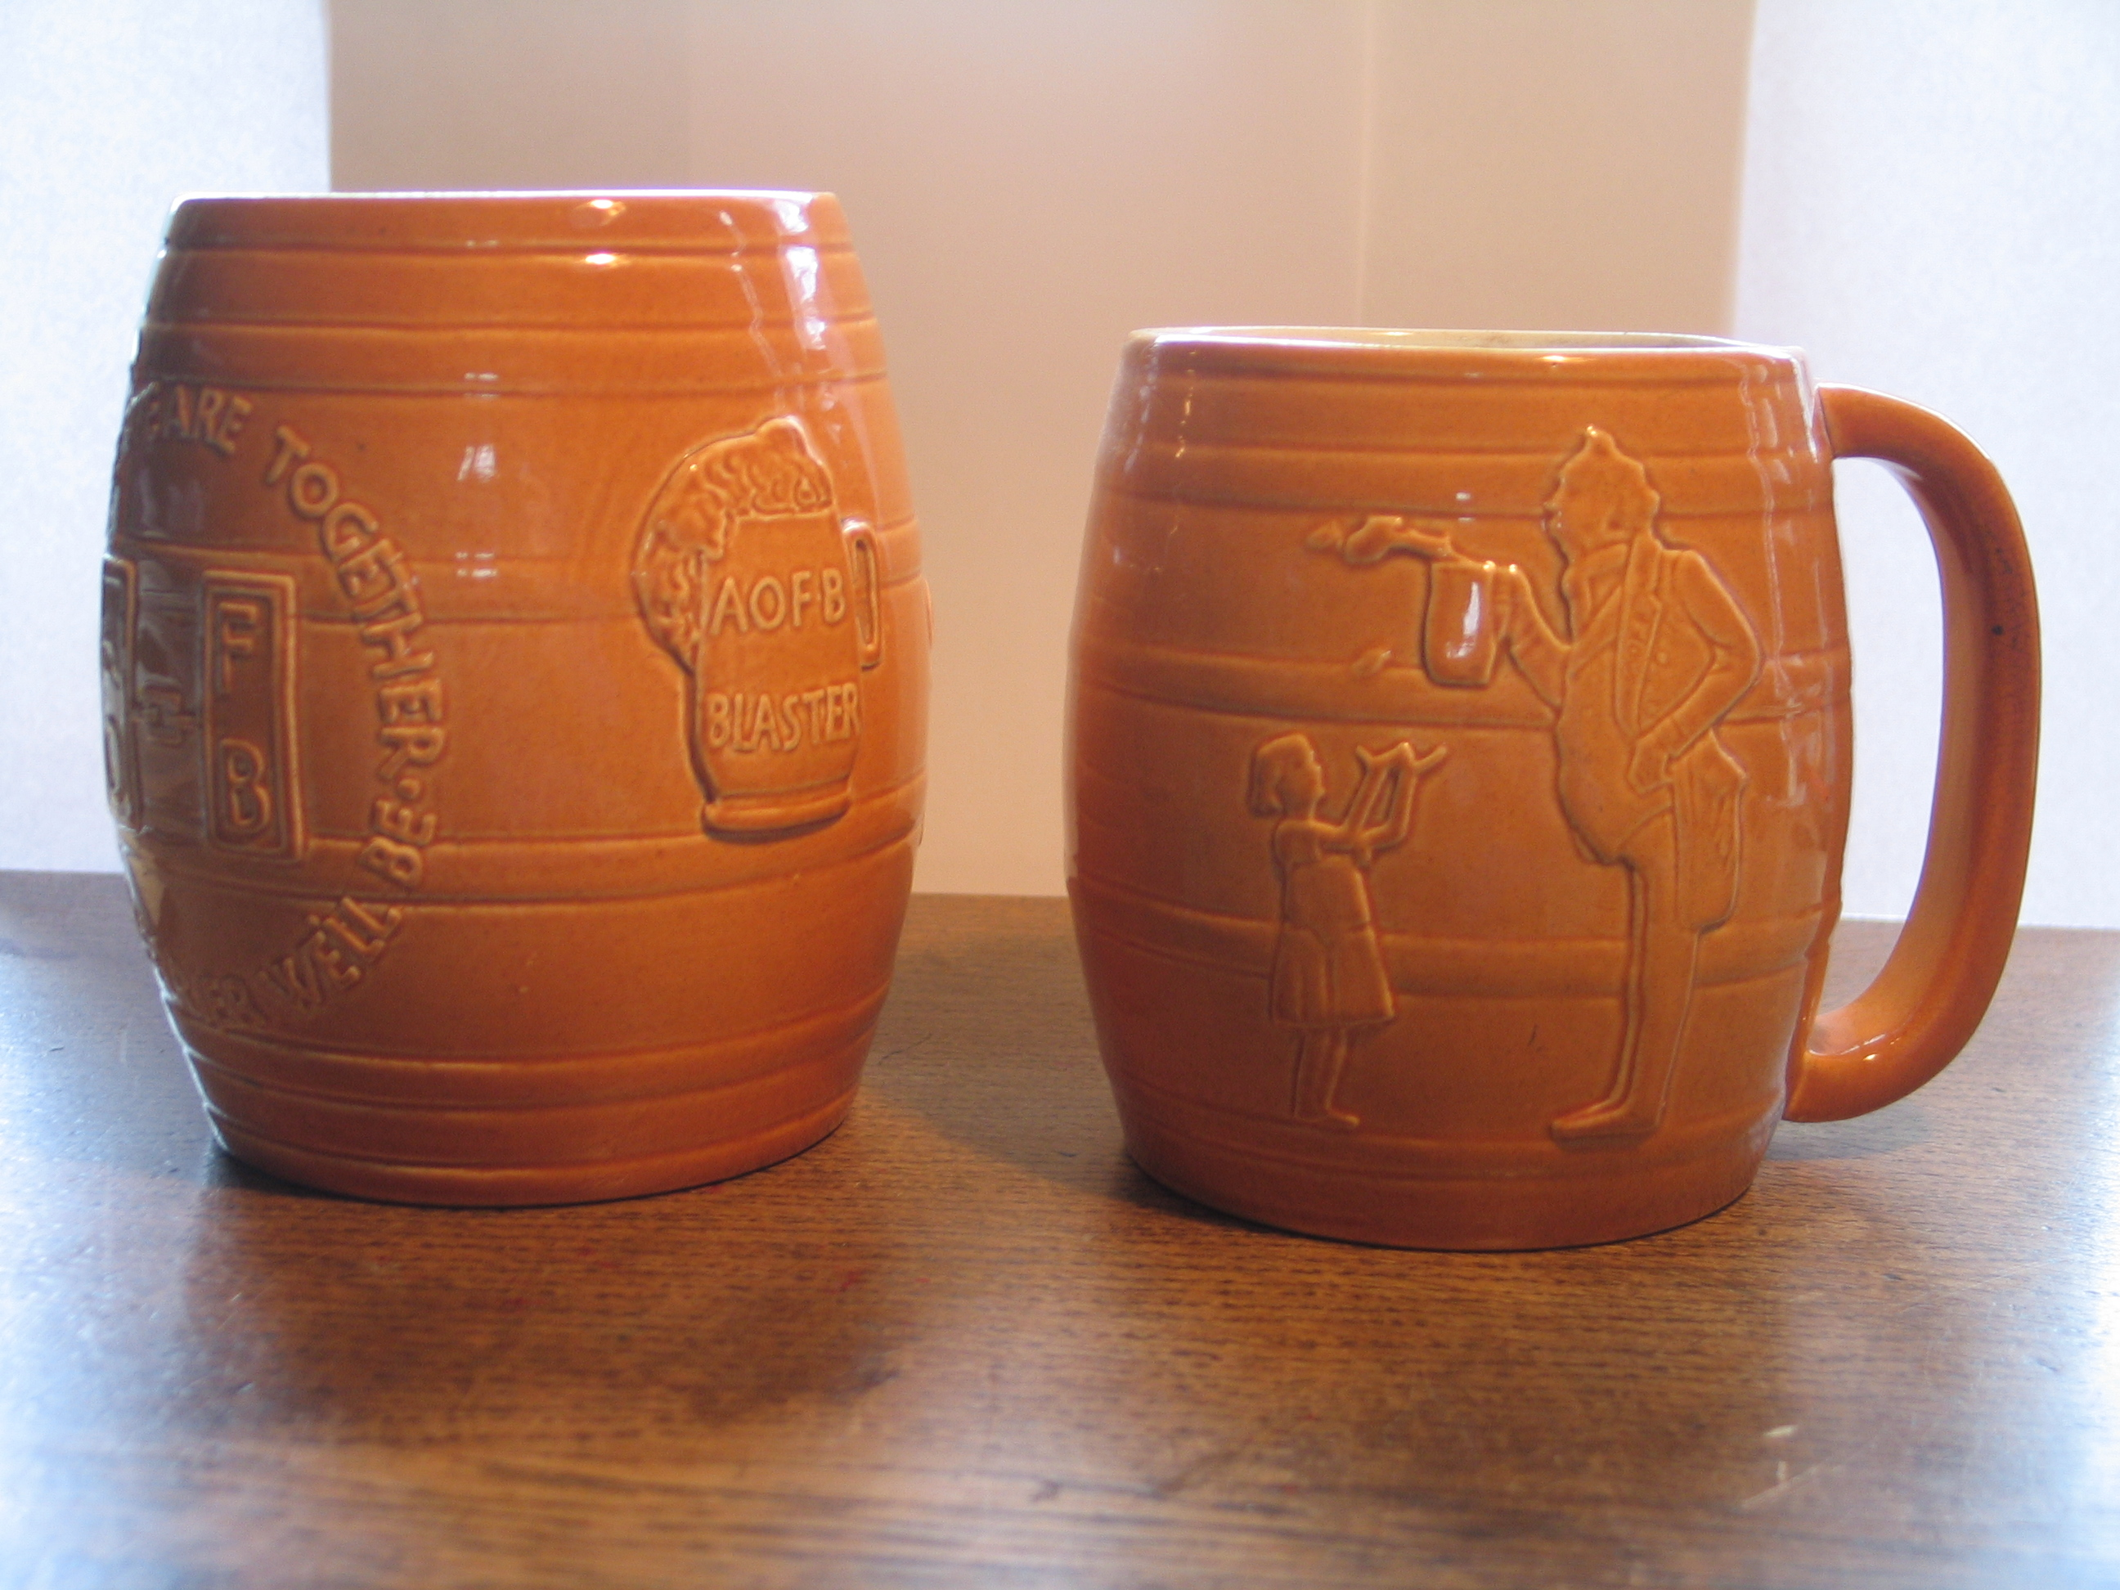
extent of his golloping capability. were part of the considerable investment
portfolio built by Bert’s father, Alfred. There
was also a wholesale warehouse in the area
(perhaps the same building?) which proved
to be a disastrous investment. There is a
famous picture of St. Paul’s surrounded by
smoke and flames during the Blitz, with a
caption describing the warehouse as being
reduced to a ‘stinking heap of rags’. That, I
am sad to say, was the bulk of Alfred’s
estate.” Richard (Longdale Temple) - now
made F.O.F.B. Member No. 000. D.L.W.
FROTHBLOWER DAY: 29th MARCH 2008

The Swan, Fittleworth
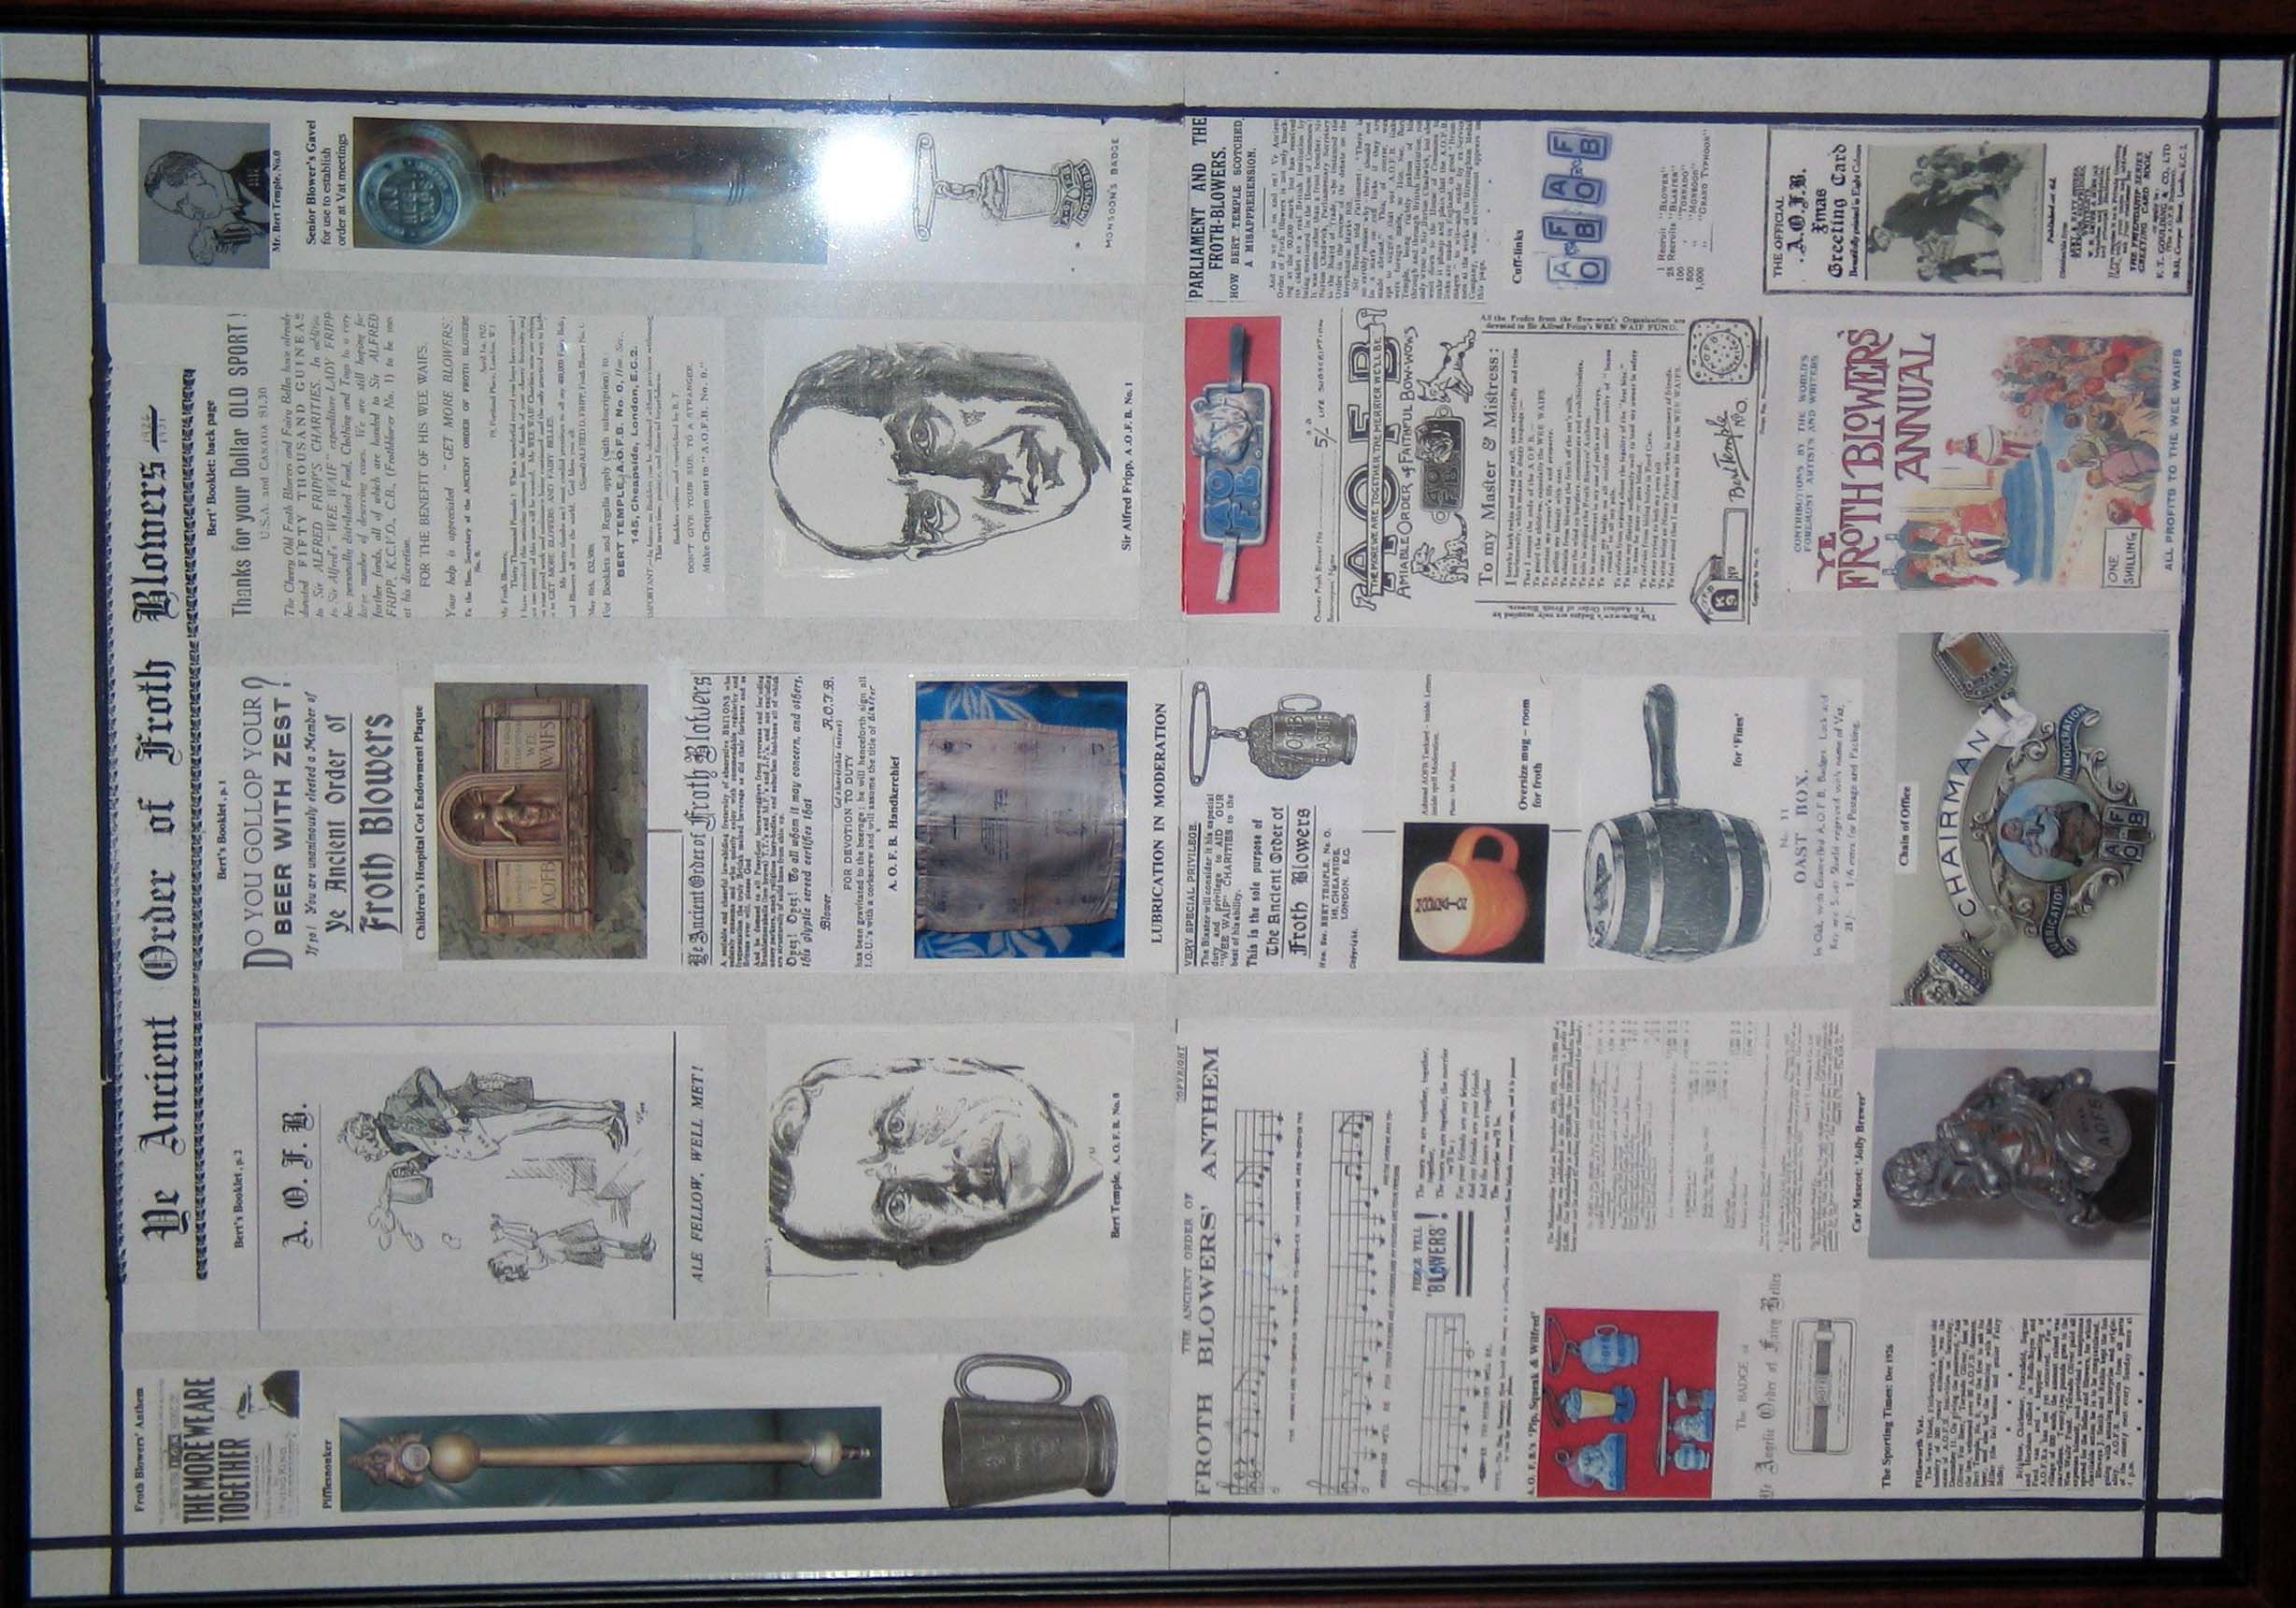
For over a year it has been my intention to hold a second annual event at the site chosen by me for Camra to immortalise with a plaque to the memory of the A.O.F.B. and Bert Temple. For some reason, Bert decided that this Sussex pub should be his ‘No. 0 Vat’ – presumably because it was a ‘proper’ country pub where fishing and dancing were delights he could share with his close friends while raising money for the cause. That the host, ‘Monsoon Oliver’, was particularly bonhomous and generous, was an added incentive.
The present lessee of the Swan, Paul Warriner, and his manager, Nigel, are happy to further the cause of the A.O.F.B. by making room for this (which I shall take to the Swan on the day) and other displays on the 600-yr-old walls; in some contrast to the picture-frames containing 19thC sketches contributed by artists when signing the Guest Books all those years ago. It is worth visiting the pub to view these books, if there were no other reasons – which there are: good food, cask ale, accommodation, village setting and the Froth Blower plaque.
I have provisionally booked a table:
for 1300 hrs
on Saturday, 29th March, 2008
pay as you go (2 courses £10 -£15)
at the Swan, Fittleworth, nr Pulborough, W. Sussex. 01798 865429
info@swaninn.com + website
I need to know of your intention to attend a.s.a.p – but by Easter (Friday, 21st March)

Advance Warning
All things being equal, the Third Annual Reunion of the F.O.F.B. will take place in Salisbury at the Frothblowers Arms, Milford Street, at midday, followed by lunch at the Red Lion Hotel on Saturday, 13th September, 2008. rsvp
David Woodhead finwood40@btinternet.com

