FOFB NEWSLETTER NO. 7 Summer 2007
YE ANCIENT ORDER OF FROTH BLOWERS

3rd FOFB REUNION
This took place in the Froth- onwards. Our man from the B B C proved to be in
blowers Arms, Milton St., the great tradition of pub performers, as his sketch
Salisbury, at noon on Satur- proves. Paul, the licensee, is happy for a small dis-
day, 15th Sept. 2007. A liquid play cabinet to be hung in a prominent place to act
lunch was taken here and a as a mini-museum and a permanent reminder of the
solid one in the Red Lion A O F B’s activities. I hope we will inaugurate this
Hotel - courtesy of mine host, in late March (say, 29th) next year.
Blaster Mike Maidment. After a bonhomous coda from our host, a natural
The event was well attended raconteur, the twelve apostles rose from the table
by the F O F B stalwarts (the for the annual photo, at which point a spontaneous
not-so-dirty dozen) with the rendition of the noble chorus of the Froth Blowers’
welcome addition of Chris the Anthem was captured in silent stillness:
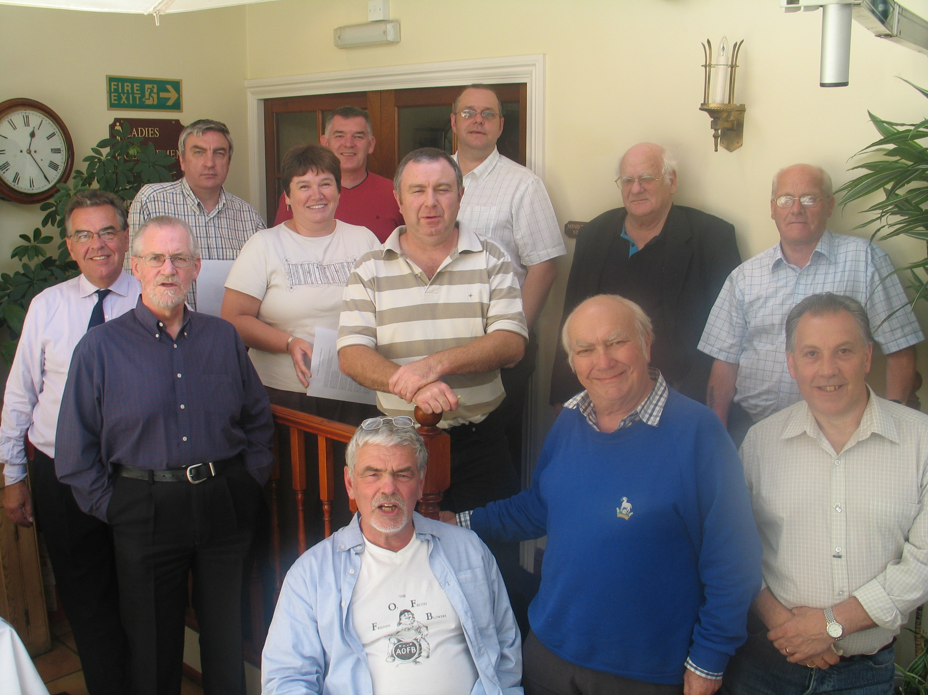
cuff-link king and his friend,
Jack of the Bushveld, plus
Fred, a real ale-man working
for a real brewery, Wadworth.
Much as the stalwarts like
each other’s company, more
Freds and Jacks would be much
appreciated.
Having said this, for myself
this was another great day out –
despite driving a 300 mile round
trip, 24hrs after a flight from
Singapore. The sun shone – as
usual – the company sparkled,
as did the two cot plaques, and THE MORE WE ARE TOGETHER…
the Froth Blowers’ Anthem rang Following this all visiting F O F B’s repaired to the
out (briefly) through the old inn’s Wyndham Arms for a refreshing pint of Hop Back - and
courts. Your scribe reminded a fortuitous piece of lardy cake.
the assembled F O F B’s that Aufwiedersehen…
Bert’s No. 0 Vat - plaqued by
Camra - the Swan at Fittleworth, Ye Froth Blowers’ Annual
had as yet been visited by only One of Mike Maidment’s prized possessions is
five members: the A O F B’s one-off Annual (of late-1927, by my
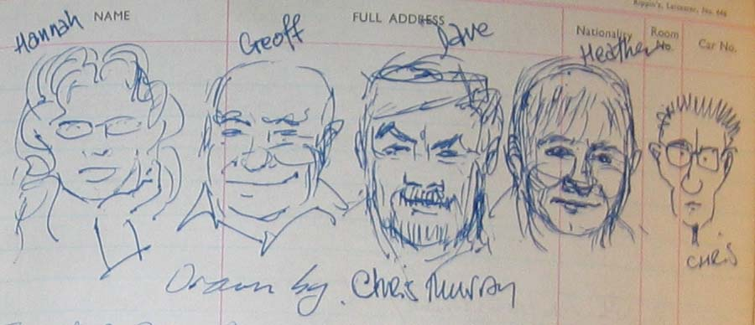
estimate) in which various writers and artists of the
era contribute to yet another fund-raiser. It contains
144 pages of articles (one by Sybil Thorndike),
drawings (one by Mabel Lucie Attwell) and ad-
vertisements - both AOFB-related and otherwise.
The first article is ‘Why I Am A Froth Blower’ by
Another reason for visiting the Sir Alfred Fripp, and others by Bert, ‘The Origin
Swan is the quality of its Visitor Of The AOFB Anthem’, by Dorothy Roper, ‘The
Book drawings from the 1880’s Gentle Zephyr’s Greeting’, and by David H Cain,
‘Queer Clubs And Clubmen’.
On page 69 is this little gem:

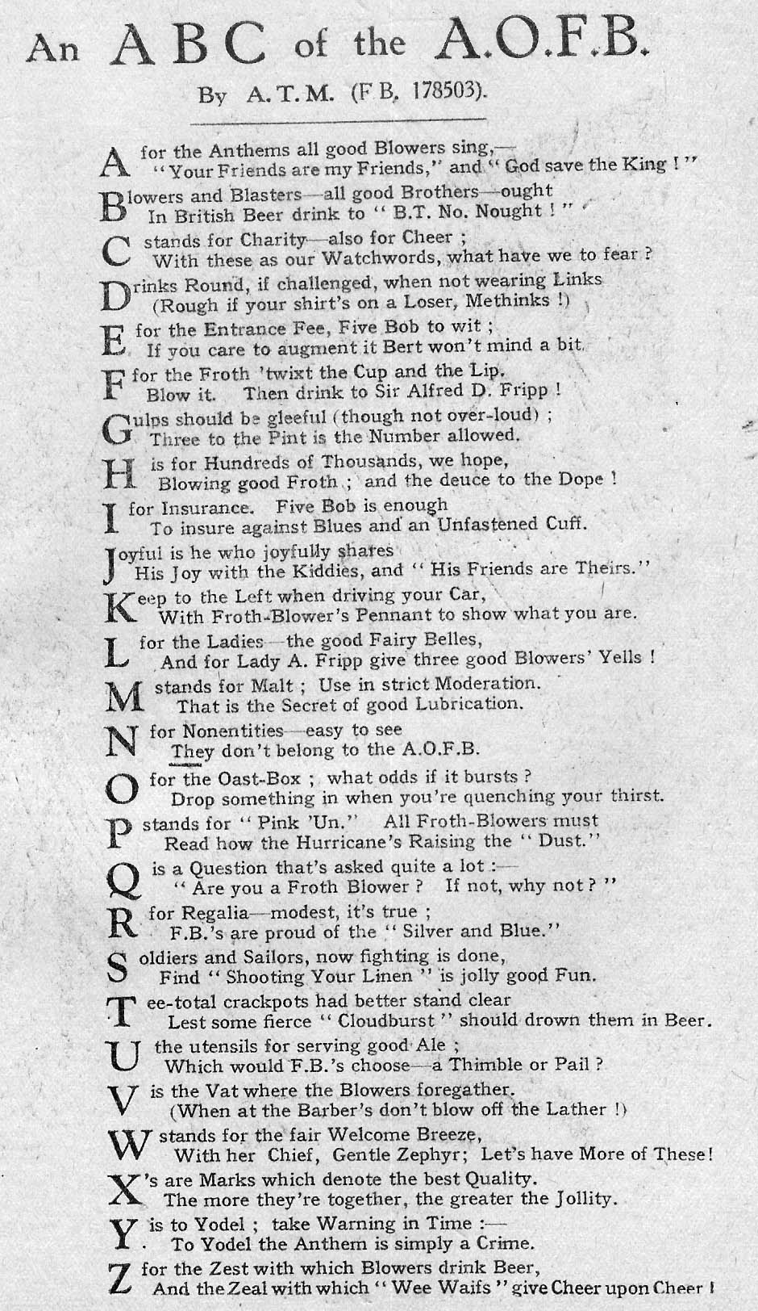
F O F B Vats
The establishment of modern Vats seems to be something of a problem:
The Holly Lane Vat suffered a set-back when the club-house they used was taken over by unsympathetic own-
ers, and they are yet to re-form.
The instigator of the Glaston-
bury Vat, Chris Harding, has moved to Poole; we await a
Dorset Vat.
I have heard nothing from the Phoenix Vat of North-West
Kent; I hope they are still gol-
loping their beer with zest.
The Singapore Vat based at
Brewerkz (Riverside Point) is
flourishing, led by Blaster Rob-
ertson and Blower Tang – both
proud wearers of the FOFB T-shirt.

AOFB Vats
A O F B Vats in the London area are being indefatigably
tracked down by FOFB Steve
Wilson. Read all about it on the FOFB website:
http://www.btinternet.com/
~ianb/fofb/fofb.htm
Keep us posted, Blowers!

Memorabilia
It is clear that the FOFB’s formation has brought about a renewed interest in the AOFB from people outside our membership, especially those wishing to sell pieces of family history they were previously puzzled about. Now many pieces are in the poss-ession of enthusiasts – pifflesnonker, chain of office, cigarette box, car mascot, play-
ing-cards, ashtray, tankard - the list is long and growing longer after each treasured pur-
chase. At some point I would like to have a ‘Display Day’, conveniently situated for as many collectors as possible, and with some press coverage, if possible. Any ideas?

Tailpiece: Analysis of a 5/- Subscription
Cost of Links or Wristlets and Badges . . . . 1 9¼
Cost of Membership Book . . . . . . . . 5¼
General Office expenses, Postages, etc., etc. . . 3¾
Wee Waifs . . . . . . . . . . . . . . 2 5¾
LUBRICATION IN MODERATION DLW

