FRIENDS OF THE FROTH BLOWERS
NEWSLETTER NO.16 AUTUMN 2009

THE SIMPSON’S BASH
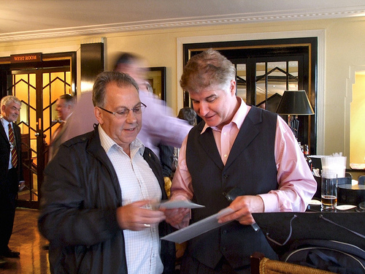
Our fifth annual gathering – or ‘Fourth Annual Reunion’ – took place, as advertised, at Simpson’s-in-the-Strand on the 144th birthday of Sir Alfred Fripp: 12th September, 2009. As the first recorded income of Ye Ancient Order of Froth Blowers is dated the 9th of Sept-ember, 1924, the luncheon also celebrated the 85th anniversary of Bert Temple’s ‘whimsical’ idea.
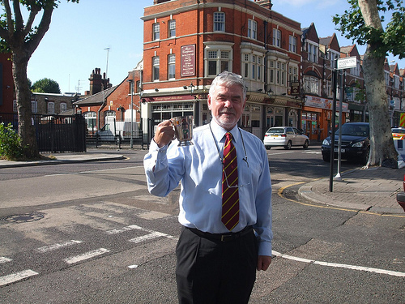
For the Birmingham Four plus the Lichfield One, the day started early: at 0830hrs your Chairman had fed and walked the dog, packed the car and driven the eight miles to Lichfield to pick up the One. At 0900hrs, the Erdington Three and their artefacts were safely stowed in various parts of the car, and London beckoned. At 1100hrs, we were outside the Three Compasses in Hornsey with an empty Temple tankard in our hands – too early for beer here, but grateful that the Oxfords had left Bert’s beautiful pot to grace the occasion.
The usual horrors of driving in London – with one-way systems that make it impossible to get where you want, forcing me to do an illegal U-turn in the middle of the Strand – meant that I had no time to down a pint at the Coal Hole with the other gentlemen. However, it meant that at 1230hrs the car was unpacked, the three cases of Frothblower Ale were in place in the dining-room, artefacts were safely stowed and I was able to take an aperitif (if a bottle of London Pride falls into that category) with the assembled throng.
Holding the event in London was supposed to attract Home County FOFB’s: in the event, Jill, John, Chris and Richard were the only Londoners present – and Richard had made a journey from Belgium and back to spend an hour with us, for which he is to be made a Fellow of the Frothing Beermug. Admittedly, the Drinks Correspondent from The Chap, Neil Ridley, is domiciled South of the river, but Jeff and Eileen live in deepest Kent, Bill and Dawn came from Tewksbury to be with us, and Steve journeyed from Peterborough but had to leave for a wedding (not his) – plus, two more from out-of-town, Caroline and Annabel, who should have been present but got the wrong day.
So, at 1330hrs, fourteen of us sat down to a sumptuous and leisurely feast; but not before I had risen to my feet to welcome 21stC Blowers to the 19thC venue:
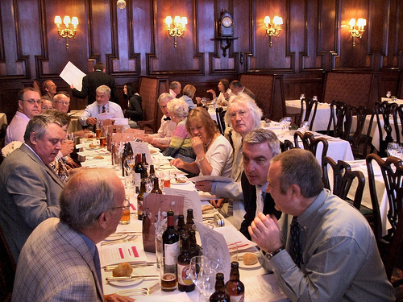
As one of seven diners who chose the roast beef option, washed down with ale and/or wine, I realised why Simpson’s has survived for 190 years.
ARTEFACTS
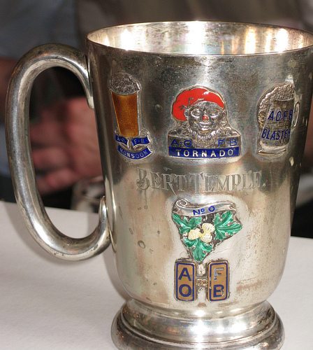
I had arranged with the management to use the Bishop’s Room to display the many treasured poss-essions brought to the event by the AOFB collect-ors present – and a brave sight it was, but still Bert’s tankard must take pride-of-place:
During the meal we had, with a complete disregard for swine ‘flu’ and the Black Death, already passed it round the company as a sort of ‘loving cup’. Despite our natural reticence, we also regaled waiters and other diners with a decorous rendition of ‘The More We Are Together...’
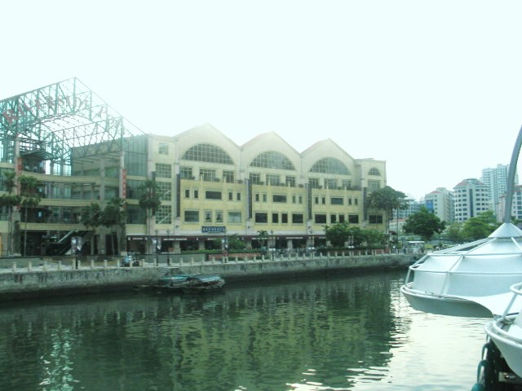
Taken all-in-all, I think we can claim to have celebrated the anniversaries of Sir Alfred Fripp’s birth, Bert Temple’s Ancient Order of Froth Blowers’ inception and the Fourth Annual Reunion of the Friends of the Froth Blowers – in style.
Many, many thanks to all those attending for making it so memorable – for me, at least!
THE JOURNEY HOME
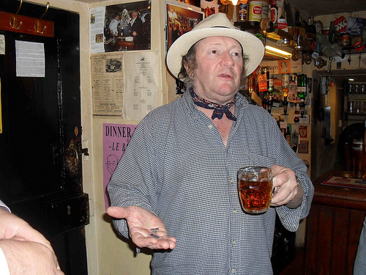
Normally speaking, I would not expect other FOFB’s to be interested in the pubs we visited between London and the Midlands. However, this time, although we called in on the wonderful White Horse at Hedgerley and the relatively unspoilt Leathern Bottle at Lewknor, we did have FOFB business to transact at the completely fabu-lous Peyton Arms, Stoke Lyne. Over the last year-or-so I have given the landlord, Mick the Hat, a copy of my book, a T-shirt and a Newsletter or two. It, therefore, seemed appropriate to induct him into the full mysteries of the AOFB and the FOFB and make him a member – to which end Ian presented him with a pair of AOFB cuff-links in a small but touching ceremony, treated with due seriousness by all present.
As I have said before, do not miss the opportunity to visit this quintessentially English institution.
The FOFB will hold a gathering here in the new year, but The Hat does not like large groups cluttering up his small bar, so I propose a ten-man/woman event (first-come-first-served) in, say, March. Meanwhile, I will have to visit the pub as often as possible to smooth our path into the Dragon’s Den.
OTHER MATTERS
Singapore Vat
It has proved difficult to set up genuine Vats of our own – the Holly Lane Vat was turned out of its premises, the Phoenix Vat did not report back, and the Glastonbury Vat was short-lived because Chris Harding moved to Poole and has since been in hospital. There is, however, a functioning Vat at the Brewerkz brew-pub in Singapore. Before I left, three weeks ago, we had an FOFB meeting of a dozen people, ate Mexican food, drank beers of the world (a choice of eight), and put money in an impromptu Oast Box for the Brewerkz’ charity collection (for children). We raised the equivalent of £60 in a two-hour meeting. The resident Hon. Sec. of the Singapore Vat is Dave Hogan. If you intend to visit Singapore, contact me and I will give you information about this, the most interesting brewery outside Britain that I know.
Coming Events
Second Brum Trudge - Saturday 14th November: meet at the Wellington, Bennetts Hill; times, etc. to be arranged by Steve Williams/ Dave Woodhead
See Pub History Society and FOFB websites.
To The Hat: Saturday, 27th March (probably)
Plaque-wetting: Saturday, May 1st – Fittleworth
Fifth Annual Reunion: Saturday, 11th September –Salisbury (for me, but open to suggestions)
Dave the Chain finwood40@btinternet.com

