FRIENDS OF THE FROTH BLOWERS
NEWSLETTER NO. 15 SUMMER 2009

The Fourth Annual Reunion
On the 23rd of October, 1926, the Pink ‘Un Vat (i.e. The Sporting Times branch of the A.O.F.B.) held its Inaugural Dinner in the Knight’s Room of Simpson’s-in-the-Strand “to pay tribute to the magnificent work for charity done by Sir Alfred Fripp, K.C.V.O., Blower No.1 and the founder of the now famous Order, Bert Temple, Blower No. 0.”
As you know, in order to celebrate this significant gathering of senior AOFB’s, we Friends of the Froth Blowers are to hold our Fourth Annual Reunion, not at the Frothblowers Arms/Red Lion Hotel in Salisbury, but at Simpson’s itself. In choosing the second Saturday in September, five years ago, I had in mind the fact that Sir Alfred was born on September 12th, 1865, and that the first date mentioned in Bert’s accounts was September 9th, 1924. So, 2009 is the 85th Anniversary of the founding of the A.O.F.B.
As I write this I have had a positive response from eighteen FOFB’s and hope one or two more might join us on the 12th. The following is the projected timetable of events:
1215hrs – meet in the Knight’s Room
1245hrs – order food
1300hrs – move down to the Grand Divan
1305hrs - endure the Chairman’s Greeting
1310hrs - enjoy a leisurely lunch
1430hrs – inspect artefacts, articles, etc.
1530hrs – sing “The More We Are Together...”
1535hrs – gradual disintegration of party
1600hrs – go home or repair to local hostelry
The cost of two courses is £24.50 and a bottle of wine is a similar price. The Chairman is to present each diner with a bottle of well-kept Frothblower’s Ale - for immediate froth-blowing consumption (from AOFB tankard or pot, of course) or as a memento of the occasion.
Simpson’s-in-the Strand
John Simpson’s ‘Grand Divan Tavern’ of 1828 might appear to be a ‘gentleman’s club’ but, in fact, it is just a restaurant – arguably the most famous in London. Its grandeur nowadays does seem a little faded but it is always worth a visit. This will be my third.
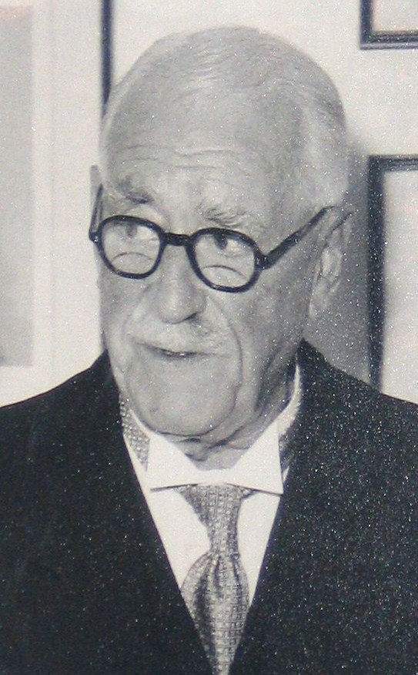
On the walls are prints and photographs, many relating to its importance as a venue for prestigious events in the world of chess. One, however, is of Fred Heck, the man in charge of the AOFB’s dinner here in 1926. He and his predecessor ruled at Simpson’s from 1865 to 1955 between them.
By October, 1926, the A.O.F.B. had grown from a few hundred members at the turn of the year to a hundred thousand – and was still increasing rapidly. On the night of the Dinner, Sir Alfred was handed an ‘extra’ cheque of a thousand pounds, and this was increased by another hundred or so by frivolous fines of the deliberately incautious members.
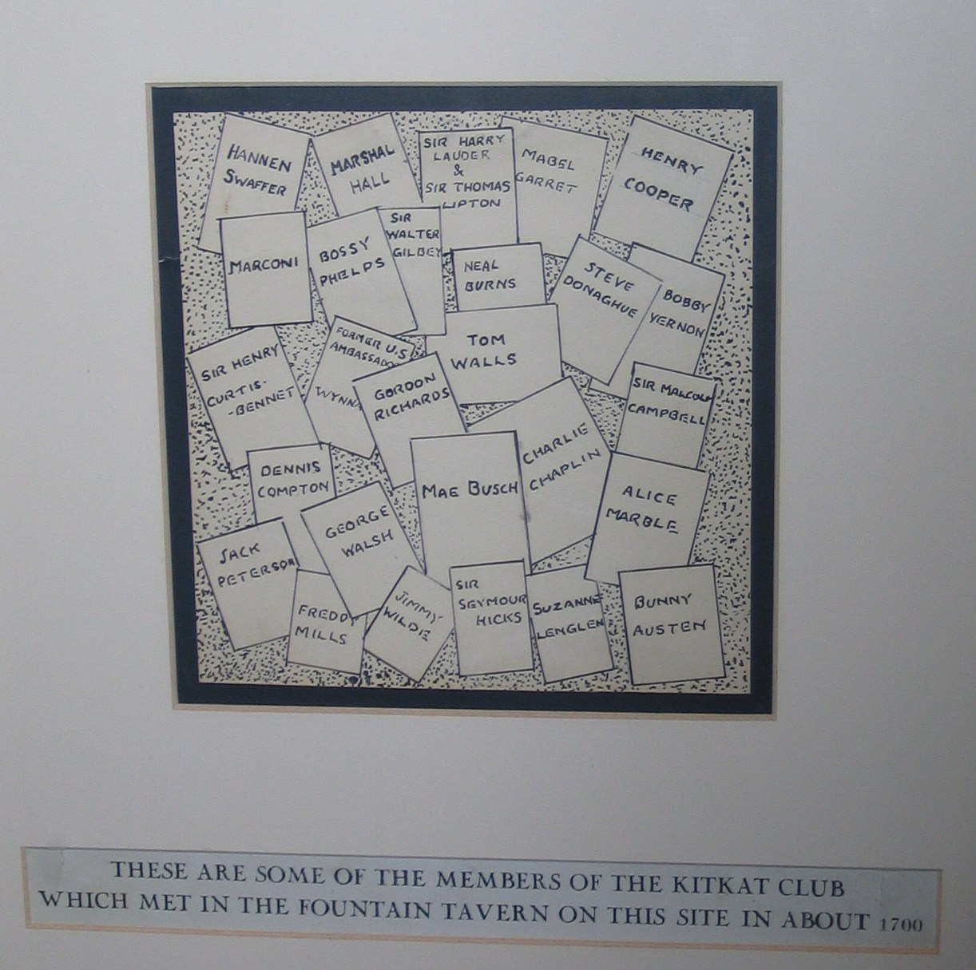
As Simpson’s is the third Vat in all the booklets’ lists of Vats, it must have been much frequented by the Order’s original members, some also in the Kitkat Club – which met here. The first Vat, the Pink ‘Un, and the second, the Carlton Hotel, Haymarket, are both no more; so, Simpson’s-in-the-Strand is the earliest extant Vat.
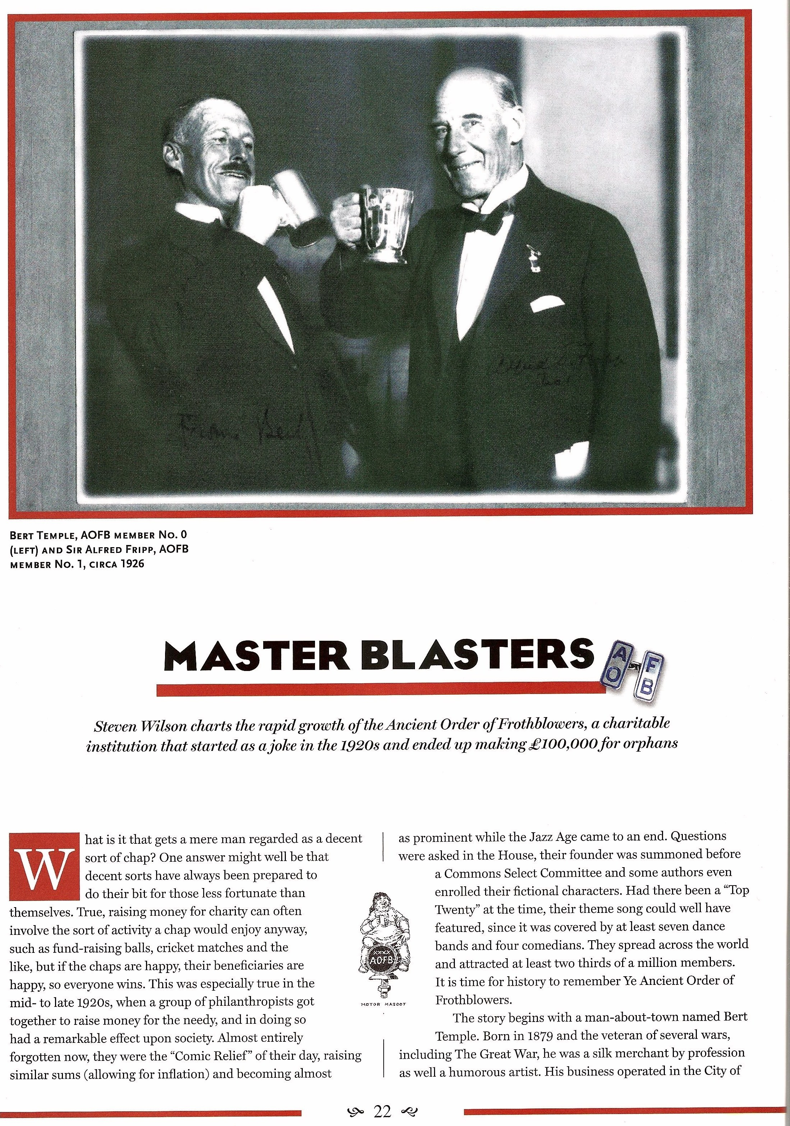
The Chap
FOFB Steve Wilson wrote an article- of which this is the first page - for a relatively-new magazine called The Chap. It is worth buying the current issue not only for Steve’s excellent article but for another, coincidental, article about AOFB Jasper Maskelyne. Not only that but the tongue-in-cheek attitude to political correctness, modern mores as compared with those of our grandparents, and general ‘chappishness’ make all its contributions something to smile at. This issue apparently nearly bankrupted it, so may turn out to be the only A4 edition - A5 being its previous format. Finally, Gustav, their editor, has said that either he or another reporter from the magazine will attend our Simpson’s gathering as a guest with an eye for further copy – and spreading of the Froth of Friendship message in the 21st Century. Another reason to come and join us to celebrate 85 years of the existence of Ye Ancient Order of Froth Blowers!
Get More Blowers – and FOFB’s!

LUBRICATION IN MODERATION
Other Matters
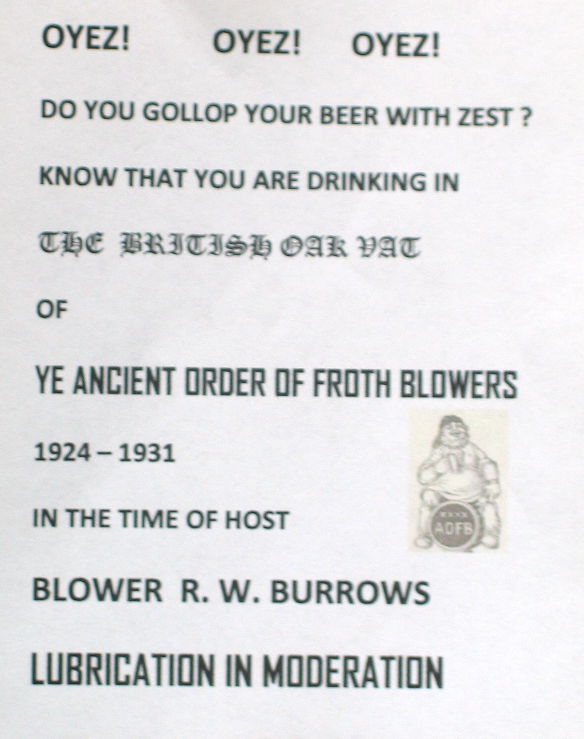
I have start-ed to track down a few extant Vats of my area of the Midlands – to add to the many located in the London area by Chris Mur-ray and Steve Wilson; plus those of the Peterborough area researched by Steve Williams. I recently gave this small (4” x 3”) ‘poster’ to the Old Cottage Tavern in Burton-upon-Trent which, as the British Oak, was the only pub Vat in that famous beer-town.
Perhaps other FOFB’s might wish to fill an idle hour with this area of research.
Pub History Society
On Saturday last (8th August), I joined nine other PHS members at the Royal Oak in Tabard Street, SE1, for the AGM of this august Society. With Chaucer’s pilgrims listening in to deliberations about our role in the world of taverns, inns, pubs and hostelries generally, had they been able to speak I am sure they would have said that the world is different but the concerns of the drinking man have not changed so much!
After the meeting, at which I updated the members on FOFB events - and agreed to lead another Brum Trudge (in November, prob-ably) – I was able to catch up with FOFB Paul Turner at the cider–stall he mans in Borough Market. He has recently acquired a copy of the Froth Blower Annual – lucky man!
I was happy to find the Market Porter sold a decent selection of SIBA-type products, of which I had a sample before returning – via the White Horse, Hedgerley, and the Peyton Arms, Stoke Lyne, to my abode in Four Oaks.
Dave the Chain - 13th September, 2009

