FRIENDS OF THE FROTH BLOWERS

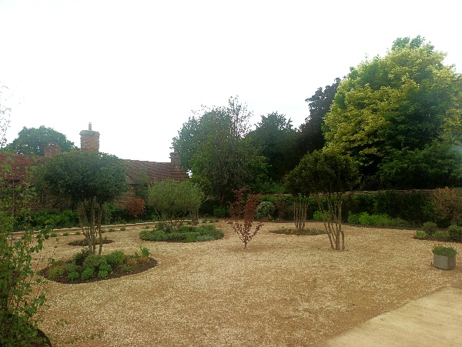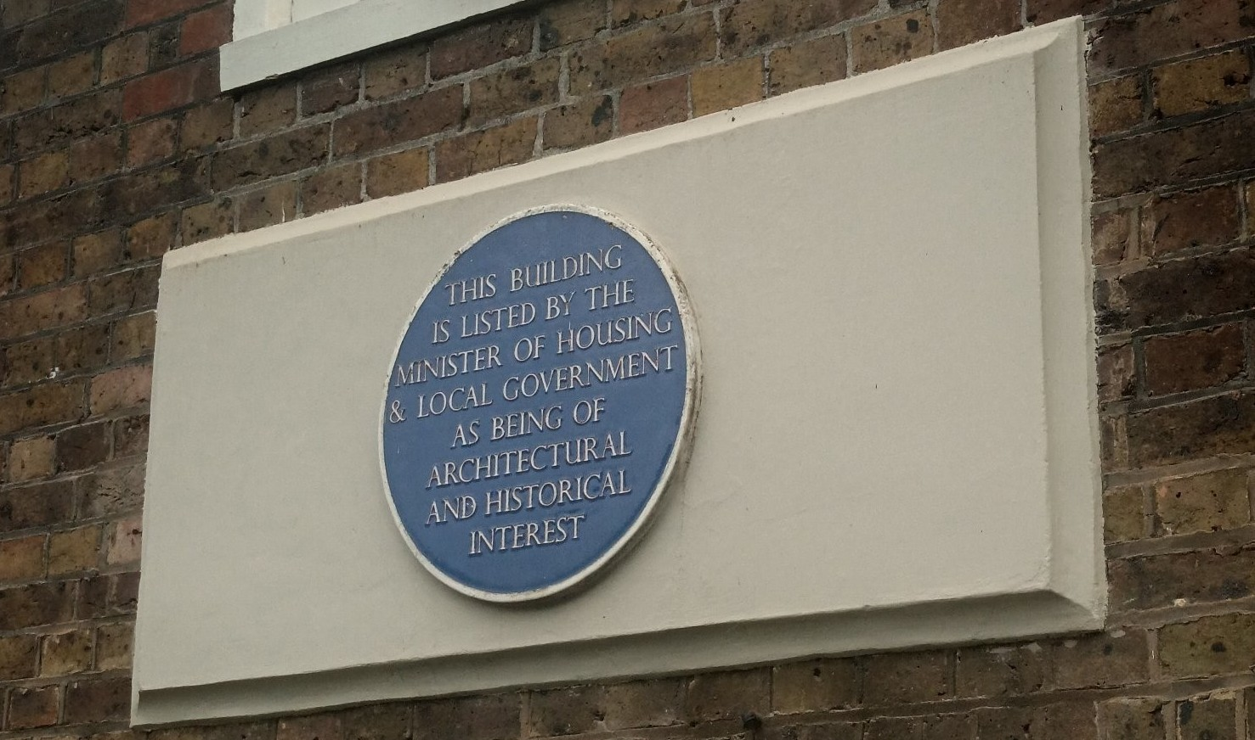NEWSLETTER NO. 79 SUMMER 2025

Plaque-Wetting

This was the only plaque available for the small (in number) but dedicated FOFB’s to drink to on the occasion of our return to the ‘No. 0. Vat’ of Ye Ancient Order of Froth Blowers. We were pleased to find that only the garden had been ‘refurbishedd’ beyond recognition, and that, otherwise, the place had been restored – including the Visitors’ Books. However, only the inter-war one was on display for us to see; the others – unsurprisingly - were being ‘refurbished,’ too.

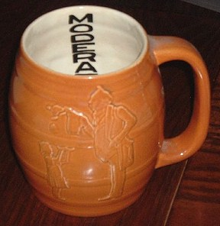 Another’positive’ was that the five ‘old’ members gathered there were joined by Andy and Judith – from Ashtead – making their first appearance at a Froth Blowing event. We did not actually blow much froth, but talked quite a lot on the subject of Lawrence Weaver and the Ashtead Pottery, about which Andy is something of an expert – even to the extent of possessing a ‘MODERATION’ mug (another of which I have recently purchased at auction, involving an extra cost of a cask of beer for a charitable event supported by a couple from the Thirsty Giraffe who collected the mug for me from deepest Suffolk because the auction-house wanted to charge me a fortune to send it to me). So - returning to the Plaque-wetting - although there were only seven of us, the trip was worth the effort. Angus is genuinely interested in the Inn’s connection with Ye Ancient Order of Froth Blowers. Judging by the number of diners, the locals approve of the new-look Swan – even if there is not, as yet, a plaque on the outer wall of the inn to inform them that, perhaps, they should be blowing froth off their Peronis before tucking into their steaks. The journey home involved dropping FOFB Mike, Jim the Larger’s brother, and his folding bike on the edge of Uxbridge, before Ian and I returned Jim to his car outside the Hat Vat. It would have been rude not to have partaken of a Hooky or two with Blower Weston – so we did.

**ANNIVERSARY LUNCH of the FOFB’s: 2005-2025**

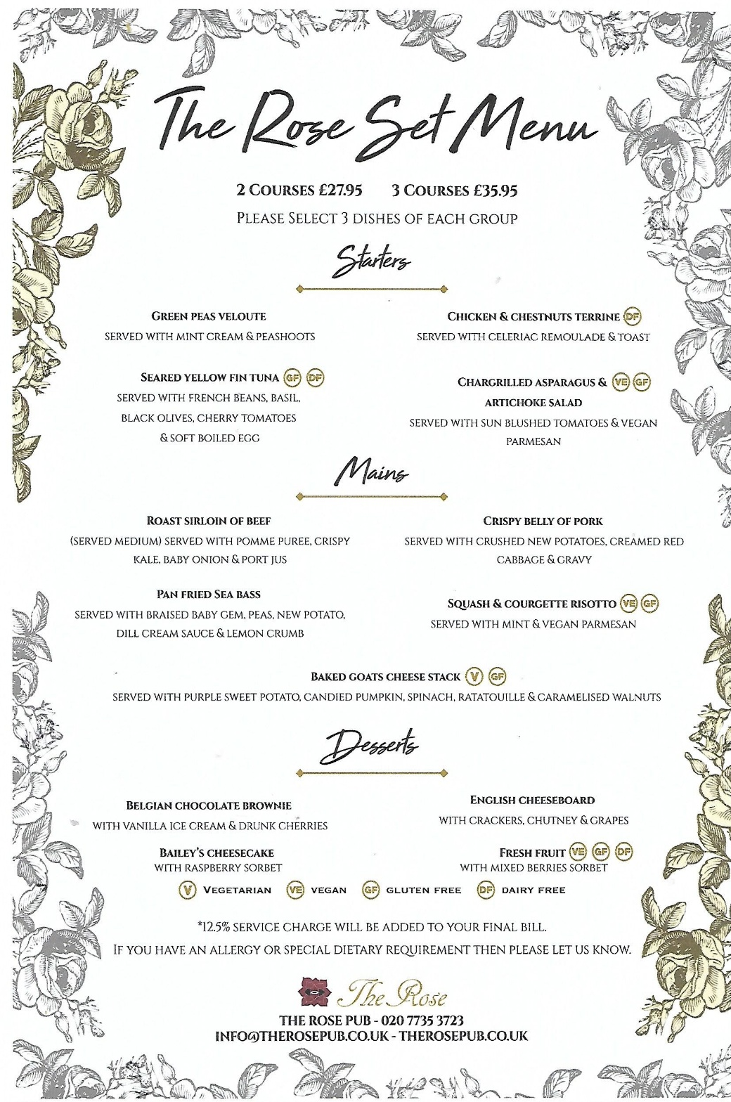Saturday 25th October, 2025: 12noon for 1300hrs to 1530hrs.

**1 The Rose**, SE1 7TL After considering other places to meet at this year, I have come to the conclusion that The Rose would still be the best place. Apart from poor cask ale, it ticks most of the boxes: ease of access (for London), nice room with iconic back-drop, good food (for a Gastro-pub) and reasonable wines. However, they require that we spend £1000 there. This would mean that I need 12 FOFB’s (and guests) to pay £75 each all-in – food and drinks - for it to work financially for me. Obviously, the more people to sign on, the lower the base price. If I have not got at least 10 positive answers by the middle of this month, I will not make a booking.

**2 Birmingham** A reasonably=priced lunch in Birmingham (private room at the Wellington, probably).

So, reply as soon as possible to say

(a) you can and will make Venue 1 (making meal choices to save time, if you like)

(b) if the Rose does not have enough takers, then you will make Venue 2 (c) you prefer Venue 2 to Venue 1 but can make both.

(d) you can make 2 but not 1

(e) you can make 1 but not 2

or (f) ignore the (a) to (e) and just tell me what suits you!

If the Rose is a no-goer and you are undecided, I will be in the Wellington in Birmingham between 11:30 and 12:30 on the 25th to meet and greet the decided, but may move on if we decide to eat elsewhere – rather than arrange to bring food into the Wellington (as is possible).

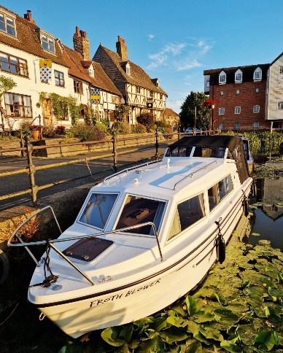Froth Blowers Brewery

The hospitality industry – and cask ale production, in particular - is in such a dire state that selling-up a brewery is almost impossible. As we have bargaining power with our landlord because of the on-going dispute following the fire of July, 2024, we hope to sign a reasonable agreement with them in November – when our current 5-yr plan finishes. I doubt I will be involved into my nineties, but here’s hoping!

The good ship “Froth Blower” is ready to navigate the Avon and beyond – with Captain Bill, a Wizzard wizard, at the helm. Good luck to all who sail in her!

Dave the Chain (07525 100644) finwood40@btinternet.com