FRIENDS OF THE FROTH BLOWERS

Newsletter No. 77 Winter 2025

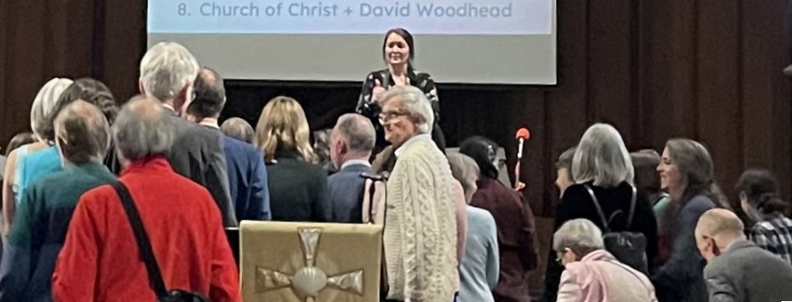

The Singapore Vat

I draw your attention to the words at the top of this photograph. Eighty-five years have passed since I was last singled out by a Christian group: more-or-less at birth I was accepted by the Society of Friends of Birmingham as a potentially Quakerly soul, and yesterday the Wesleyans of Oxford added my name to a list of wedding guests for the purposes of capturing my features on camera for eternity. However, had I not inaugurated an FOFB Vat in Singapore some 25 years ago, my serendipitous participation in this event would not have been recorded.

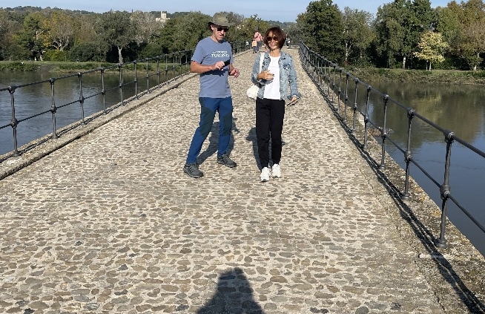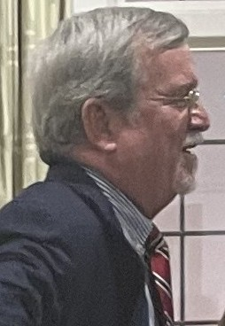 I met Dave (pictured) on the north bank of the Singapore River in 1999 (we think) as we were both customers of the then newly-opened Brewerkz brew-pub (3 pints of beer and food for 17 Sing dollars – a sort of lunchtime ‘loss-leader’). My new friend was part of a group of Brewerkz drinkers that included the brewer, Scott, and assistant-brewer, Kim. Before I left for home the nucleus of the Vat had been established – with Dave as its inspirational leader. So, after all these years of long and short distance friendship, I became his natural ‘plus-one’ to the wedding of two young Malaysian women of his church, having to marry in Britain as they were not allowed to marry in Singapore. This has meant six hours of excellent wedding-celebrations - in which Dave was a pastoral celebrant participant - interrupting six days of beer celebration (with Froth Blowers’ beers being central to all tours).

In October, I had helped (I hope) to celebrated the tenth anniversary of the wedding of Blaster Scott and Fairy Belle Eriko by journeying to the south of France in order to dance ‘sur le pont d’Avignon.’ Early members of the Sing Vat, they are now the only members of the Peachland Vat, British Columbia.

No Stone Unturned

A recently-found clipping had this to say about Bert’s state-of-health: *“On the Water Waggon*, *Bert, for the rest of your days.” This was the sentence passed by Froth Blowers No.1, Sir Alfred Fripp, the most charitable of Britons, on Froth Blower, No.0, Mr. Bert Temple, just before opening time on December 1, 1923.* This is a date some months before I had supposed the operation to have taken place: it was the following November when the final medical consultation occurred. It seems that one of the 80,000 teetotallers said to have been enrolled in the Order was Bert himself. The description of the operation is in motor-mechanic terms: *The surgeon had just previously deftly removed Bert’s beer viaduct, bolted and barred the spare tank, inserted smaller meshed gauze in the filter, and fitted smaller inlet pipe – in short, performed a major operation which saved the life of Blower No. 0. … who, he says, since 1897 had been a happy-go-lucky rover who had gazed into countless brimming tankards in the Artist’s Rifles’ canteen, golloped incredible quantities of French P. N. P. with the 1st Sportmen’s Battalion, and sample native vintages in all parts of the world from Dublin to the Fiji Isles.* The description suggests that, as well as the pulmonary problems shown on his death certificate, Bert might have had cancer of the oesophagus. It certainly proves that he did travel widely.

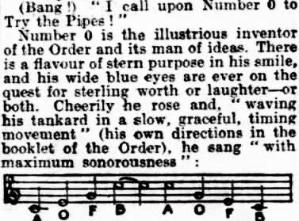 Another ‘find’ was an article describing in detail how David Cain chaired an actual (but anonymous) gathering:

The article gives a flavour of what AOFB gatherings were like, as well as why they worked.

Monday, 17th March, 2025

With gloating apologies to all those unable to foregather on the actual day of my **85th** birthday, I propose a **mini-‘Brum Trudge**,’ starting from the **London & North Western** (Wetherspoon) in Birmingham’s New Street Station at 11 a.m., followed by a visit to the **Barton Arms** (under new – ‘free’ – management), **the Prince of Wales** (Cambridge Street) and finishing at the recently re-furbished **Wellington.** Other hostelries may be added according to my state-of-health. Food can be fitted in somewhere for those who need the ‘blotting-paper.’

Plaque-wetting

With or without a plaque to wet, I propose to visit the **Swan, Fittleworth,** from midday on Saturday, 24th May, 2025. It is to be hoped that its part in the A.O.F.B.’s history is remembered.

r.s.v.p. Dave the Chain (07525 100644) finwood40@btinternet.com