FRIENDS OF THE FROTH BLOWERS

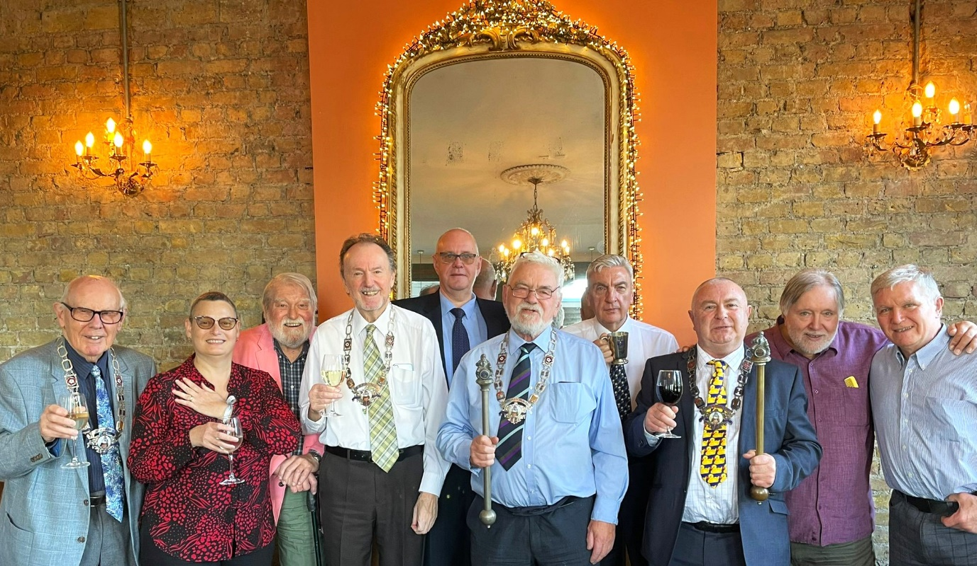NEWSLETTER No. 76 AUTUMN 2024

A CELEBRATION OF 100 YEARS OF YE ANCIENT ORDER OF FROTH BLOWERS

On the last Saturday of October, nine stout Blowers and one mild Fairy Belle found their way to the upstairs room of The Rose on the Thames Embankment shortly after midday to take pleasure in each other’s company – in sight of the Houses of Parliament. The mindless mayhem called ‘government’ occurring within its walls in recent years was in stark contrast to the purposeful way in which we accomplished the task of eating, drinking and talking amicably – because “my friends are your friends, and your friends are my friends,” of course. We seem in the picture to have two Black Rods and at least four enchained Chairmen. The mace-holders – as self-appointed Chairman of the Friends of the Froth Blowers and self-appointed (originally, I think) Secretary of the Pub History Society – expect not to be taken seriously. What we say goes … in one ear and out of the other. The powers behind our thrones have been captured in place on the day, Webmaster Ian and Editor Chris. Secretary Steve has two ‘checks’ on any Trumpish desire for world-domination as ‘she who must be obeyed’ - despite the apparent vow of allegiance – is within hearing … and reach. But such suggestions of hierarchy are meaningless in such company; symbolised by the seventy years of brotherly-love displayed by Jim and Mike (right). Having ten aficionados of the froth-blowing laws and customs, the rendition of the Anthem was suitably polished: in fact, not quite as raucous as Bert Temple might have wished, had his ghost been listening. It would be nice to think that he was a guest at the feast. I know Jill (née Fripp) and Dr. John wished us well. It did, I think, go very well. I thank those pictured for attending, and hope that all FOFB’s get a little merriment in the coming months – perhaps even some lubrication beyond moderation!

The Future

To adjust the Anthem’s message, ‘the more we are together the better it will be;’ so, (to quote Fitzgerald’s version of Omar Khayyam’s *Rubaiyat*) together let us “fill the cup before life’s liquor in the cup be dry” and meet again. I am informed by a local that the Swan, Fittleworth, is at last ready to re-open and, therefore, should I survive beyond my 85th birthday next March, would hope to have a plaque-wetting in May, despite the lack of plaque.

I decided not to look through all 75 of my previous Newsletters to see if I have shared this with you before – so, here it is (warts and all).

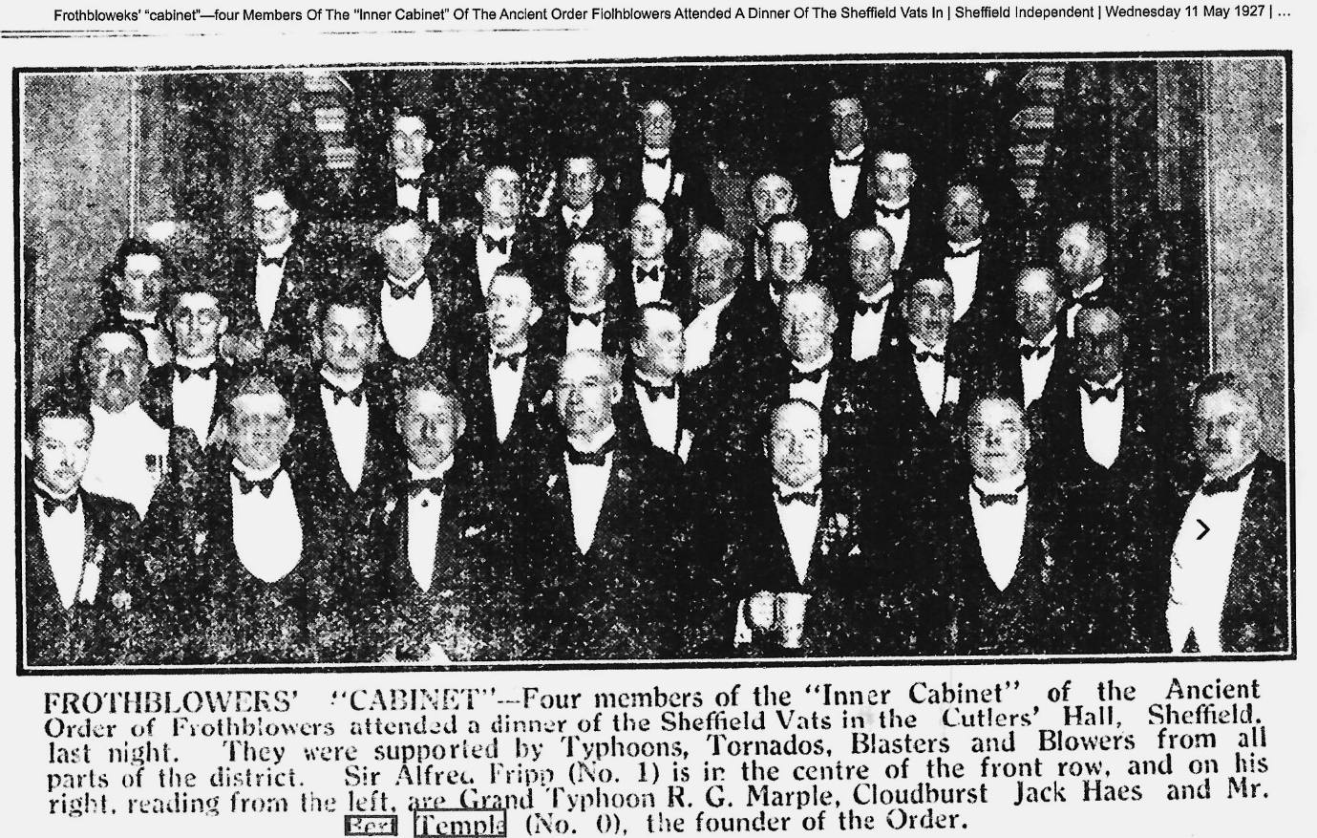Up School!

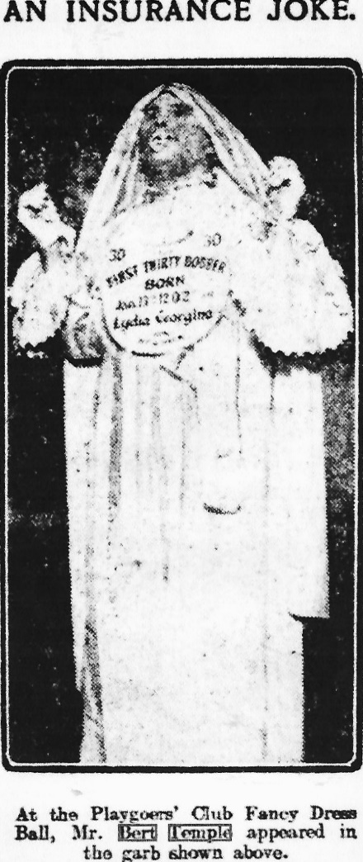The gentlemen above may well have had grandchildren educated with me from April, 1953, to July, 1956, at High Storrs G.S., Sheffield; unfortunately, a complete list of attendees in Cutlers’ Hall was not recorded – so, we’ll never know! Had I kept in touch with my cotemporaries, it might have been different: only two weeks ago I was at a reunion of ‘Old Scholars’ of my next school, Ackworth, sixty-five years on.

Odds and Sods

 This ‘Insurance Joke’ about ‘Lydia Georgina’ as a ‘First Thirty Bobber’ is beyond comprehension - mine anyway! If the garb is biblical, one wonders what ‘Lydia Georgina’ has to do with the satire. As a Playgoers’ Club event of 1913, it is interesting, given that this is definitely Bert himself: he is recorded as using the Club as his address after the War (possibly, before by the looks of it). Also, his friendship with H. Thorpe Oliver of the Swan, Fittleworth, obviously dates from at least as early as 1922: both keen fishermen, *Angling Notes* reported that in late September of that year *Mr. Bert Temple and Mr. H. T. Oliver have had good roach fishing on the Hampshire Avon*.

Happy Christmas! Dave the Chain: finwood40@btinternet.com