FRIENDS OF THE FROTH BLOWERS

NEWSLETTER No. 75 SUMMER 2024

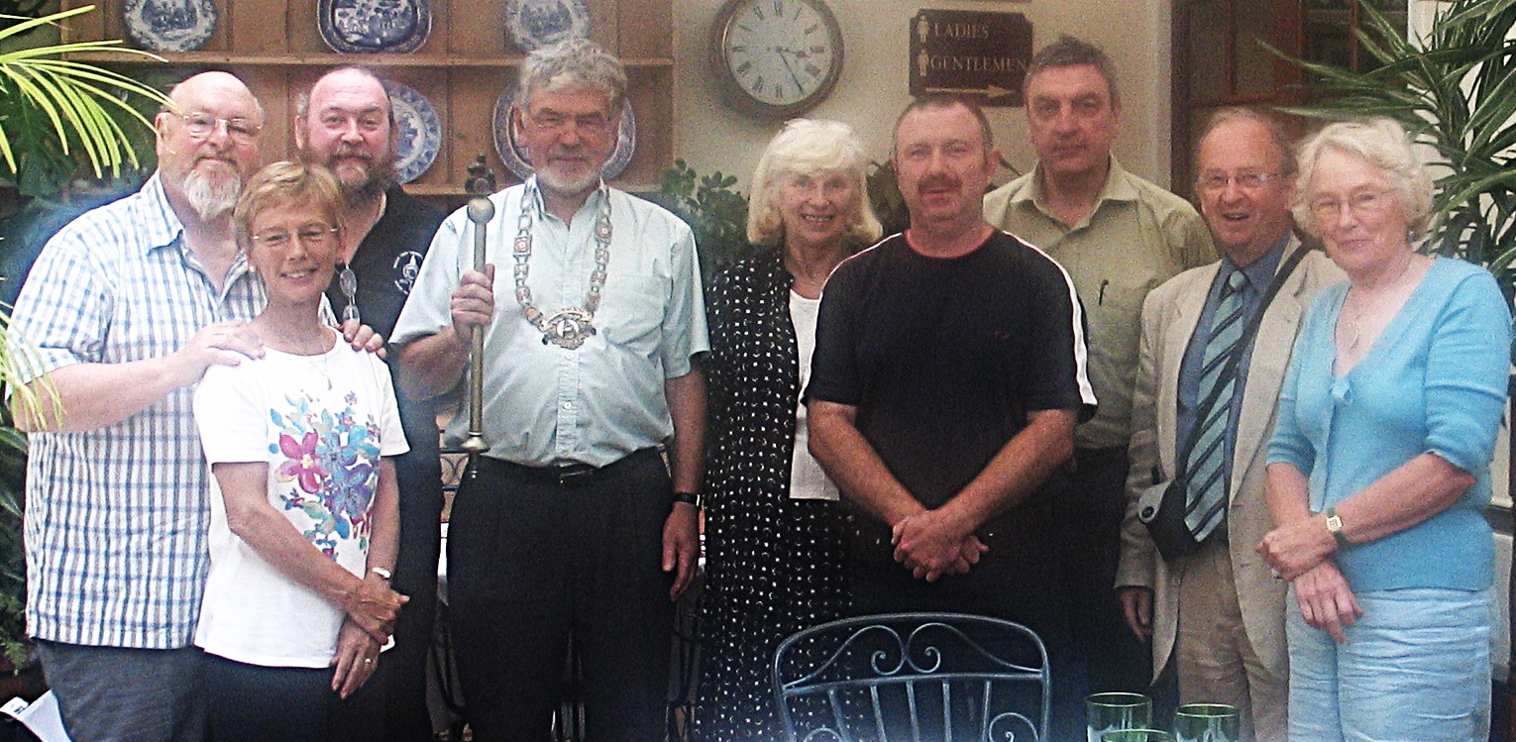 Ye Ancient Order of Froth Blowers: founded 1924

Ye Friends of the Froth Blowers: founded c. 2004. First meeting: Red Lion, Salisbury, 2005.

FOFB researchers, such as webmaster, Ian, and myself, assume that any money raised by Bert in 1924 would have been shortly after his final consultation with Sir Alfred that November – money most likely raised as fines from his pals of the 1st Sportsman’s Battalion. We know that our first meeting was in Salisbury, first at the Frothblowers Arms and then at the Red Lion, to which it abutted, and both managed by the son of a Froth Blower: Mike Maidment. He took the above photo, featuring Sir Alfred’s granddaughter, Jill (on the right – with her husband, Dr. John Roberts)

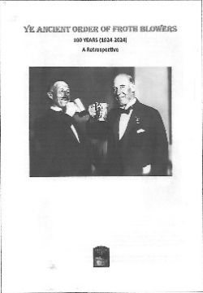Retrospect

In order to celebrate, Mr. C. Murray, Esq., has edited a ‘Retrospect’ – with contributions, I believe, from himself, Mr. Williams, Esq., Mr. I. Brown, Esq., and Mr. D. Woodhead. All four gentlemen will have P.H.S. copies to distribute to all those FOFB’s and others requiring a paper version of the work, which includes accounts both of some previously published historical information and of ‘new’ material, too. If you are not able to collect it and want a copy through the post, then all we require is an address to send it to. It will be freely available on-line at some point, I have no doubt.

2024 Reunion Lunch

Earlier this year, both the Swan and Simpson’s were being saved by restaurateurs, and I was hoping one or the other might be ready by October. It appears that Simpson’s will not be ready until early next year, and the Swan appears to be taking orders for the second week in November. It is too late in the day to wait to see if the Swan is likely to open before this so, rather than do nothing, I have made a booking at The Rose again.

**Saturday, 19th October**, 2024 at **The Rose**, 35 Albert Embankment, SE1 7LT: **12:00-15:30**

Overleaf is the menu: If you wish to join me, choose I, 2, or 3 courses, and let me know your (+ guest’s) name and choice (1c:2a:3b – my choice) a.s.a.p. Pay as we go on the day.

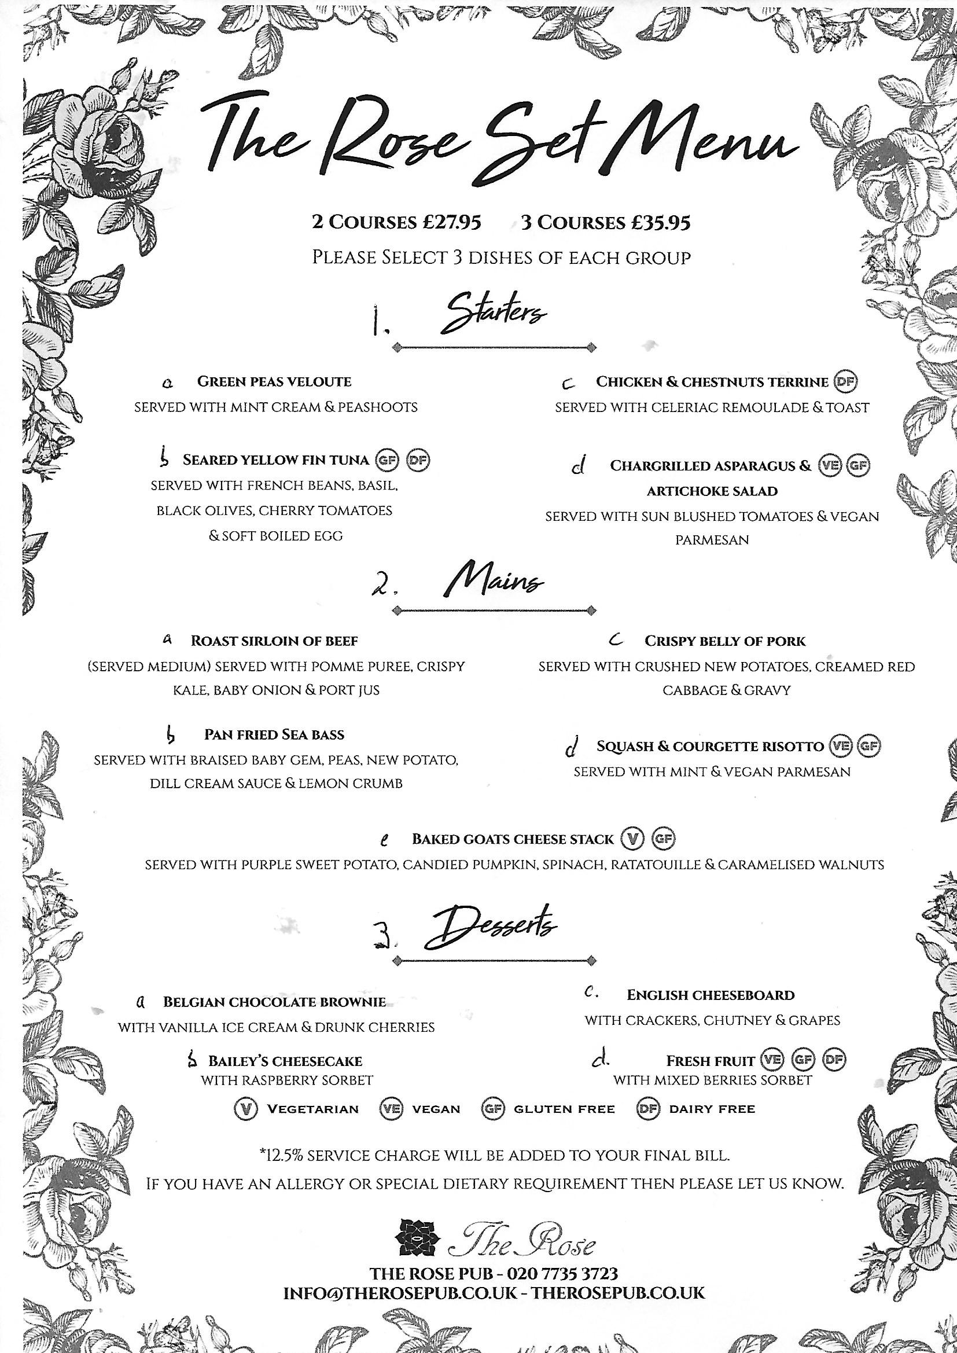 Sorry to have given you such short notice of this year’s Centenary event! I hope you can make it!

Froth Blowers Brewing Company

As a sort of post-script, the brewery came close to being razed to the ground on the 17th July. A fire broke out in a nearby block and it took 90 fire-fighters three days to bring it under control. We were without water for over two weeks (Google ‘Erdington Fire’). The mangled remains – 20 yds from the brewery – will be there for months before insurance claims are agreed to.

**R.S.V.P.** Dave the Chain (07525 100644) [**finwood40@btinternet.com**](mailto:finwood40@btinternet.com)