FRIENDS OF THE FROTH BLOWERS
Newsletter No. 74 Spring 2024
Some Friends on Tour
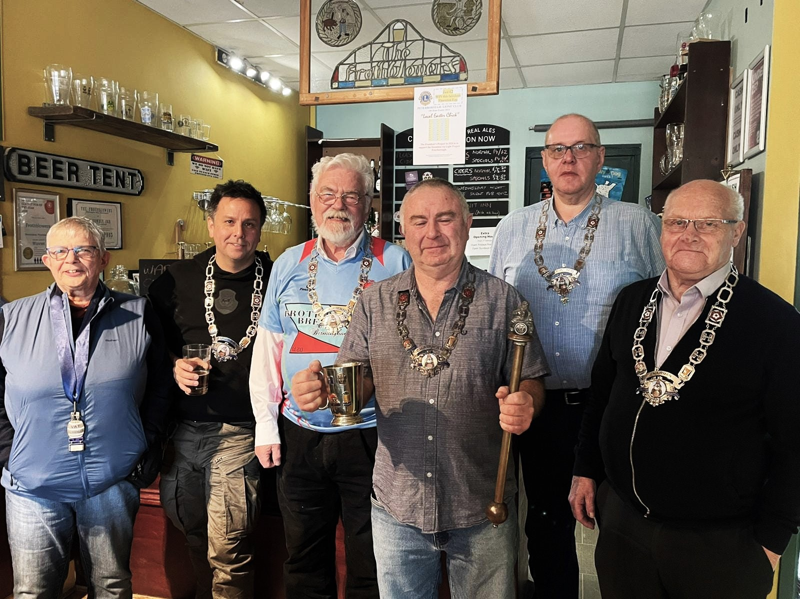
Heather the Sash; Chris the Chain; Dave the Chain; Steve the Chain; Ian the Chain & Brian the Chain
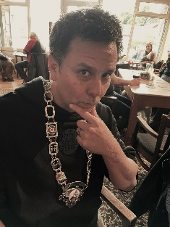
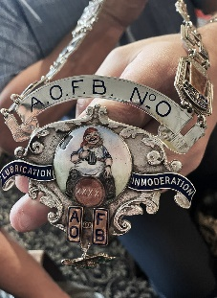
This picture was taken by Hannah: triply involved with the Froth Blowers, as one-time Accountant to the dissolved Ancient Order of Froth Blowers Girl Guide and Boy Scout Charity Ltd, Accountant to the Froth Blowers Brewing Company Ltd, and an original member of the Friends of the Froth Blowers. Also missing from the picture is Jim the Larger, searching for a hole-in-the-wall – thus enabling this picture to be taken without a wide-angle lens. (It was stretched to the limits as it was!) Never before had so many chains been displayed so resplendently! It was particularly satisfying that the chain once belonging to Bert Temple, A.O.F.B. No.0, was able to be with us (courtesy of Ian) so that Steve, the co-owner of The Frothblowers, could stand proudly – tankard in right hand, chain round neck, piffle snonker in left hand, eyes ecstatically closed – for this picture to be recorded for posterity. Once again, Chris – Grand Overseas Lounger – landed in town; this time to join in the double birthday party: the pub’s 7th and your scribe’s 84th. Just to make his journey back more difficult, we travellers from the west took Chris on safari to the Fens and left him there, surrounded by giraffes: that is, we took him to the Thirsty Giraffe, Deeping St James, where the denuded Steve was already dispensing more Froth Blowers’ beers from behind its counter – in particular, Riverside Stout, named after a stout made by FOFB Scott in the brewery by the Singapore River.
The Singapore Vat
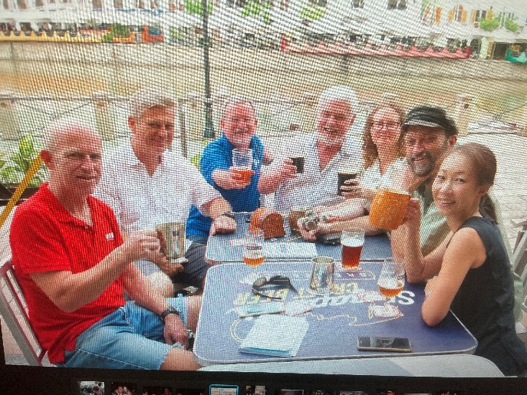
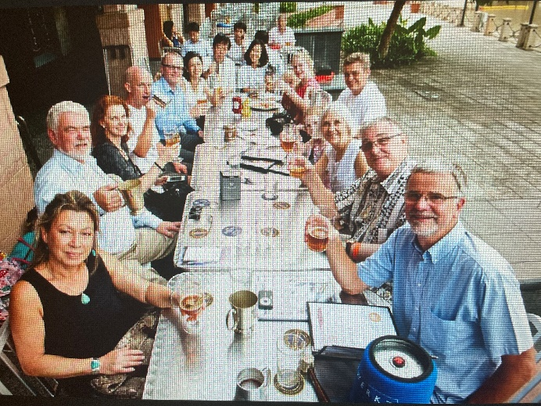
It is here that Fairy Belles Kim, Debbie and Felicity, Blowers Tang, Ted, Devin and Dave, the Grand Overseas Scrounger, still live. However, Scott returned to Canada a few years ago. Recently his mother, Elaine, died. I met the lively lady at Scott’s wedding to Eriko in Singapore: I know you would like me to express our sympathy to him.
This photo (left) taken by Dave - with his wife, Debbie, and their newly-initiated FOFB guest in the foreground – is of a major gathering of the Singapore Vat some ten years ago. However, my friendship with nearly all of these people started twenty-five years ago, pre-dating the formation of the F.O.F.B., and nearly all have been taken to various pubs in Britain by me at one time or another. Of the regulars, only Michael and Adele (originally from Montana) are missing – probably, in China at the time – but feature on the right (Scott, Ted, Dave, DLW, Adele, Michael, Eriko).
Froth Blowers Brewing Company
We are still balancing the books – precariously - although FOFB Hannah the Accountant’s mysterious calculations say otherwise! We have another 18 months of a 5-yr rental contract, before which, if we/I survive, we will try to sell the 18BBL brewery and take the old 6BBL brewery to more affordable premises: but this is not the only option. Last week we sold 100 9’s when on average we sell 35: so there’s hope!
The A.O.F.B. Centenary
The aim of the cabal planning the Centenary celebrations is to produce a booklet and to hold a lunch. At the moment the articles for the booklet are beginning to take shape; but any contributions concerning, say, old Vats known to you which have not featured in FOFB publications any detailed way before, can be forwarded to me for inclusion in the booklet. I wrote that September was the starting month in 1924 but I am inclined to give us more time by having the lunch in October as usual – but in a more appropriate venue than the room at the Rose.
A.O.B.
As the plaque was stolen from the Swan, I hope Angus will be able to replace it as part of the major refurbishment; otherwise, we might do something? DLW finwood40@btinternet.com

