FRIENDS OF THE FROTH BLOWERS
NEWSLETTER NO. 73 WINTER 2024

A Temple Family Retrospect

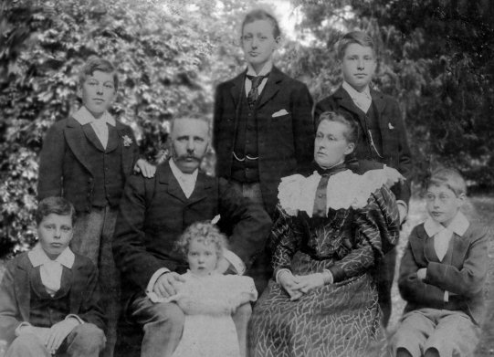

The Temple Family c. 1895: Alfred, Ernest, Alfred (snr.), Marion, George, Mary, Herbert & Sydney

On 2nd November, 1829, Richard Temple of Norfolk was married in Whitehaven to Harriet Knowles of London. By the time of the 1841 Census, they were (surprisingly) living in Addison Alley, St. Bees (nr. Whitehaven). In 1851, the household consisted of:
Richard Temple (49) – Master Tailor, originally of Gaywood, Norfolk (employing 10 men and 3 boys)
Harriet Temple (40) – his wife. Their children were – Richard (20); Charles (16): Edmund (12); Harriet (9); George (5); William (3); and Alfred Lonsdale (0).
In 1869, Richard Temple (snr.) put this notice in the local paper: “in returning thanks to his numerous friends for their generous patronage so liberally accorded to him during the last 40 years, (he) begs to announce that he has disposed of his business to Messrs. J. Tyson & Sons.” By the end of the year, he was dead. The 1871 Census shows Bert Temple’s paternal grandmother, Harriet, as living on her own in Addison Street, aged 60. She was still there ten years later, at the time of Bert’s first birthday - celebrated in the city of her own birth. For she and her late-husband to have moved so far from their south-eastern roots is difficult to explain – unless Richard had a little money and bought a going-concern that happened to be in Whitehaven.
Bert’s father, Alfred, had moved to London – via Manchester, it is thought - to find work. However, the 1871 Census shows him to be one of a dozen-or-so young warehousemen employed by Higgins, Eagle & Co., in Cannon Street, London. Six years later, in 1877, he married a young widow named Mary Jane Gibbon.

Mary Jane Temple
In 1840 Charlotte Smith of Westwick (nr. Ripon) married Robert Smith of Givendale (nr. York). The 1861
Census shows that they had moved to Storrs Farm, Undermillbeck, Windermere:
Robert Smith (46) Farm Bailiff Ripon, Yorkshire
Charlotte (née Smith) Smith (47) “ “
Their children were: Richard (19); Robert (18); Jacob (16); Charlotte (15); Henry Edwin (13); Thomas (10); and Mary Jane (7).
In 1872, Mary Jane married Henry Josiah Gibbon, in Kendal. He died on the 20th May, 1874 (aged 28). He had been a farmer at Holmscales, near Kendal, but his estate was not for Mary’s “use and benefit until she should attain the age of 21 years.”
Three years later Mary Jane (née Smith) Gibbon married Alfred Lonsdale Temple (both with five brothers and one sister older than them). The 1881 Census shows the Temple family as living at 2 Chaucer Road, Brixton:
Alfred L. Temple (30) – Lace Buyer – Whitehaven, Cumberland
Mary J. Temple (27), with sons:
George (3); Herbert (1); Ernest (0)
Charlotte Smith (67), Mary’s mother, was living with them
Curiously, in 1891 Mary and her sons - George, Alfred and the not-yet-blinded Sydney - were lodging in Christchurch, Hampshire. It may have been the school holidays when the Census was completed. However, Alfred (snr.) is shown as living in York Villa with Herbert and Ernest – so the school holidays may have been different for them (Alleyns/Dulwich, perhaps). The week before the Census they may all have been holidaying together in Hampshire.
To show how far up in the world Alfred had risen by the mid-1890’s, in 1896 he attended the Guy’s Hospital Banquet, and must have paid a significant sum for the privilege of hearing the future King – Edward VII – refer in his speech to “his friend, Mr. Fripp,” not knowing what part the young surgeon was to play in his family’s life thirty years later. However, this history shows that both Bert and Alfred only had life because one of their parents had been widowed – both being children of a re-marriage.

Froth Blowers Brewing Company
Selling ‘real ale’ is not getting any easier: the demographic for this type of product has not changed – and the people in it are getting older. One more unthought-out decision from the ‘government’ (an inaccurate term nowadays) and we could go to the wall – along with others of our kind. However, after over ten years in the trade, we have at last produced what used to be a staple product – ‘Bitter.’ Ours is 3.7% and called ‘Blowers Bitter.’ Sensible drinkers seem to like it.

100 Years On
I took the month of the first major AOFB Dinner – October (1926) – as the one in which to hold FOFB Reunions, but it is not too clear when Bert actually started dining with his friends for the purpose of raising charitable funds. The operation(s) were performed in 1924 and Bert was ‘signed off’ by Fripp in November of that year, at which meeting, we assume, Bert’s offer to raise £100 was accepted. The formation of the ‘Order’ could have been earlier – or later, when recuperating at the Swan in early-1925. However, for our purposes, I am taking 1924 to be THE YEAR! Now, I/we only have to decide what to do, where, and when. I am pencilling in Saturday, 26th October. More later!

The Chairman’s 84th
Thanks to Leap Year my birthday is a day late – St. Patrick’s Day logic – Sunday, this year. Therefore, on Saturday, 16th March, 2024, I will happily take beer in the London & North Western bar, Grand Central, Birmingham (New Street Station) with all Friends and other friends, from 11 a.m. to noon – after which a Brum Trudge might well take place.

Other news
The Swan, Fittleworth, is not scheduled to re-open until Autumn, at least – so, no plaque-wetting.

Dave the Chain 07525 100644 finwood40@btinternet.com

