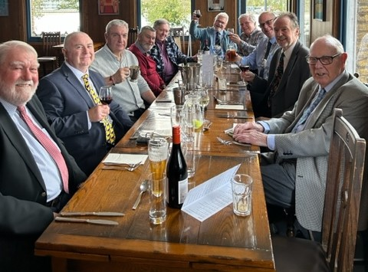
FRIENDS OF THE FROTH BLOWERS
NEWSLETTER No.72 autumn 2023
Annual Lunch 2023
So important is this event for your chairman, he bought an (old) new car the day before in order to guarantee his attendance. His ‘old’ car (two years younger than his ‘new’ car) seemed unlikely to do the extra 200 miles-or-so after managing the previous 245,000 miles - mainly as a brewer’s dray. The new car performed heroically considering the girth of its occupants, individually or combined, but did try to poison us when jammed in London traffic. Beer and red wine seemed to clear the passageways of carbon monoxide shortly after arrival; good food and conviviality did the rest. We may have been a smaller group than usual but shortage of quantity was made up by depth of quality: the crème de la crème, you might say (or we might).
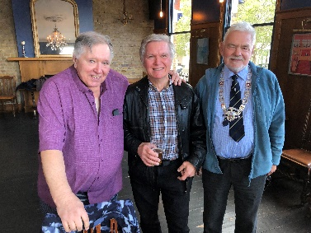
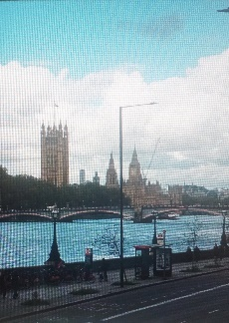
There were nine Old Boys (stretching the word ‘boys’ to its limits) and one New Boy: Chris (front left) had found his way, eventually, to our secret hideout but did not have to catch up with us prandially as there was some confusion in the servers’ minds - when trying to match the name to the food ordered - as to whom was having what. In the meantime, after responding positively to the command from the Senior Blower (me, Tornado Woodhead), “Shoot your linen, Blowers!” Chris displayed cufflinks that were actual family heirlooms – pretty impressive! (Almost as impressive as this panorama, seen from the window of the Rose!)
Continuing the ‘impressive’ theme, on the left is a picture of the writer with two Brooms, Jim and Mike: all three of us to be found in the Peyton Arms on occasions (numerous for Jim and me).
Many thanks to Steve and Dave for coming from afar - and to all for their jovial company!
Fairy Belles
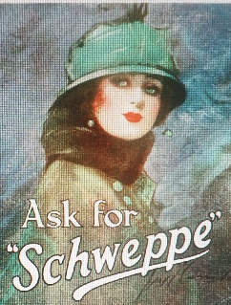
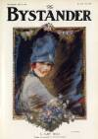
Fairy Belles were conspicuous by their absence at this year’s Reunion – I think, for the first time. In an effort to right this taxonomical omission by being partially ‘woke,’ I will focus attention on the Froth Blowers’ women. (Not that I understand ‘woke’ as a word; does it mean ‘awakened’ by someone or something, or being awake yourself to the importance of every possible gender except male?) I doubt that flappers would have worried about being ‘woke’ – they were always awake. The magistrates sometimes refused to give extensions to local Froth Blowers for fundraising events because they took it to be only an excuse for late drinking. To be fair to such magistrates, many AOFB things of this sort were advertised not to finish until 2 a.m.
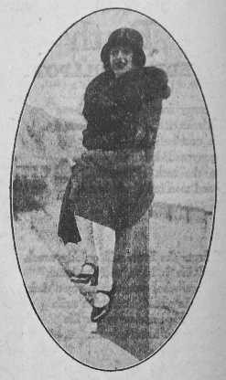
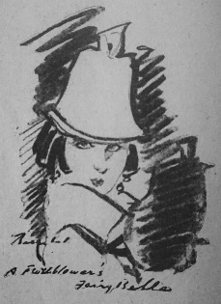
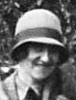
This young lady (top left) is ‘A FAIRY BELLE Though not necessarily of the Ancient Order’ by Barribal – an artist who did advertisements for companies such as ‘Fairy Soap’ – and ‘Schweppe.’ Any FOFB in possession of Ye Froth Blowers’ Annual will recognise the portrait (top right) as it appears on its inside-cover. They say that Barribal used his wife as a model for most of his paintings of this type so they may both be of her. The sketch (from the Annual) on the left – “A Frothblower’s Fairy Belle” - appears to have his signature across it.
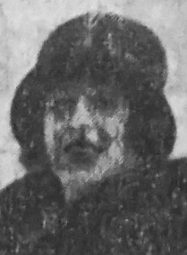
Dorothy (née Roper) Sheppard – photographed (right) in the garden of the Swan, Fittleworth, is captured months later in the Annual at Christmas, 1927, wrapped up and sitting on a bollard at the seaside, for a Greeting: “A Merry Christmas to all Fairy Belles & Blowers from the Gentle Zephyr A. O. F. B.” The cloche hat is typical of the time but it is not the only hat that Dorothy - or her husband of twelve months - can afford, it would appear. It was a brave new world – so many girls and so few men left (from the Annual):
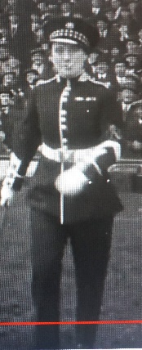
“I went out last night with Gerald in his new car.”
“Is it a Sporting Car?”
“Rather. When we were miles from anywhere it broke down.”
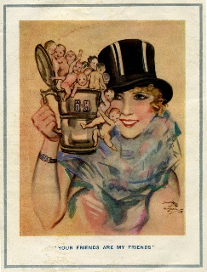
Yet another version of the Fairy Belle is the ‘Your Friends Are My Friends’ one (left), with A.O.F.B. wristlet and tankard – frothing over with Wee Waifs. Notice she is wearing a rakish top-hat in true male-impersonator style, as with cigarette-smoking ‘Miss Hetty King - to see fair play by the fair sex’ while playing Pushball on the Boleyn Ground (again, in 1927).
As for the name ‘Fairy Belle,’ it may well have been in Bert’s mind for some time. It seems that just as the idea of a ‘froth blower’ was around in Bert’s younger days, so there was a winning racehorse of the immediate pre-war period called ‘Fairy Belle.’ However, AOFB ladies seemed happy with the soubriquet.
Froth Blowers Brewing Company
Now a family firm of three-and-a-half (grandson the ‘half’ when not at ‘Uni’) – and only two-and-a-half paid – we survive by balancing sales with brews from month to month.
FOFB Events
March 17th is a Sunday in 2024 (as it was when I was born) so something might happen that weekend! The Swan, too, might be open in May (say, 18th). The A.O.F.B. was founded in 1924 so a Reunion in September or October, 2024, at some central venue shall be arranged. DLW

