FRIENDS OF THE FROTH BLOWERS
NEWSLETTER No. 71 SUMMER 2023
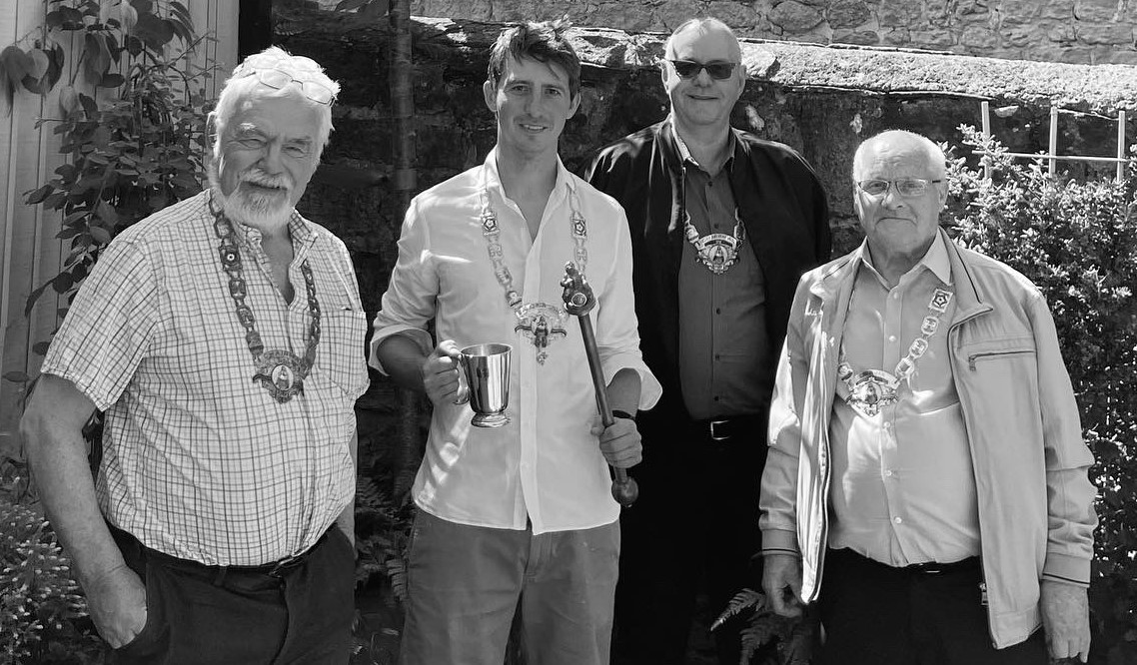
Plaque Wetting 2023
Not only has the colour been taken out of this picture (not by me) but so has Jim the Larger (picture-taker, presumably); nor are we standing in front of the plaque seventeen years after it was put in place. This is not only because the whole building is covered in scaffolding but because, apparently, the plaque has been stolen!
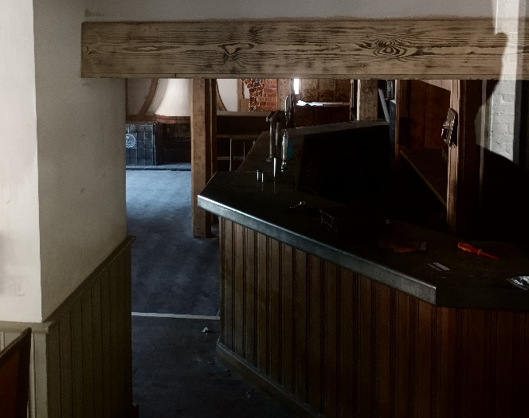
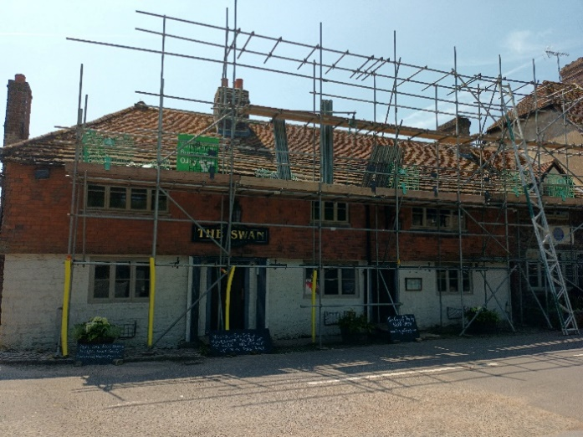
To begin somewhere near the beginning, having ascertained that the Swan had re-opened, I decided to go on the traditional May-morning-madness of a three-hundred-mile day-trip to Fittleworth in order to salute the (unknown to me) missing disc. To my delight Ian, Brian and Jim had agreed to accompany me. At 9 a.m. we set off from the Froth Blowers Brewery; at 10 a.m. we picked up Jim from outside the Hat Vat (Peyton Arms): and at 10.30 a.m. we were passing Oxford on the A34, avoiding the M25/M3 by driving south to Winchester and then turning left on to the A272. Apart from an unscheduled motocross ramble through Duncton Woods, all went according to plan. What was not in the plan was this:
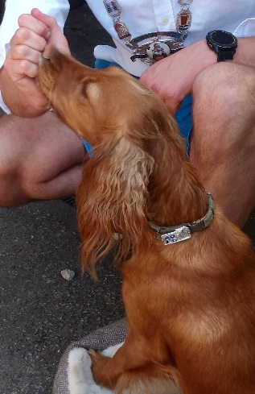
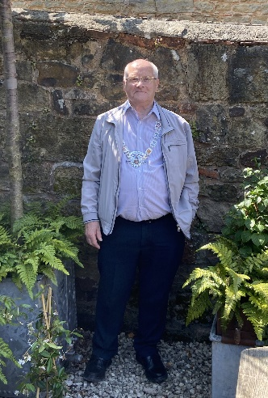
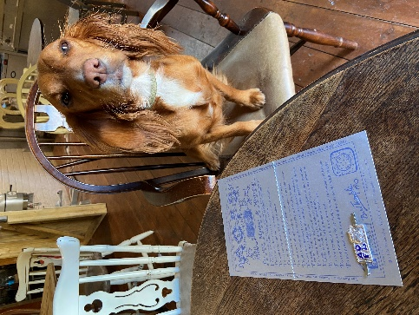
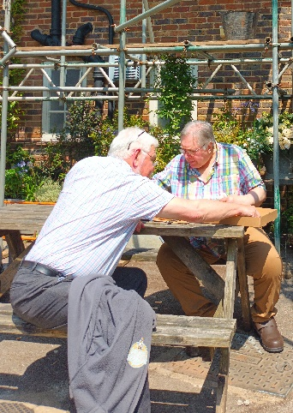
Pizza-eaters Faithful Bow-Wowess AOFB-collar in situ Blessed Brian
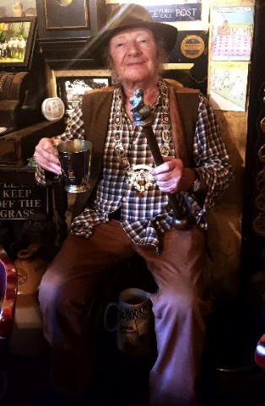
Thankfully, a short recce enabled us to find two young men dispensing pizzas, lager and wine (and not much else) in the back yard. One of the young men – Angus (pictured with regalia) – turned out to be the new partner/manager of the phoenix-like Swan (no fire involved, fortunately) and, after cooking for us and one or two other guests, seemed genuinely interested in the AOFB/Swan Inn story.
Regaled, and with regalia stowed away, we set off for the Hat Vat; and, after a pint-stop at the chocolate-box-pretty White Horse, Hedgerley, found ourselves (unsurprisingly) in the Peyton Arms, Stoke Lyne, in time for a wee-drinkie – and a ‘man-in-hat-sits-on-chair’ ceremony. Drinkie and wee over, three men in a car returned happily whence we had started twelve hours earlier. Lord Weston of Jericho
A Short History of Plaque Wetting
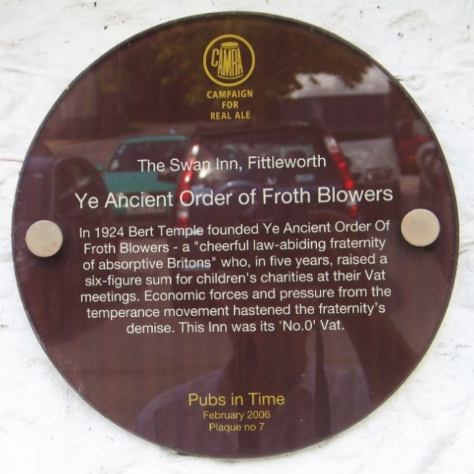
The history can be dated to the 2005-6 decision of the Campaign for Real Ale to commission and pay for plaques to be put on hostelries where things of ‘historic interest’ have happened, but at places which had not previously been celebrated in this way. Camra employed a student-researcher to dig up the facts. He got in touch with me and I wrote theses words (slightly altered by him). The plaque was put in place on the exterior wall by the front-door in March, 2006. I was informed of the low-key ceremony after the event, so five of us wetted it properly in late-May that year. This became a regular event, halted by Covid and the temporary closure of the inn. Let’s hope the Swan takes flight again.
Froth Blowers Brewing Company
A good start to June gives hope that we may stay solvent at least until we celebrate our tenth anniversary in early-October.
Further Events
FOFB ANNUAL LUNCH will be held at the ROSE, London, SE1 7TL, on Saturday 14th October, 2023, from 12:00hrs to 15:30hrs.
Dave the Rave 07525 100644 rsvp finwood40@btinternetcom

