FRIENDS OF THE FROTH BLOWERS
NEWSLETTER No. 70 SPRING 2023
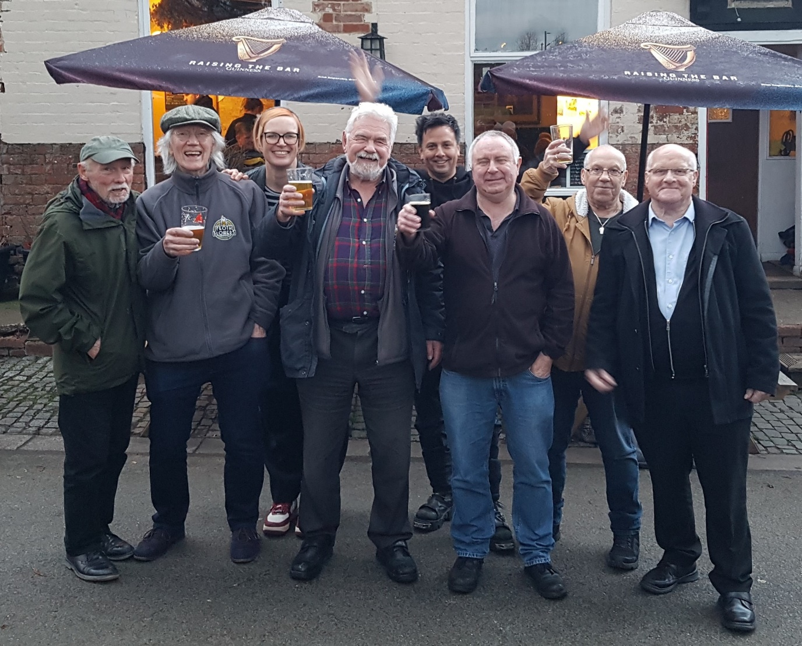
The More We Are Together …
Six elderly gentlemen were joined by two swinging Webers in Coventry to celebrate the 83rd birthday of your self-styled ‘Chairman.’ Here we are - caught on camera outside the Broomfield Tavern. It might be superfluous to add that this picture was taken at the end of the ‘jolly.’ On the left is Bill and a childhood friend, Les, from Great Barr – sixty years on; on the right are two Kilmisters for the price of one. In fact, as I do not remember paying for my drinks, for no price at all! Five Brummies, born-and-bred! (Actually, I left Birmingham when I was six and did not return until I was twenty-eight: does that mean I am a half-bred Brummie?) Next to me is Steve, the ubiquitous Secretary of the Pub History Society: ‘ubiquitous’ in the sense that at any time you might find him in any pub in Britain - including, occasionally, those owned by him in Werrington and Deeping St. James. As for the Webers, you might find them in any pub anywhere – given their jet-setting lifestyles. They even knew that, despite strikes, a few trains were running between London and Coventry that day. I count myself lucky to have such friends! (Not forgetting all the other FOFBs, of course!).
For me, the day started at the Froth Blowers brewery because I had to deliver beer early to the Great Barr Conservative Club – one of the few institutions associated with the word ‘Conservative’ that appears to be honestly-run and reliable. I got back in time to load a couple of kindly Kilmisters into the car but, in my eagerness to start the ‘Coventry Cruise’, I forgot to pick up any regalia; however, as it was my birthday, I did not fine myself! (Or anyone else, for that matter!)
In the somewhat ‘crafty’ Hops D'Amour, the Birmingham Five + Werrington One had a few halves before walking through a near-by alley where the wonderful Webers were waiting for us to walk the extra yard to the Town Wall Tavern. Before all were served, Bill the Wizzard was honky-tonking on Mrs. Mills’ piano in the next room: but, as far as I know, nobody bought him a pint for providing such a joyful noise. We should have passed the hat round in the cause of modern ‘Wee Waifs.’ I have just sold a couple of “The Zestful Gollopers” so I’ll add the £23 to the Acorn donation this year in the name of the ‘Cruisers’: in particular, Bill (on the ivories).
From there, it was a short walk to the Gatehouse: a brief stop was made here as it was full of rugby enthusiasts watching Scotland (noisily) just beat Italy. After one beer, we made the short trip to the Windmill. However, on the way - having said to Jamie, the tolerant ‘Fairy Belle,’ that women generally had poor navigation skills - I had immediately to admit that I had taken a wrong turn. You have to laugh! The Olde Windmill is impressively ‘olde,’ and it had a small festival of beers racked up in its wider corridor, as well as two or three ‘regulars.’ A little light luncheon was taken here by young Brian, I believe.
At this point, I left the walkers to find their way the mile-or-so to the Broomfield, and took the Great Barr Two via the Royal Oak, Earlsdon, for a pint of Piffle Snonker. Both these hostelries have this beer of ours on permanently – and the not-to-be-missed Broomfield takes it in 18’s! However, having arrived there, the walkers were worried enough about my state-of-health to ring me up. I told them I had been waylaid by a pub. We joined them for more beer, followed by the obligatory photograph. After this, as far as I know, all returned to the bosom of their families within the next twenty-four hours. I gave Brian and Chris an unintentional tour of north Warwickshire, but we eventually got back in one piece, too.
Another Find
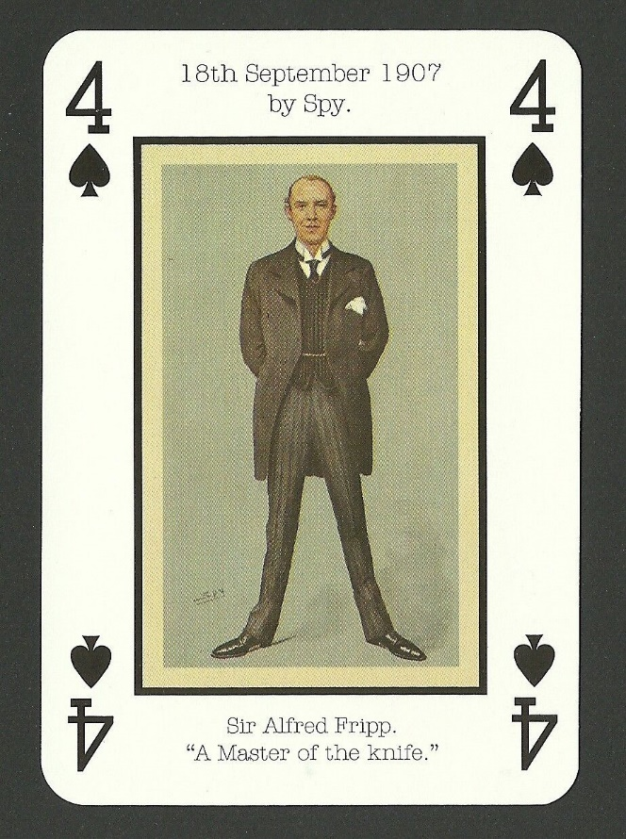
I was doodling about in ‘Google’ and found this playing-card. I can only suppose that it was an advertising gimmick of the Edwardian era. There was no reverse pictured, but it is very likely that famous ‘Spy’ characters featured on the other 51 (or more) cards. I would like to think that Fripp’s adversary, Frederick Treves, featured on the two of clubs! After her husband and Treves had died, Lady Fripp wrote about the time in late-1900 when Alfred heard from ‘Bertie’ – not yet king – that he was going to confer the C.V.O. on him. “The giving of the honour was made known to him quite suddenly at a luncheon party at Marlborough House. The Prince of Wales had a small number of guests, including Alfred and Sir Frederick Treves, who had returned from South Africa and met his future royal patient, King Edward, for the first time. It was at this party that Alfred detected, as he believed, that jealousy of him on the part of his distinguished confrere which so strongly coloured Sir Frederick’s life.” Fripp had known Edward for ten years by then; the older Treves had just met him.
Froth Blowers Brewing Company
We struggle on – six months from the tenth anniversary of our first sales. By then, having made their billions, the energy companies and the Tory plutocrats – those who rob the poor to pay the rich - might have thrown a few benevolent crumbs of comfort in our direction.
Events
I am glad we had a proper event last month: a ‘Coventry Cruise’ as a change from a ‘Brum Trudge,’ and I suggest a ‘Plaque-wetting’ lunch in the Swan, Fittleworth, at noon on Saturday 27th May, 2023.
Annual Reunion at the Rose, SE1 7TL: 12:05 for 13:00 lunch on Saturday, 28th October, 2023 – subject to Aston Villa’s fixtures for the 2023-24 Season! (Could be 21st). DLW (finwood40@btinternet.com)

