FRIENDS OF THE FROTH BLOWERS
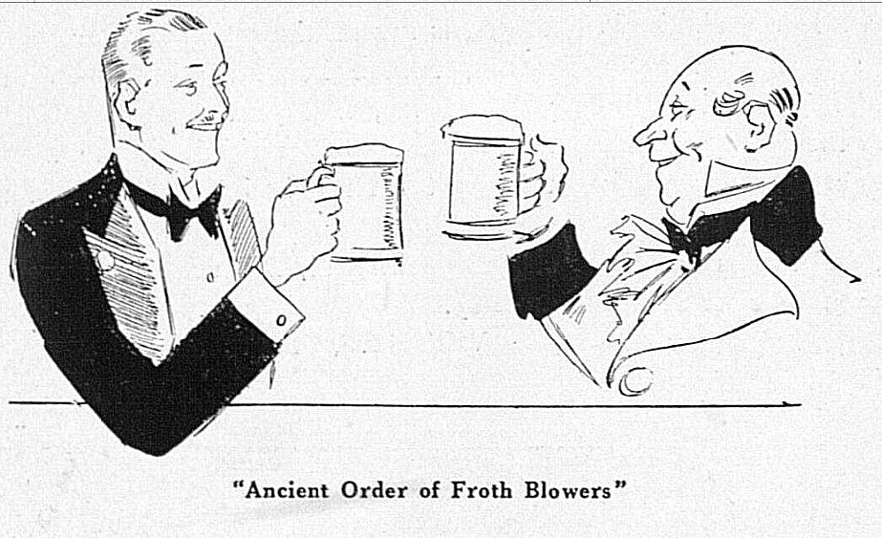
NEWSLETTER No. 69 WINTER 2023
Catching Up
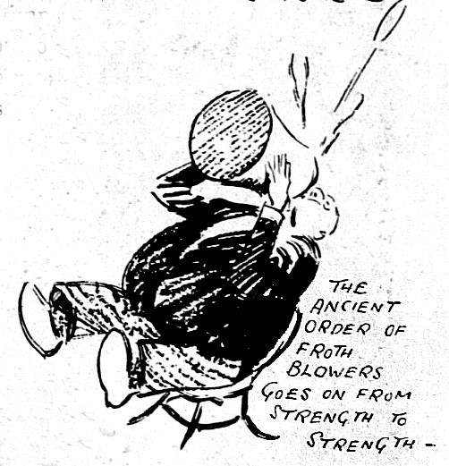
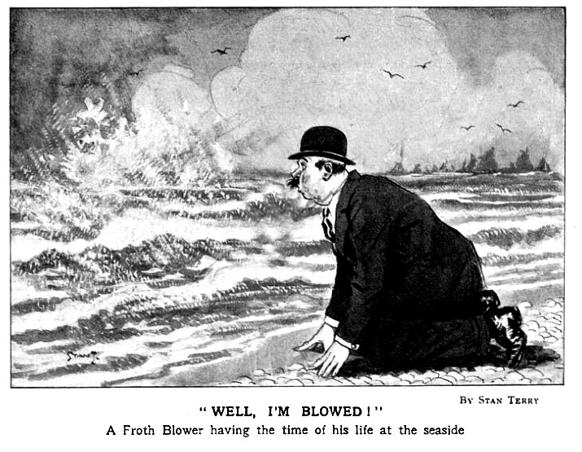
Recently, I spent a few hours sorting out thousands of emails in my inbox and realised how much interesting stuff I had glossed over; so, here are few things of interest I found.
I feel I have seen these before but cannot remember where or when. I have no copies of them. The Swan, Fittleworth, appears to be up-and-running again. FOFB John (formerly of the Parr’s Head, Camden Town) sent me the result of his searches into the inn from the days of the Hawkins family (1812-1912) to the mid-1950’s. Henry Thorp Oliver took over in 1916. He became the agent for two local breweries – the Anchor Brewery in Littlehampton, and the Swallow Brewery in Arundel – both owned by Constable & Sons. The painting of Fittleworth Mill by John Constable, the artist, means that he may well have stayed at the inn in 1834.
The 1921 Census shows Henry Thorp Oliver running the inn, with the help of Miss Miller and
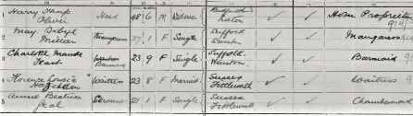
three young ladies. It is thought to be around this time that the sport of fishing brought Bert Temple and Henry T. Oliver together. By 1924, when Bert and his father stayed at the inn, the two men were firm friends. Together they are supposed to have dreamed up the idea of an Ancient Order of Froth Blowers. After Bert’s death and the demise of the AOFB, Mr. H. Thorp Oliver continued to support charities and, in 1934, entertained a number of blind men from St. Dunstan’s. Sir Ernest Beckwith Towse, blinded in the Boer War, became its vice-patron. He said that Fripp’s IYH Deelfontein saved his life, and became Betty Fripp’s godfather in 1904.
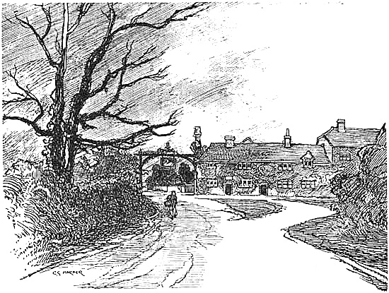
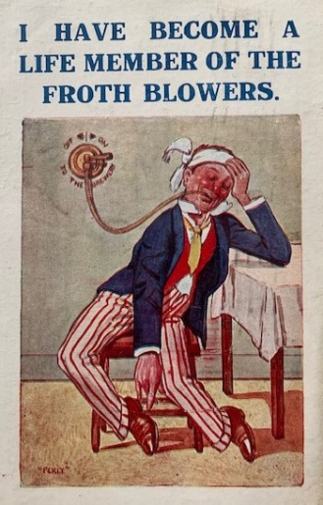
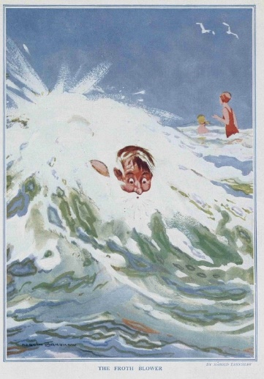
Editor Murray (PHS & FOFB) frequently keeps me informed of things I ought to know: such as that this drawing of The Swan which is thought to be of the time that Richard Caton Wood stayed at the inn and painted the inn-sign for Mrs. Hawkins – “paying for his keep” he called it. Chris discovered that in 1927, in a desperate financial and emotional state, the once-famous painter shot himself.
The Froth Blowers Brewing Company
We have just ‘inherited’ (received certain goods) from a local brewery that suddenly closed. It may be a windfall for us, but if the government continue to stand by and let the petrol and gas providers charge what they like, we will all be out-of-business sooner rather than later. For the moment, we are still trading!
Dave’s Birthday Bash
There was a time when the thought of a Coventry ‘crawl’ would not have been particularly inviting, but since the ‘City of Culture’ make-over, the place and its hostelries are more inviting. It, also, has citizens that appear to like our beer as four pubs take it: the Broomfield even takes Piffle Snonker in kilderkins. Pubs: Hops d’Amour; Gatehouse; Town Wall Tavern; Old Windmill; City Arms and Royal Oak (Earlsdon); Broomfield Tavern. Meet at Hops D’Amour at midday on Saturday 18th March, 2023, when I will already have been 83-years-old for 36 hours. Dave the Unchained (07525 100644) finwood40@btinternet.com r.s.v.p.

