FRIENDS OF THE FROTH BLOWERS
NEWSLETTER No. 68 AUTUMN 2022
Two Losses: Jim Clarkson and Bob Oliver
At the time of writing the last Newsletter, my long-time friend, Jim the Elder, was in a Home, and died shortly after I sent it out. He had lived in England for over fifty of his eighty-nine years but was as Scottish at his death as he had been when he arrived from Glasgow to teach in Birmingham in 1968. He attended a number of FOFB gatherings in its earlier years, moving swiftly from pints of beer to doubles of Scotch, as he did in all other meetings where lubrication was a factor. His eldest daughter spoke with loving disrespect of him at his funeral.
Bob I had only known in recent years but he seems to have been a great enthusiast: certainly, he took up the Froth Blowers’ cause with admirable energy. Facebook inserts meant that I found out his taste in music – and his taste in food. I shall miss the platefuls of the latter that assaulted my eyes with such alarming regularity.
It is easy to call someone a ‘character’; but Jim and Bob deserve (if that is the right word) the soubriquet, if a certain level of charming eccentricity is what is meant by it. R. I. P.
The 1921 Census
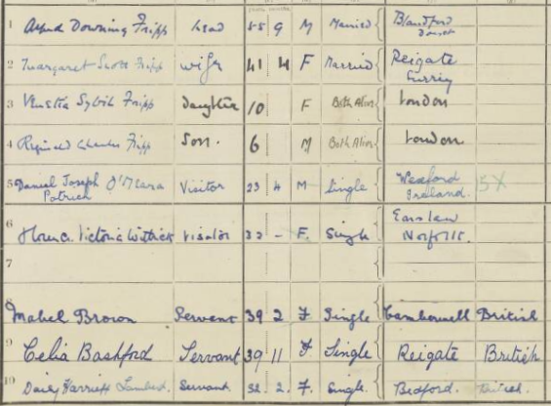
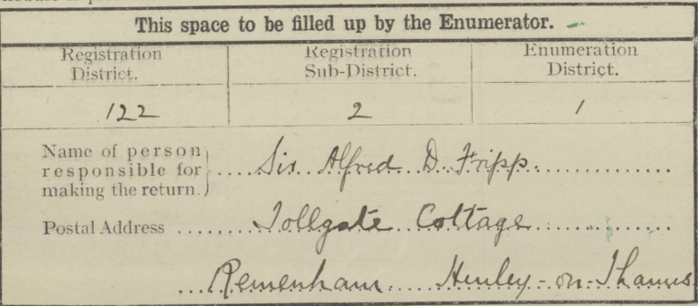
I have recently bought my way into the 1921 Census in case I am no longer compos mentis (or super terram) by the time it is freely available. From it I learn the residual Family Fripp was to be found in this ‘Cottage’ by the Thames (now worth in excess of £2,500,000) at the time. It appeared to belong to Sir Eardley Wilmot whose parlourmaid, Daisy Lambert, is the only person recorded here not to be connected to or employed by Sir Alfred. Patrick O’Meara is a doctor and Florence Withers is a nursing sister, both from Guy’s Hospital (‘visiting’ – professionally or socially, or both). Celia Bashford is employed by the Fripps as their nurse, and Mabel Brown as their cook. Reginald is six, yet there is another ‘nurserymaid’ at Portland Place, where Betty Fripp (17) is being cared for by Celia Watts, the ‘faithful retainer.’ Margaret (13) is at Abbotshill School in Hemel Hempstead (with her cousin, Mary Haywood), and Alfred Thomas (21) is at Oxford Museum studying Medicine! As Betty is at home, this must have been an April break.
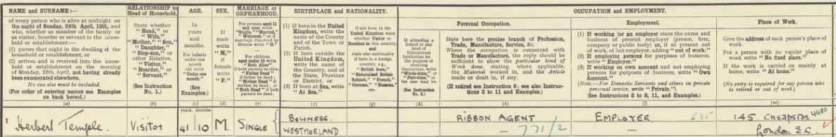
On this date, Bert Temple is shown as a patron of Hexells Hotel in The Strand (more-or-less opposite to Simpson’s). Again, it is impossible to say, knowing Bert’s lifestyle, whether this is his ‘home’ or just a short-term booking. His parents are also ‘in town,’ but staying in lodgings run by a ‘Miss Mitchell’ – in Notting Hill.
Fowler & Temple (Silk Merchants) employ Eric Allen (16) part time, and Dorothy Roper (19) - shorthand typist - full time. Her twelve-year-old sister, Gladys, was employed five years later to help with the flood of applications to join the AOFB. The two girls and their parents live at 151, Greenwich Road.
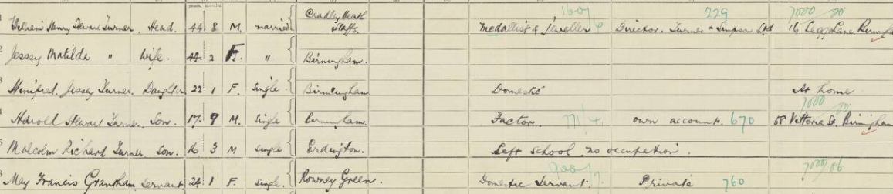
In 1921, Hal Turner, too, is still at home: 138, Harborne Road, Edgbaston. His father is Director of Turner & Simpson, situated at 16, Legge Lane, in the Jewellery Quarter; and seventeen-year-old Harold is a ‘Factor’ working on his ‘own account’ at 58, Vittoria Street – a short walk from his father’s works. In 1924, his sister, Winifred, married Edward Durandus Russell Donisthorpe, who was born in Norrishill Hall, near Ashby-de-la-Zouch. His father was a successful cloth-maker, and had moved his family to Enderby Hall by 1911. Whether any Donisthorpe money was spent by Winifred (née Turner) Donisthorpe in aid of the Wee Waifs I am yet to discover.
As for the other main ‘actors,’ David Cain was a freelance reporter and Jack Haes had followed his father into the Stock Exchange - as a jobber. These people were all to be brought together three years later when Bert Temple decided to raise £100 for Sir Alfred’s charities by starting the AOFB.
Purchases
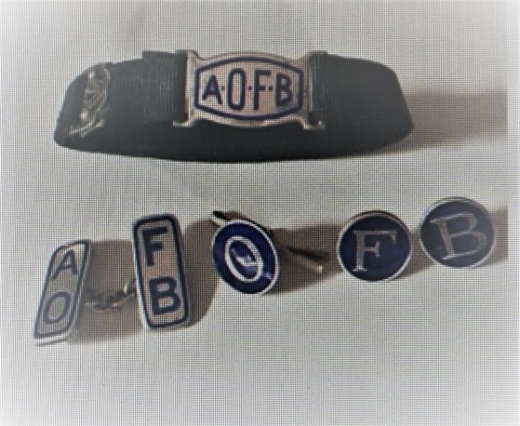
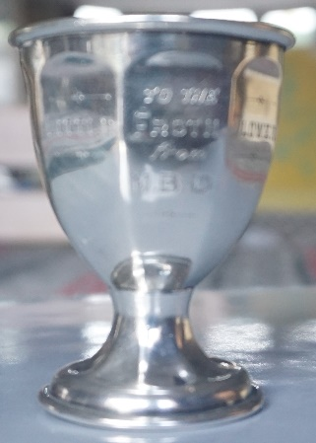
As our activities seem to have increased the prices of AOFB artefacts, I had not pushed the boat out in the direction of such collectibles for some considerable time. This small, silver christening-cup is inscribed with the words “To the Little Froth Blower from M.B.G.” As it is obviously rare and takes up little room, I am pleased to have acquired it. Ian, too, won an auction of mixed formal-wear extras, including some nice-looking studs.
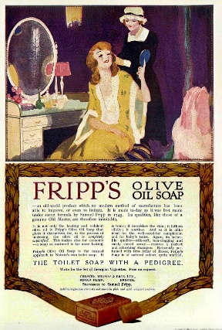
Charivari: It was fairly obvious that the Thomas Brothers of Bristol used the Fripp name, that they had acquired by an amicable take-over years earlier, to sell their wares to AOFB members and others; but FOFB John has sent me a cutting proving the actual family connection. Messrs Christopher Thomas and Brothers’ bright welfare journal, “Broad Plain Bulletin”, for November refers to the raising of more than £300 for the ‘Wee Waifs Fund’ of Sir Alfred Fripp, of ‘Frothblowers’ fame, and mentions that Sir Alfred is related ‘to our founder.’ Local history records that in 1745 the firm of Messrs Fripp and Co. was old-established, and in 1841 it amalgamated with Messrs Thomas. In the same year Mr. Thomas Thomas, described as ‘the founder,’ retired. The new firm settled at the Broad Plain Soap Works, trading as Thomas, Fripp, and Thomas. It is stated that Mr. Edward Fripp retired from the concern in 1856 … Sir Alfed Fripp contributes to the “Broad Plain Bulletin” an article on the aims and objects of ‘Ye Ancient Order of Froth Blowers.’
The Future – is bleak: but Steve Williams and I hope to brighten it by arranging a get-together next March (18th, we hope – the day after my 83rd birthday). Dave the Chain finwood40@btinternet.com

