FRIENDS OF THE FROTH BLOWERS
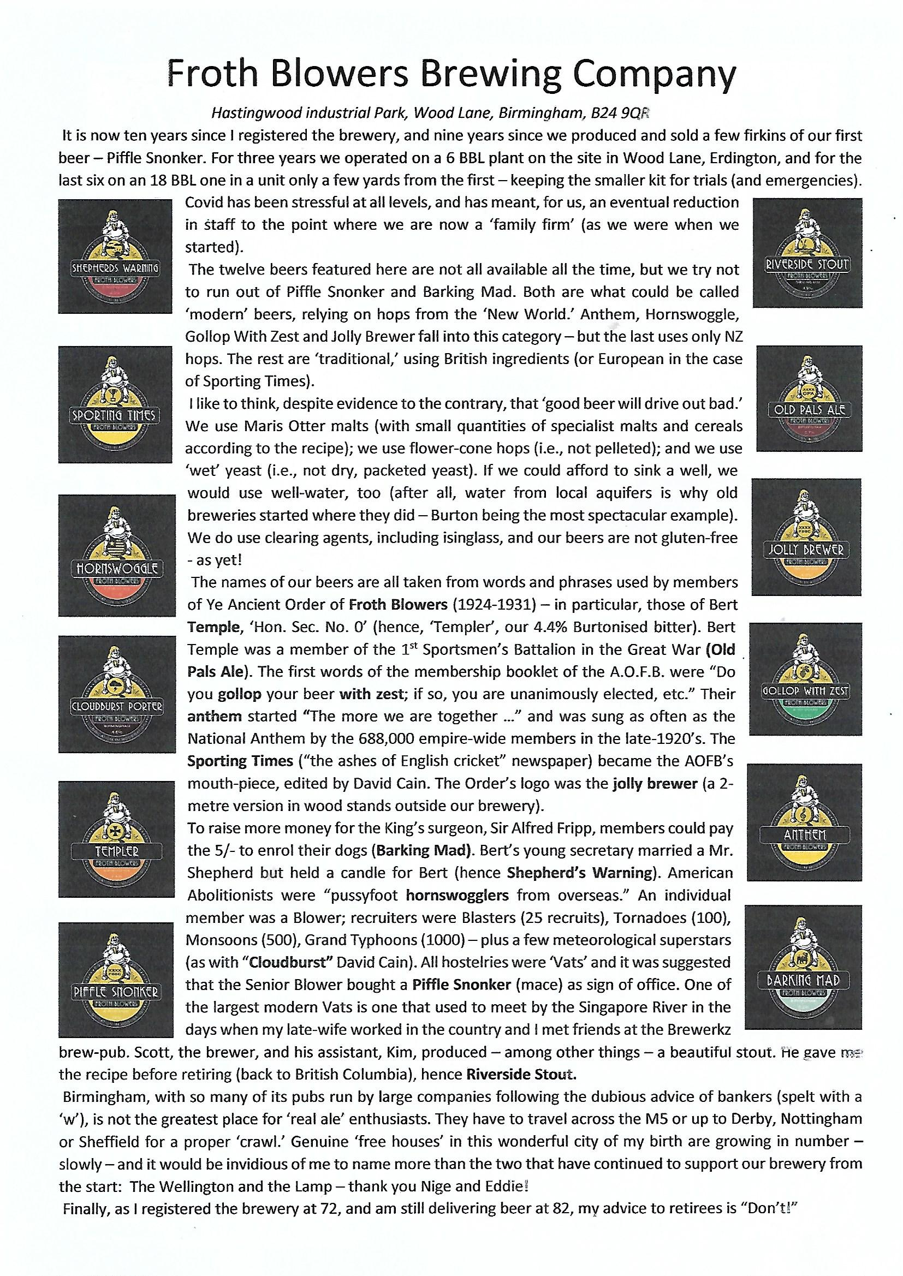
NEWSLETTER NO. 67 SUMMER 2022

Times are hard (even in ‘New Roman’) - and likely to get harder; but this is not the only reason I seem to be plugging the brewery. It is also because it is an idea that is ten years old this month and so closely associated with Bert Temple’s whimsical ‘Order’ that it is an integral part of the ‘tribute band’ that is the “Friends of the Froth Blowers.” Should you wish to try some, then the Frothblowers in Werrington and the Thirsty Giraffe in Deeping St. James – run by FOFB Steve Williams and friend, John - feature our beer more than occasionally, as does the Land of Liberty, Peace and Plenty in Heronsgate (M25 – Junction 17). Now, the Marlpool, near Heanor, almost always has one or two (Fri-Sun); the Cask & Pottle, Tutbury, more-often-than-not has one; the White Hart, Bargate stocks Barking Mad, and the Flag in Castle Donington always has our beers. The Abbey in Shrewsbury takes four to six at a time, and the Chestnut Tree in Worcester takes beer almost every week. This enables me to drop beer regularly at the Stratford Alehouse on the way and visit Sue at the (not-to-be-missed) Three Kings in Hanley Castle, to drink - and take a monthly beer there, too. In Coventry, the Broomfield (by the rugby ground) and the Royal Oak, Earlsdon, try not to run out of Piffle Snonker; which, of course, can also be said of the Wellington in the wonderful ‘workshop-of-the-world’ that is Birmingham.
TRAM-CAR-TOONS
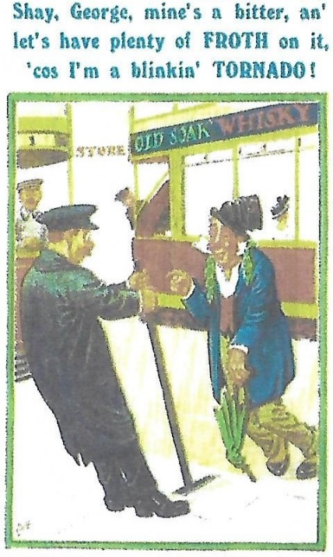
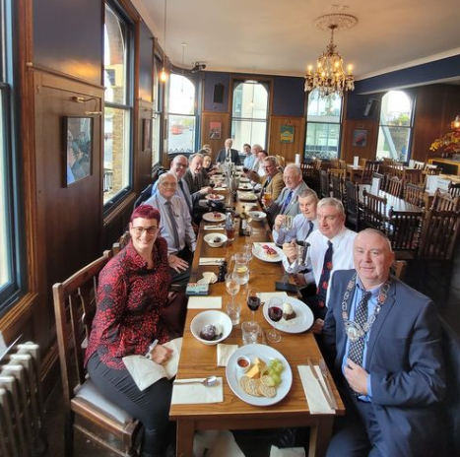
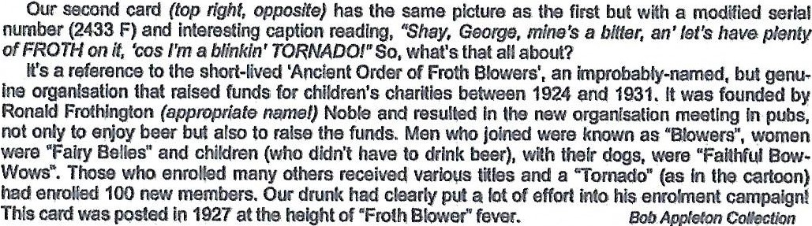
I was amused to receive this attachment about the AOFB which appeared in a Tramcar magazine. It was one of three, showing a drunken man confusing a tramcar official with a bar-tender. This is the only one directly identifying the gentleman as being a Froth Blower – a ‘Tornado,’ no less! Bert would not have been pleased: nor, I doubt, would he have liked the idea that his name had been supplanted by a ‘Ronald Frothington’ as being the founder of the Order. You would have thought that the writer of the article might have looked him up.
Annual Gathering
No place is perfect but, as Simpson’s has become rather Americanised and its bureaucrats unhelpful, and the Rose is booked on the 29th, I contacted the Fox & Anchor, Charterhouse Street, EC1M 6AA, who can do that date (drinking in the pub and eating next door, it seems). I am putting £100 down (refundable) so if only one other turns up, we can share the bill! As their menu is somewhat convoluted, I suggest using my letters and numbers – e.g. I am opting for ST5/MC3+SI2/PU1. As it will be pay-as-you-go, should you wish to spend less – or more – feel free to tailor your choices to your needs (including sharing). Try to respond before the 22nd. Given the economic forecast, this might be our ‘last supper.’
Dave finwood40@btinternet.com 07525 100644.
