FRIENDS OF THE FROTH BLOWERS
Newsletter No. 66 Spring 2022
In Memoriam: The Swan, Fittleworth
I would like to think that this article is premature, and that a new Swan will rise - phoenix-like – from the yet-to-be-confirmed ashes of the (very) old Swan. That a hedge-fund owns a property worth at least twice its value as a private house than as a hostelry, gives me little hope that such an event will happen. £1.25 million seems a ‘snap’ to me but only as potential house: I doubt an investor is going to spend money on it to keep it as it is.
Therefore, a la recherche du temps perdu, I offer up some results of my previous ‘recherches.’ (Swann, of course, being Proust’s original ’searcher’). As I have already devoted a Newsletter to some of its history, I will try to find new things to uncover specific to froth-blowing – if I can.
A Little Bit of History
It is thought that some sort of inn has stood beyond the fording-point/bridge over the river Rother, serving travellers on one of the oldest roads in England, since just after time immemorial. Topographical journalists of Bert Temple’s time claimed that the Swan was at least six hundred years old then. Whatever-the-case, the two licensees of the 1880 to 1930 period - Mrs. Hawker and, following her, Mr. Thorpe Oliver – were celebrated for their care for the inn and their hospitality. It was in the former’s time (and a little before) that artists drawn to paint the Rother and its surroundings left sketches to adorn the walls of the inn as a ‘thank you’ to the lady. One, Richard Caton Woodville, donated the inn-sign of a swan in rushes (and a frog, too, apparently) beneath which carts and cars have passed for close on 130 years. Most of these artists – and one or two musicians – left smaller contributions in the leather-bound Visitors’ Books. Recent vandalism and thefts – by owners and lessees – have meant that most of these valuable objects have gone ‘who knows where.’ (Some of them belonged to me!)
Thorpe Oliver and Bert Temple
At some point in his life Bert stayed at the Swan in order to go fishing. He and Thorpe Oliver became friends, so that after Fripp’s operation on him (in late-1924, I think), he and his father went to the Swan early the next year in order for Bert to recuperate. The Swan became the first rural hostelry to form a Vat. In honour of this – and that the idea of the ‘Ancient Order’ was decided on in conversations with his host – the Swan became Bert’s ‘No. 0 Vat.’
The Australian Test Team
I am not aware that Fripp ever joined the parties at the Swan. If he had then it might have been on the occasion that one or two members of the 1927 Australian Touring Team visited the inn. A reporter at the time wrote about a bat belonging to Victor Trumper and presented by him to the late Sir Thomas Fairbank (wrong surname, I think) after he had used it in his last test at the Oval in 1909. Sir Thomas was a great personal friend of Mr. Oliver, to whom his widow presented the bat, and last year the value of the trophy was increased by the addition of the signatures of all the Australian test team. It appeared that one or two had stayed there by chance and got the rest to sign the bat. However, Fripp had been an unofficial ‘go-to’ surgeon for the team when in London since he had operated successfully on Clem Hill in 1899. Both test teams were honorary Froth Blowers in 1927.
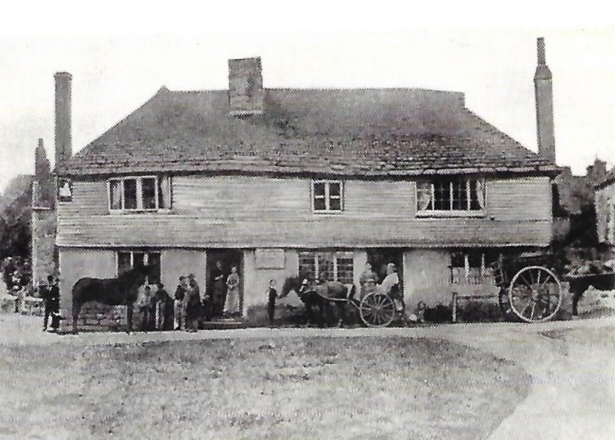
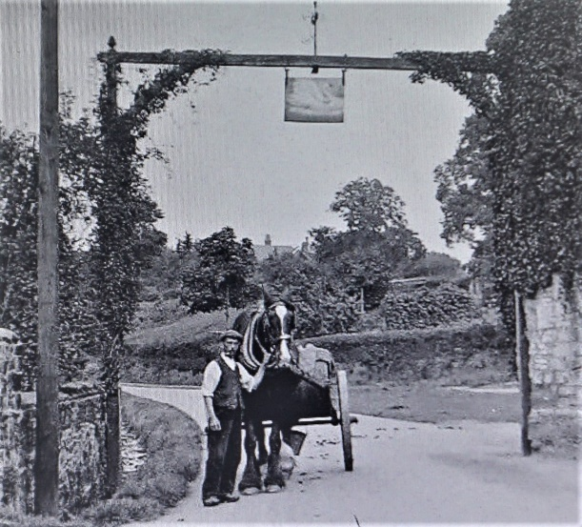
From My Collection
c. 1860 1895
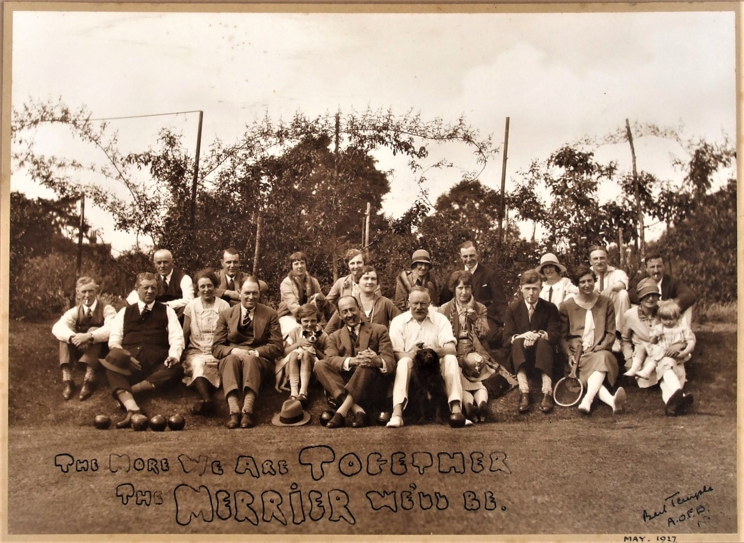
On June 22nd, 1897, Queen Victoria’s Jubilee was celebrated on the Green in front of the Swan. Thirty years later Typhoon Oliver entertained this group - the crème de la crème of Ye Ancient Order of Froth Blowers - as he did a number of times. This picture adorned the walls for the next ninety years. I doubt it will be seen there again.
Other Matters
As Aston Villa are away at Newcastle on Saturday 29th October, I propose that the Friends of the Froth Blowers meet this year at 1200 hrs in the Rose on the South Bank (London) again. More later. Dave the Chain (finwood40@btinternet.com)

