FRIENDS OF THE FROTH BLOWERS
Newsletter No. 64 Autumn 2021
The Kentish Hoard
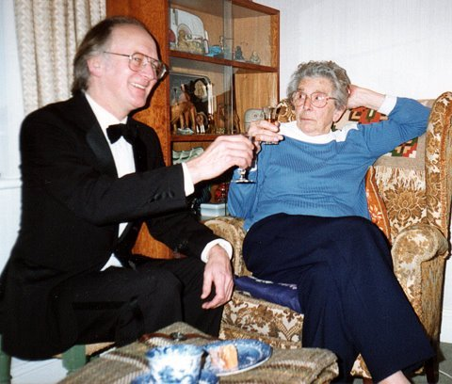
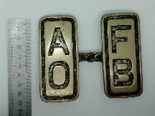
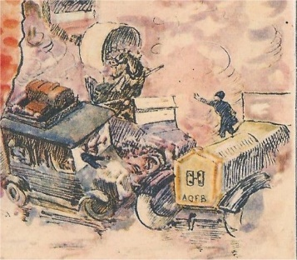
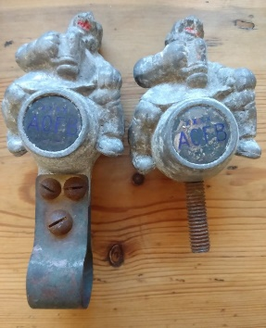
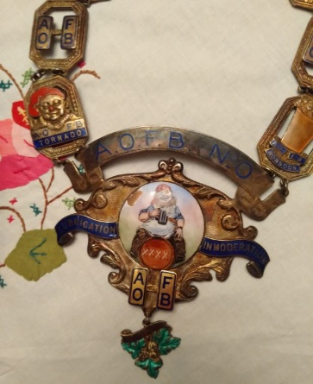
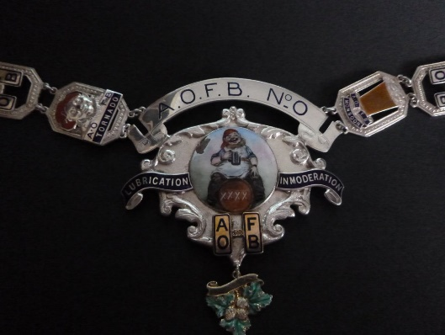
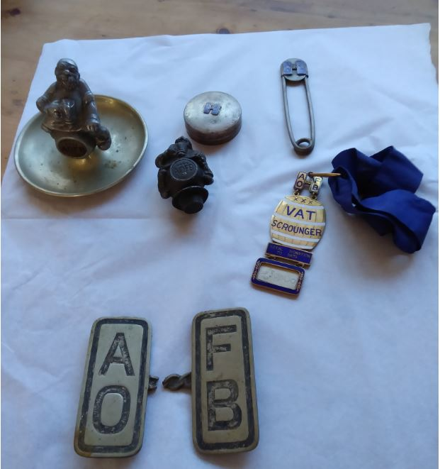
Two years ago Ian was contacted by a dealer in Kent who wanted to know about an AOFB collection he had acquired. It took the gentleman over six months to get round to sending a picture or two for identification but, when he did, Ian was somewhat excited: it seemed to be one that might have belonged to Bert himself. The large single cufflink could really only have come off Bert’s car. As Dorothy (née Roper) Sheppard inherited all Bert’s worldly possessions and then willed them to her sister, Gladys (pictured), it is more than possible that these artefacts were taken in a house clearance after the ‘Welcome Breeze’ died – in 1998. For twenty years after this they lay undisturbed in a shoe-box in a barn owned by an antique dealer who had not got round to doing anything with them before his retirement, when he sold them on to another dealer - in Faversham. So it was to Faversham that Ian took himself in September, 2020, and – after a satisfactory financial agreement – brought back the ‘Hoard.’ These included a chain-of-office with a degree of vert-de-gris, patiently removed to reveal the chain gleaming as intended when crafted by the Birmingham Medal Company 95 years ago. The car-mascots may need even more t l c in order to reveal their original splendours.
Knowing that Dorothy gave Bert’s tankard to Major D. T. Oxford in 1952 – and that his family still have it, having lent it to us once or twice – we have caught up with quite a number of what might be called ‘important’ possessions of the ‘inner group’ of the Froth Blowers at the time. It is good to have one or two in our possession.
Froth Blowers Brewing Company
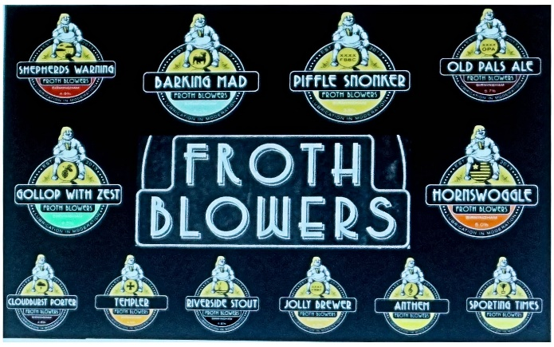
It is now a family firm. The two people we employed - not Bill and Ben but Will and Ben - left at the end of the furlough payments which had enabled us to keep going. Emma, my granddaughter and I, do the selling and office work, Andrew does the brewing and cleaning, and he and I do the delivery. Grandson Sam is off to University, but has been on hand to help during Covid times – having, sensibly, decided to defer his university studies for a year. We have tried to make sure that most sales are more local than they were and things are picking up slowly.
Friends of the Froth Blowers Annual Gathering 2021

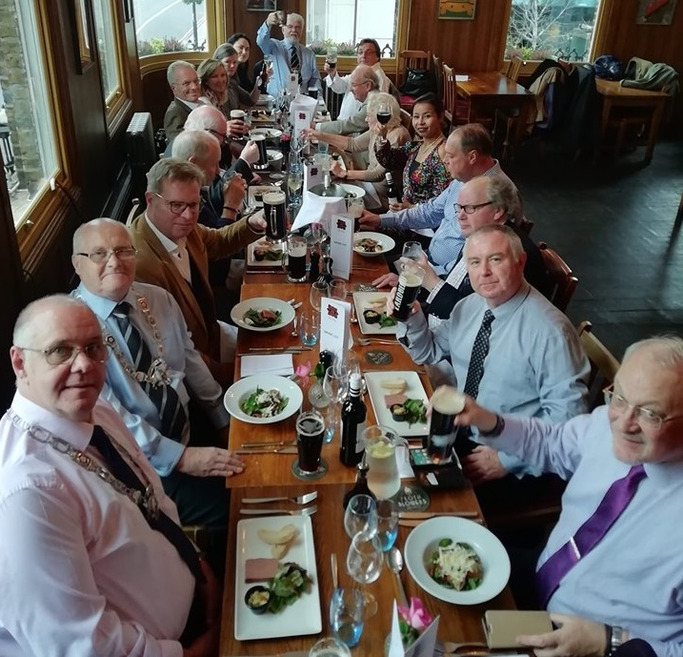
Ladies and Gentlemen!
I have booked the same room at the same place as two years ago in the hope that you – and others – might join me in celebrating the 97th year of the A. O. F. B. and 16th of the F. O. F. B.

Saturday, 30th October: The Rose, Albert Embankment, London, SE1 7TL: midday - for 13hrs. lunch

I expect a three-course menu choice to be sent to me soon so that, as before, attenders can choose two or three courses from a set of three, I assume. At the moment, I just need to have some idea of numbers wishing to attend. The cost will be around £30-£40 for the meal. It would be nice to think that the gathering would be so popular that we would need a bigger room but I will cross that bridge if I have to!
Dave the Chain
Let me know if you wish to join me and how many others you might bring – names when known.
finwood40@btinternet.com
07525 100644

