FRIENDS OF THE FROTH BLOWERS
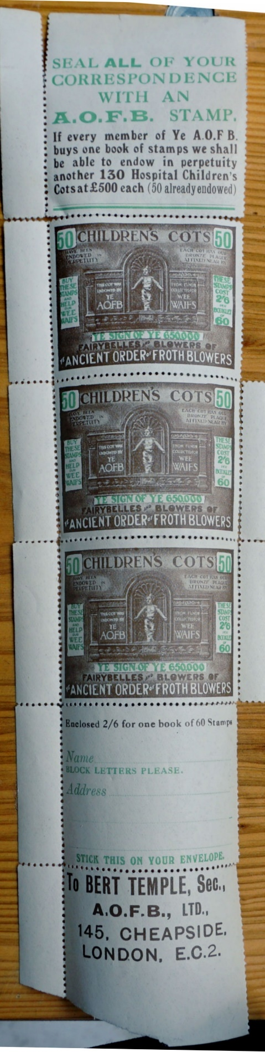
NEWSLETTER NO. 63 SUMMER 2021
Artefacts
When we first met – in 2005 – FOFB Paul brought to the gathering in Salisbury some goodies in a case, including a Chairman’s chain and a Piffle Snonker. One or two other FB’s who pre-dated the FOFB had a few things hidden away in a loft, too, it turned out. However, the Birmingham Four – Ian, Brian, Chris and I – have sought out as many artefacts as we can in the last fifteen-or-so years; and we are not the only ones.
Ian’s website is pretty all-inclusive when it comes to the naming of them – and in the illustration of many of the surviving pieces. We are four years away from what we take to be the centenary of the first artefacts – that is the cuff-links and the booklet. (However, before the booklet there was a single card of membership). Six years later there were dozens and dozens of metal, wooden and paper collectibles for the members at the time, and for us to track down now. The one artefact that would seem more likely to survive than these paper stamps – the club tie – has been particularly elusive.
The Chairman’s Charivari
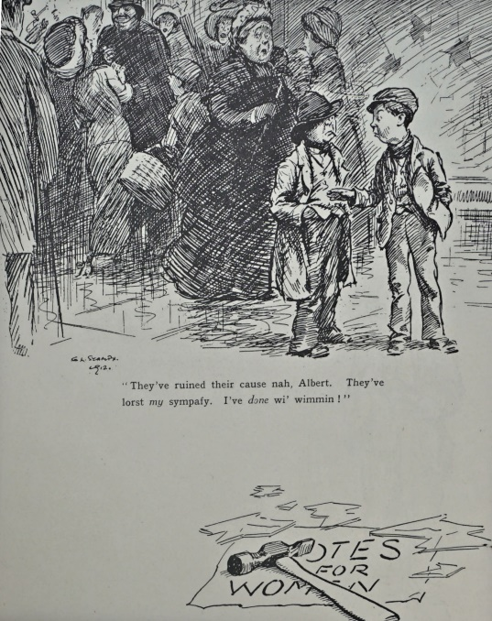
I have written about Stampa, Bert’s chosen caricaturist for the booklet. His Ragamuffins were often political commentators - as with this view of ‘civil disobedience’ made comical by contrast. He did the same with Lord Derby’s scheme to get volunteers to enlist by door-to-door visits to pressurise fit men to sign-up. This had to be shored up by an Act to bring in necessary conscription. Bert obviously liked his use of ‘wee waifs’ for commentary on such things.
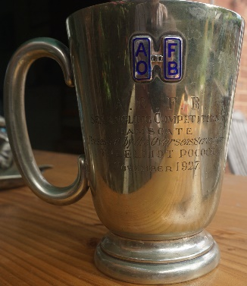
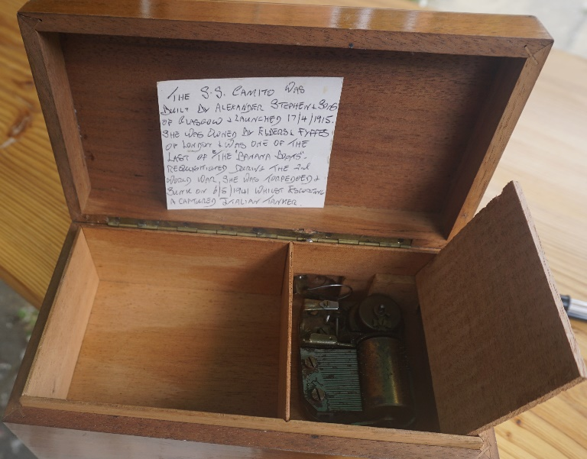
From 1900 and the start of the Hollywood influence until at least 1970, to be seen with a cigarette in your mouth – or in a holder – was de rigeur for men, women and boys from all levels of society. Frequent enjoyment of ‘beer, beef and baccy’ to Bert was the English way; even Surgeon Fripp found no fault with the regime. This is a type of plain cigarette-box for handing out your favourite cigarettes to your visitors – and it played two or three tunes, including the Anthem, as did other types of such boxes made for the AOFB. This sea-going box might have been used by the donator of this tankard, the ‘Overseas Scrounger,’ F. G. Elliot Pocock – here, sponsoring a ‘Sea-Angling Competition’ in Ramsgate in November, 1927. (A recent acquisitionof mine).
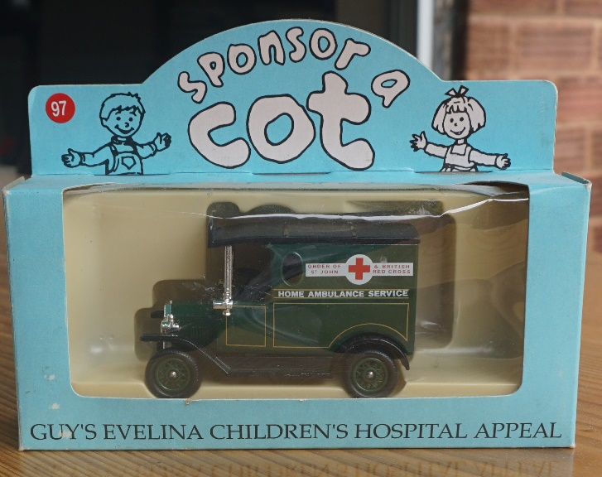
Sponsoring a cot was one of the most important uses of the £100.000 raised by members between 1924 and 1931. Each cot cost £500 to run initially, and the AOFB paid for fifty of them, countrywide. An Innes Fripp plaque referring to the AOFB’s generosity was placed on the wall by each ‘cot,’ much to the displeasure of the Abolitionists who felt that beer was causing most of the childhood problems to be seen in hospitals. Guy’s was Fripp’s hospital and the Evelina was a children’s hospital paid for by Frederick Rothschild in memory of his wife, whose name he gave it. Fripp’s brother-in-law – and Guy’s colleague – had trained in the Evelina Hospital.
Events
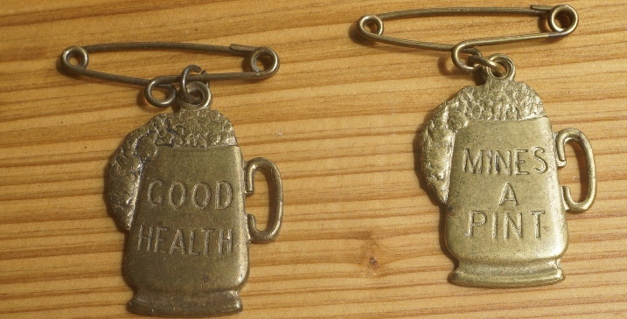
I assume no-one made their way to the Swan on Bank Holiday Sunday as I have received no enquiries as to where I was on the day – at home, I’m afraid. If I do go this year, it will be at the drop of a jolly brewer’s hat. (See ‘Events’ – if so).
I would like to think that the Annual Reunion will go ahead – but, by then, we may have Martian ‘Flu’! I will get in touch and use Ian’s site as soon as our shambolic leader makes a decision of some sort. Dave the Brave finwood40@btinternet.com

