FRIENDS OF THE FROTH BLOWERS
NEWSLETTER NO. 62 SPRING 2021

‘More Madness For A May Morning’

The ‘darling buds,’ shaken as they are by ‘rough winds,’ are an indication of why I am sitting in front of a screen typing this particular contribution to our collective madness. ‘Had I but world enough and time,’ today I would happily recall only ‘the best of times’ we have shared – and ‘happy the man … who can call today his own.’ However, ‘tomorrow … and tomorrow … and tomorrow,’ will takes us to Monday when ‘all our yesterdays’ will have lighted this particular fool for 42,500,000 minutes. As I hear ‘Time’s winged chariot hurrying near’ - having gone from
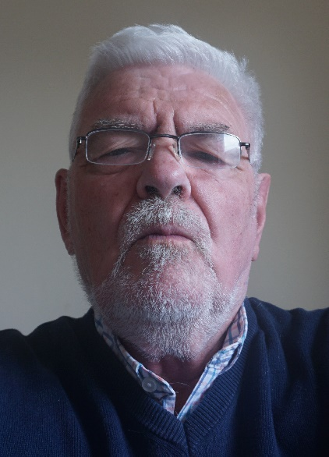
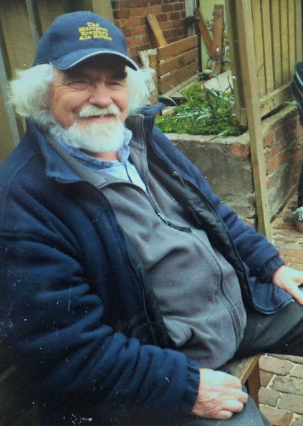
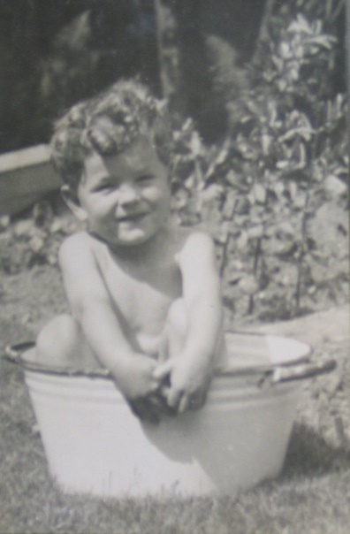
,,,…………. .THIS ………………………………………….to THIS……………………….via (recently)…..THIS……….................

- I shall not waste any more of them … for the next few minutes, anyway!

Close to Bert’s ‘Last Syllable of Recorded Time’

‘Our mutual friend,’ Ian Brown, Esquire, recently unearthed the following article, published as Bert may well have been ‘crossing the bar’ … I include it in this newsletter in case you may not have read it before.

“A letter announcing the death of Mr. Herbert Temple has been received by Mr. Ernest Chalk at the Elbow Beach Hotel. Mr. Temple founded Ye Ancient Order of Froth Blowers, which has been styled ‘the most cheerful charity in the world.’ A paragraph from the letter will be of great interest to all members of the organisation in Bermuda: ‘The doctors had advised a sea-voyage for Bert, and he had booked a passage to the West Indies. He had planned to sail on the 5th of February on the S.S. Coronado, and from that ship to transfer to the Lady Somers which reached Bermuda on March 2, staying there for a few days. Though this trip was purely for his health, and he would not have made himself known to anyone, yet he had arranged to call at the Elbow Beach Hotel and promote Monsoon Chalk to the rank of Grand Typhoon. This was something he was greatly looking forward to, and you would have been the first Grand Typhoon to have received a personal visit from No. 0 in such a way.’
The following account of Mr. Temple’s death and his career is taken from a London publication:
‘With deep regret I have to record the passing of yet another stalwart – Herbert Temple, who as ‘No. 0’ (founder of the Ye A.O.F.B.) was known the wide world over. I make no apology for placing ‘Bert’ (as he was popularly known) in the category of England’s heroes. Sportsman, traveller, philanthropist, and good fellow, he had explored the four corners of the world in peace. With the call to arms, Bert Temple joined the Sportsmen’s Battalion, and it was chiefly due to his Wartime experience that his health became permanently impaired while still a young man. This brought Temple into contact with the late Sir Alfred Fripp, and a sturdy friendship – in which sympathy for the ‘under dog’,’ a love of outdoor life, and a strong sense of the whimsical were the principle factors – resulted.
Out of the association was born Ye Ancient Order of Froth Blowers, whose activities on behalf of child welfare are too well known to Refereaders to need re-stressing. Sir Alfred Fripp became ‘No. 1’ of the Order; Bert Temple, although the originator of the scheme, was content to figure as the modest ‘No. 0.’ The membership grew up to approximately 800,000, and up to the end of 1930 the Order had distributed to various child welfare organisations some £100,000.
How many successive operations Sir Alfred performed upon poor Temple’s suffering body I cannot compute. Yet with each exit from the nursing home Bert emerged bright and cheery to present a smitten but smiling cheek to the world.
A confirmed bachelor, his love for children was almost a fetish; and to thousands of little ones in the darker corners of this great city ‘Uncle Bert’ enjoyed popularity only equalled by that of Santa Claus.
With the death of Herbert Temple at the regrettably early age of fifty-one the children of this country have lost a stout and faithful ally; and England have lost – a man.’ PHARAMOND.”

One would not want to write ‘his love for children was almost a fetish’ nowadays, but the article does prove one element of Bert’s life as true – that is, his world-wide travels. I had thought that descriptions of his time in the ‘South Seas’ were fanciful but it is obvious that they had taken place – possibly, in Edwardian times. A trip to Bermuda on what is described as a cargo ship (one that foundered two years later), shows a healthy attitude to ‘a life on the ocean waves’ for an unhealthy man. Had he made the journey, his cruise-ship looks more comfortable:

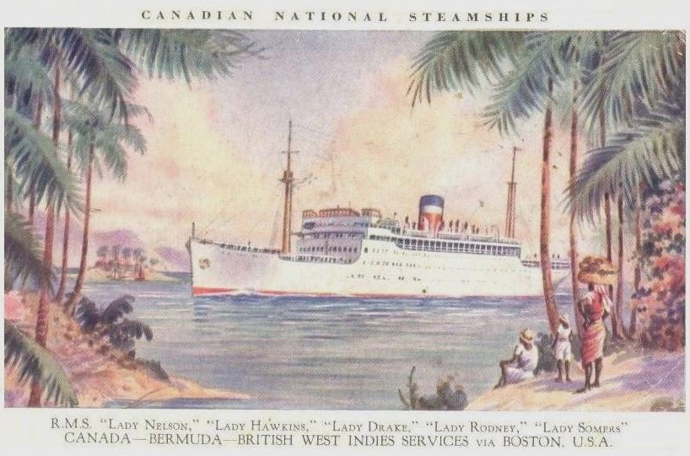

Fitttleworth
I fully intend to make the trip to the Swan at Fittleworth on Saturday 29th of May and expect to arrive at around 12.30 p.m. I would be very pleased to take lunch and swap lock-down survival stories with other FOFB’s.
R S V P – if, like me, you intend to attend.

12th May Update
Swan Inn plaque wetting re-arranged to Saturday 3rd July 2021 – after COVID restriction easing.

19th May 2021 Update
Postponed indefinitely until COVID restrictions allow.

Doctor John
Jill’s husband, Dr. John Roberts, has been in-and-out of hospital for reasons other than the pandemic, and I am sure you would want me to take this opportunity to express your best wishes and mine for more tranquil times for him and Jill.

Dave the Whimsical finwood40@btinternet.com

