FRIENDS OF THE FROTH BLOWERS
NEWSLETTER NO. 61 WINTER 2021
The Singapore Vat
This, as you might have guessed, is not a recent photograph – nor does it represent anywhere near the full complement of Sing Vat members: only Blaster Dave (to my left) knows the number and the names; but I would say that he was well on the way to being a Tornado before the diageo virus took over. Kim, Tang, Scott and Dave, I salute a friendship going back to the last century! Steven and Eriko, you have added your wisdom and charm to the mix! To the late, lamented Hannah (the chip on my shoulder), you were as great as any Great Dane! To others – Ted, Felicity, Debbie, Devin (in Singapore), Greg, Corinne (freezing in Texas), Michael and Adele (in Ruanda, possibly) – thank you for your continuing friendship, too. If this sounds valedictory, it is only an insurance policy in case … I seem fit and I hope to live as long as my mother - which would give me another twenty years. My good wishes to all Froth Blowers!

The Froth Blowers Brewing Company
Since my last letter, things have only got worse: the almost complete shut-down of any type of outlet for our product – cask-conditioned beer – has meant that we have brewed one small batch in three months. Only a few small operators have bothered to apply for a ‘take-away’ licence so our sales have been over 90% down. We filled 180 five-litre cans with Piffle Snonker and Barking Mad and have sold 150 of them, but this does not make much profit. We have had to borrow money to try to ride out the storm, not knowing when it is going to end. We might be able to start trading again in April.
Books
Covid has given me time to finish my book on Sir Alfred Fripp – although I have not done a final proof-reading of it yet. I wrote it because his (very readable) official biography seemed to gloss over the last ten years of his life, having only a few paragraphs on the Ancient Order of Froth Blowers; nor did it stress the importance of Fripp the Reformer, being more interested in Fripp the Socialite.
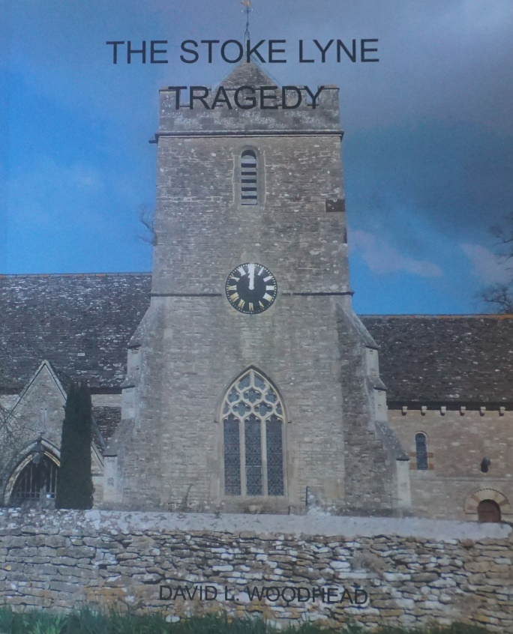
I have completed about ten booklets (fewer than forty pages) on pubs and other such things, and two or three longer books – of which The Zestful Gollopers is the chief in terms of sales (over 350) and wider appeal, I suppose.
My latest book is my first attempt at a novel – albeit, a biographical one. It starts: “Entering the dining-room of the vicarage the Reverend William Bryant moved to one of two wing-backed chairs and sat down. He put the gun he was holding to his head and pulled the trigger. The lethal bullet entered at the right temple, exited his skull obliquely and buried itself in the woodwork of the window nearest the fireplace. His body slumped back in the chair and blood flowed like crimson lava over the left side of his face.”
This event happened in 1914 in Stoke Lyne, Oxfordshire, the village I lived in from 2013 to 2016. I have used Census information, newspaper articles and the like for the facts and filled in with conversations and likely scenarios for the rest. It is 400 A4-size pages long (including photographs, etc.). It will be ready in two weeks’ time and I will sell it myself for £20 (inc. postage).

Events
There is obviously no point in arranging anything for the 17th of March … but … on Saturday, 29th May, I hope to be in the Swan at Fittleworth for lunch – let us say, 12:30hrs for a 13:00hrs meal. I would expect to leave at 15:00hrs. to arrive at the Peyton Arms, Stoke Lyne at 18:00hrs should anyone wish to join me there.
On Saturday, 30th October, I suggest we return to the Rose on the Embankment at noon for the Fifteenth Anniversary of the founding of the Friends of the Froth Blowers.
Dave the Rave finwood40@btinternet.com

