FRIENDS OF THE FROTH BLOWERS
NEWSLETTER NO. 60 AUTUMN 2020
Lies, Damned Lies, and Donald Trump
Would it not be wonderful if Trump lost the election, was charged with tax evasion, found guilty and imprisoned – as a sort of latter-day Al Capone? To compare him with Scarface is a little unfair: Capone frightened a few people and killed a few others, but ran a tight ship; Trump has frightened the whole world, caused the death of hundreds and rendered his father’s ship full of holes. I have no doubt, if he does lose the election he will keep his job as long as possible with legal battles about postal voting and vote-rigging. However, we have to hope that Biden, at 77 (to Trump’s 74), does not die before being sworn in!
Froth Blowers Brewing Company
Pussyfoot Johnson, meanwhile, has managed to get it wrong at every stage – even by recovering from the pandemic he was causing to spread. He and his plutocratic cronies, with their fortunes dependent on the City – and beyond, have kept London and the South moving, but locked, unlocked, partially-locked everywhere else on a daily basis. The Brewery, therefore, based in the Midlands, has lost 75% of sales while still paying the same rent, rates and beer duty. In order to survive we have to try to calculate the level of debt we might be racking up by some unguessable date next year (?) when some sort of normality might return.
Ian’s Diggings
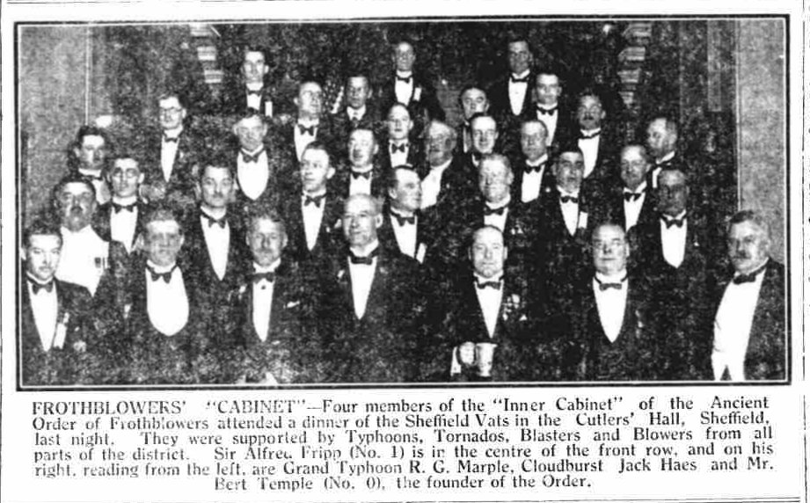
Your indefatigable webmaster goes on unearthing snippets from various sources. He has sent me newspaper cuttings showing members of the four-man committee actually in attendance at various major shindigs - as with this one in the city my family called home from 1953 onwards. For a newsprint photograph of the time it is in remarkably good order.
The Kentish Hoard
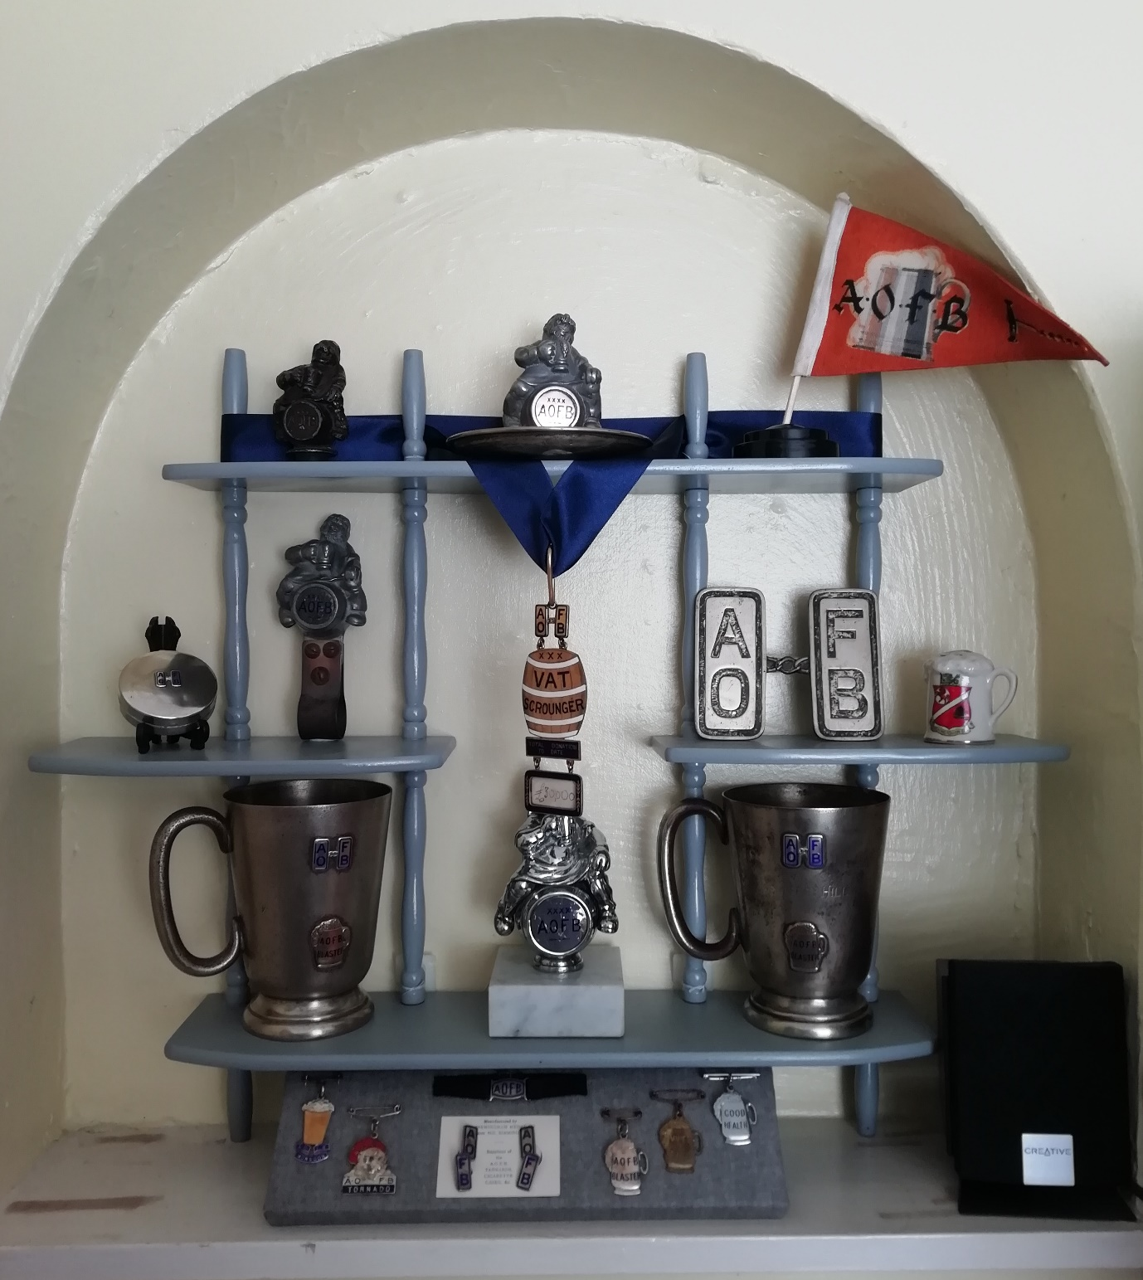
Some people – i.e. Ian and I – will go to the ends of the earth (or, at least, Kent) to secure a purchase. In this case, Ian seems to have been offered one man’s collection of AOFB artefacts, including the barrel insignia of a ‘VAT SCROUNGER’ of the Fred Desborough type. There could be more from the same archaeological site.
The Future
If there is a future after Covid - and what looks like being the Second American Civil War - then I shall endeavour to get to Fittleworth on the last Saturday in May (29th) and, possibly to the Rose in London on the last Saturday in October (30th).
My birthday – 17th March – falls on a Wednesday in 2021 and things might still be uncertain then, so I will keep the Brum Trudge on ice (metaphorically, I hope).
Dave the Chain finwood40@btinternet.com

