FRIENDS OF THE FROTH BLOWERS
NEWSLETTER NO. 59 SUMMER 2020
My Obsession
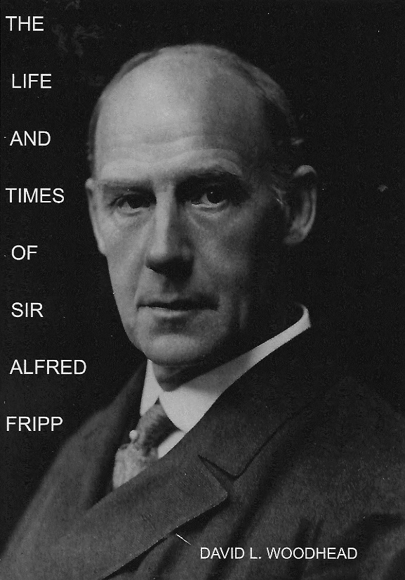
To recapitulate (see Newsletter No. 38): in 1995, when I first read the words “Ye Ancient Order of Froth Blowers,” I was not too sure that Temple and Fripp were real people: I thought the whole thing might be a spoof of the Masons, or other ‘secret’ societies, in the form of a little booklet. I soon found that a man named Sir Alfred Fripp had indeed been a surgeon to Edward VII and George V. It was not until 2005 that I had a book printed – called “Of Fripp and Froth Blowers” – and held the first meeting of the Friends of the Froth Blowers. Ten of us gathered at the Froth-blowers Arms in Salisbury – including Paul with a Piffle Snonker and a chairman’s chain-of-office, and Jill, Fripp’s granddaughter (with her husband, John).
After this I met Ian Brown - and sold him a book – since when we have continued to research the subject. He has found, among other things, a remarkable amount about the lesser-known Bert. I have continued to delve into the life of the once-famous surgeon. As a practising surgeon or physician, you would have to do something very special to be remembered by the man-in-the-street two or three generations later. Fripp’s contemporary, Sir Frederick Treves, featured in the film “The Elephant Man” but, if people recognise his name at all, it would be for this and not for the fact that the film’s story was based on Treves’ last book, “The Elephant Man and Other Stories,” or that he saved Edward VII’s life by cancelling his coronation in order to drain his appendix, or that he was one of the world’s first surgeons to perform an appendectomy because he had pioneered a method that avoided the trauma that had led to the death of patients previous to 1888 - when he performed Britain’s first one.
Fripp’s Achievements
His first achievement, given their rivalry, was to make sure an autobiography would be published soon after his death: Treves’ wife dithered about what the biographer should write and, when it was near completion, decided not to have it published. He did not get one – written by Stephen Trombley - until 55 years after his death, when a lot of the original material had been destroyed. Cecil Robert’s – very readable - biography of Fripp came out in 1932. Because this biography did not deal adequately with the last ten years of Fripp’s life, I decided to write another one – so now he has two to Treves’ one.
To his student contemporaries, he was something of a hero: he made things happen, and could have played rugby “at the highest level.” He was a fine cricketer, strong rower and an unbeatable swimmer.
He became a personal friend, as well as medical advisor, to both Prince Albert Victor and, after the Prince’s early death, to his father, Edward (both when Prince of Wales and when King). He went on to serve George V (born a few months before Fripp and dying five years after him). He was surgeon to the Duke of Connaught and his family, and became friends with other high-ranking patients.
He became unofficial surgeon/physician to the acting profession, the visiting Australian Cricket teams, and a number of other sporting clubs – such as West Ham United.
He saved Guy’s Hospital from financial embarrassment by getting his “friend,” the Prince of Wales, to preside over a Fund Dinner which raised more than £150,000 for the Hospital. He also got him to agree to be President of the Hospital – two royal involvements which had never happened before. He followed this by working with the King’s advisors to set up a “King’s Fund” for London Hospitals, but turned down the King’s prestigious offer to be its first Secretary on the grounds of inexperience. He went on to raise thousands of pounds for the Hospital because of his high society contacts as a surgeon/friend. He started his own branch of the Invalid Children’s Aid Association in Hackney and, over a twenty-five year period, raised similar amounts for it and its parent body.
In 1898, he married his girl. They had 32 years together, five children and scarcely a dull moment.
In 1899, at the age of 33, he was asked to plan, equip, staff and run a hospital for 550 soldiers of the Imperial Yeomanry on an empty bit of the Karoo nearly 500 miles from Cape Town. The actual man-in-charge was Lieut.-Col. Arthur Sloggett of the Royal Army Medical Corps – but in the event he went along with what Fripp (and his older colleague, Edwin Cooper Perry) had planned. The resultant “I.Y.H. Deelfontein” became the blueprint for future base hospitals in a war-zone because of its spectacular success compared with the dismal failure of the R.A.M.C. hospitals in the Boer War. He had had over £100,000 to spend on the hospital so set up huts where the dental pioneer, Newland Pedley, could repair broken jaws, where Hall Edwards – the x-ray specialist – could diagnose problems, and where, too, a masseur could operate: all firsts in a war-zone. He even took his 20-yr-old wife with him to distribute previously-unheard-of ‘comforts’ – tobacco, mainly. He took a huge laundry, capable of handling the blankets (and, eventually, sheets) from over 550 beds. He took with him five times as many nurses as any R.A.M.C. hospital took per capita – essentially, being the first war-time hospital to use trained nurses as first-call carers (leaving orderlies to do the heavy work). He was particularly praised (later) for being the first to ask a physician to give his services abroad when at war. Guy’s had the brightest young physician of his age, John Wichenford Washbourne, on their books. So impressed were the organisers by him that he was persuaded to stay for three six-month stints, when no surgeon was required or requested to do more than one. (Unfortunately, the strain put on his system led to his death a few months after his return).
It was recorded in a newspaper report that Fripp had advised soldiers to eat lightly or not at all before a battle because he noticed that it lowered the risk of complications when operating.
Having been sent on a tour of inspection of other hospitals before his return, he jotted down notes for the complete reform of the R.A.M.C. and went straight to Cooper Perry and then his acquaintance, Arthur Balfour, to put the plan in action before another debacle happened. The new Minister for War, St. John Brodrick, met Fripp and, with the full support of the new King, they selected a committee – including the eventual chairman, Alfred Keogh - which thrashed out the general principles from Fripp’s notes and Cooper Perry’s plan so that the Advisory Committee could make sure the Reforms were working successfully in time for the next war – which, of course, started in 1914. In 1939, Brodrick (as Lord Midleton) was at a dinner to remember the perceived success of the R.A.M.C. in the Great War. He wrote, “I felt their most deserving guests would have been King Edward and Alfred Fripp.” Thousands more sick and wounded soldiers would have died in 1914-18 if Fripp and the King had not forced the reforms through with urgency. Fripp and Perry were the only members of the Committee knighted for their services in the reform of the R.A.M.C. – and Fripp was 37, one of the youngest medicos ever to be so honoured. During this process he got the main army medical teaching hospital moved from Southampton to Millbank in London, to everyone’s satisfaction.
From the age of forty, he had his own ‘Firm’ at Guy’s, and many of his students attested to his influence upon them both as a fine surgeon and as one more concerned than most with the aftercare of patients and their families. He often gave his time and expertise freely to those in need.
He co-wrote the successful Art-primer, “Human Anatomy for Art Students.”
In the Great War he was Consulting Surgeon to the Navy and persuaded the War Office to put a student doctor on each ship as before there was no such ‘professional’ on ships at war. He wrote a 27-page account entitled “Experiences of a Civilian among the Naval Medical Service in War.”
The two men in charge of the R.A.M.C. in 1914-1918 were Sloggett and Keogh – Fripp’s ‘acolytes.’
In 1927, he got Edwin Lutyens to design and build a house for him above Lulworth.
He left money for an annual lecture on “Happiness and Success,” and a Guy’s medical scholarship.
And then there was “Ye Ancient Order of Froth Blowers” … What a full life!
Finally, the Brewery is struggling on, but for how long is uncertain. Until the next time! Dave the Sane.

