FRIENDS OF THE FROTH BLOWERS
NEWSLETTER No. 58 SPRING 2020
Time to Reflect
I apologise in advance for any apparently flippant remark I make in the course of this quarterly offering that might seem inappropriate for the present situation, but ‘Keep Smiling’ was always the British response to undesirable attack from foreign bodies … and it is difficult for me not to keep smiling. Although I have been very happy while helping to run the Froth Blowers Brewery in the last six-and-a-half years, I have had no time to myself and it has cost me money. Now, having celebrated my 80th birthday in time to have an unfrowned-upon family outing to our favourite curry-house, I have unlimited time to do what I am now doing – putting finger to keyboard – and, even after only a week in solitude, must have saved over £200 in petrol and beer not purchased. What is more, the Government knows it has to keep small firms alive so having to close the brewery is not a suicide-inducing decision – and we have a product which, depending on alcohol strength, only gets better for being ‘lagered’ (but at 12º). That I have to sit at home and drink wine and spirits (something I have never regularly done before) when I have about 20,000 pints of beer five miles away in a brewery I own is a little ironic, but I am getting used to the privation. I have just made a stew with a red wine and dark chocolate gravy and had the rest of the bottle of Merlot to accompany it (and you will be glad to know that I did not put a picture of it on Facebook). Usually I do not have enough time or energy for indulging in the home-cooking which was something I did for fifteen years as a bachelor and over thirty years as a married man. However, I know the overgrown narcissistic child that is the U. S. President will learn nothing from the experience but I hope the rest of the population of the world might feel the fragility of existence … no flippancy here.
What About the Brewery?
I cannot say that we were making a healthy profit or that we did not have to drive greater distances than we would have liked to sell our beers but we were just about holding our own in a cut-throat market when the virus struck. We had, also, produced the new beer based on the Neds Wonder we made for Will’s cousin’s concert tour two years ago, called Wild Geese (see my last newsletter). It should be good by July, fingers crossed! We must sit and wait.
Harold Stewart Turner
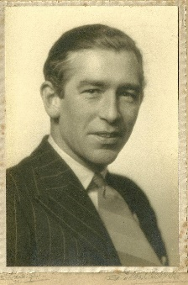
Ian and I have always been a bit puzzled that we have not found out more about Hal Turner, the AOFB’s Birmingham boy – and, at 15 when the Great War ended, he was a boy. After the AOFB came to an end, the Birmingham Medal Company continued to trade into post-War times. Like Bert, Hal seems to have over-enjoyed a bachelor life until he was 44 when he married a 24-year-old girl he had met eight years earlier. They had two children, the second of whom, Amanda, was born when he was 57. He died aged 73.

Events
Things will have to be put on hold, obviously, but I hope some of us can meet in October.

Corossword:
For any FOFB’s with time on their hands I offer this largely alcoholic “Corossword.” I expect the editor of the Pub History Society’s Journal to answer by return of email. Results will be published at some point.
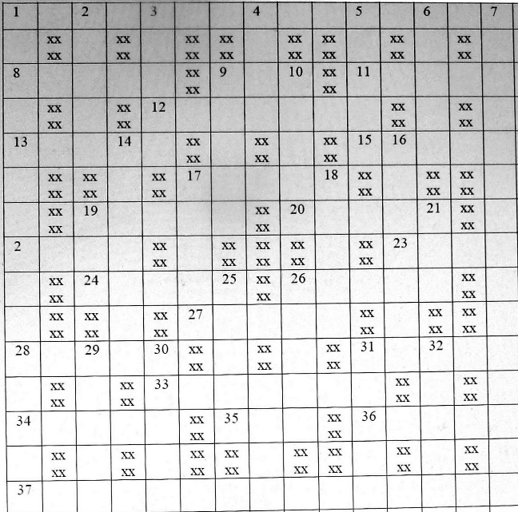
Across
1. After the Barley Mow, where next? (7, 8)
8. Thatcher’s girl … or builders’? (5)
9. In Manhattan Bourbon’s not top, Rye’s better, see! (3)
11. 4% … 5% … 6%? Agh! This type of thing leads to anger management. (5)
12. Jam and lots of beer. (7)
13. Too much alcohol can cause death – as can happen in shotgun-duelling (5)
15. Rod Steward? Help! What’s his name? (5)
17. Do we act like this when we’re silly-drunk?
19. Beer! American rubbish, mates! (5)
20. Case number bottled after snap (with no starter)? (5)
22. Wilson stood behind it. (4)
23. Wort next? Hop in after it. (4)
24. I can stand like this after seven but with no. 8, et cetera? Impossible! … (5)
26. … and 8 is typical of it. (5)
27. Entitled to re-order some of our real ales? (5)

LUBRICATION IN MODERATION
Until next time!
Dave the Chained
28. Bit of lemon from her-indoors to add to my poolside drinks? (4)
31. Stop drinking, Jack – less you mess up! (5)
33. See a sound but ordinary whisky – the type that ends things. (7)
34. Market for ice-cold beer – such grot! (5)
35. Indian home may suggest they have drunk a lot of this. (3)
36. High as a kite? Regrettably, found in the drink usually. (5)
37. Boycott drinks – only those that are, I imagine. (9, 6)
Down
1. Noble, indeed, to spoil a Roman who is mostly off-colour (N. B. internally). (7, 2, 6)
2. Sometimes red and can follow a bottle, too. (5)
3. What an over-indulging school-leaver might become if he heads in this direction? (5)
4. Where drunken-bum Arsenal fans are from? (4)
5. Dicky Bird’s performances? Sounds like them. (5)
6. First-class bread often turns up after a few - from Lewis’s Wonderland, perhaps? (5)
7. Owls’ winning ways are not always appreciated here. (9, 6)
9. Drink deeply it says in here: perhaps – almost - religiously. (5)
10. Give me this year’s supply of barley, or else! (5)
14. A toast! Well … how most of it was delivered. (7)
16. What might a rowdy customer be given by the landlord of this pub? (3, 4)
17. Bloody Mary! What might cause an upset to both? (5)
18. Mine’s a pint! What’s … missing? (5)
19. The man is not the 1st fifth of 7. (3)
21. Is that a negative from another customer? (3)
25. Tell-tale turn of the pack. (5)
26. High-sounding greeting? (5)
29. Found locked-up in the precinct but not as bad as it could be. (5)
30. What she does after too much to drink – from Schweppes, it seems. (5)
31. Dirigible animal? (5)
32. Killed Batman’s boy? This means war … or not. (5)
33 Cut it this way to eat it? (4)

THREE GULPS TO THE PINT, FOURTEEN TO THE GALLON
finwood40@btinternet.com

