FRIENDS OF THE FROTH BLOWERS
Newsletter No. 57 Winter 2020

“Mad Mike” Hoare (1919-2020) R. I. P.

This pump-clip (not the finished article) is the Froth Blowers Brewing Company’s memorial to Thomas Michael Hoare. He was born in Calcutta to Irish parents on St. Patrick’s Day, 1919. I was born in Birmingham to English parents on St. Patrick’s Day, 1940. Both of us claimed belated membership of Ye Ancient Order of Froth Blowers: I to research its history and he to invade the Seychelles. Given that his father was a river pilot in India and mine was an insurance salesman In England, any further attempt to establish a connection would be risible – especially as “Mad Mike” fought in Burma and India in World War II (becoming a major) and my father, as a conscientious objector, drove ambulances in Egypt and Italy.
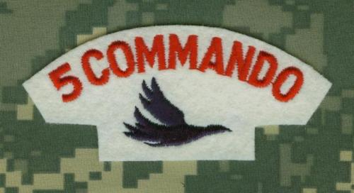
There might have been less of a contrast if Mike Hoare had made more use of his qualifications as a chartered accountant but, having emigrated to South Africa, he offered his services as a mercenary soldier to any African country who wanted to hire him and, by 1961, was leading ad hoc mercenary groups during the Congo Crisis. Then, in the mid-1970’s, he was employed as technical advisor for a film (starring Richard Burton, Richard Harris and Hardy Kruger) based on a fictional story about mercenaries hired to rescue a deposed African president. It was called The Wild Geese. Hoare had already appropriated the “wild geese” idea for his Five Commando, ANC from the 17thC Irish mercenary army named thus because they migrated from Ireland to fight in any European army who would pay them.
Shortly after the release of the film, James Mancham, a real president – of the Seychelles – found himself in exile in South Africa, having been deposed in an absence from his country by France-Albert René. A counter-coup was proposed by his supporters, unofficially backed by South Africa and the U.S.A., so Mike Hoare and his white, middle-class mercenaries were employed to lead the ‘invasion.’ He decided they would go as holidaying rugby players of a club called Ye Ancient Order of Froth Blowers. Showing his knowledge of the AOFB, he later wrote:

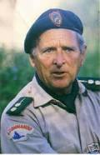
In the best traditions of the original AOFB we collected toys for underprivileged kids and distributed them to orphanages … I made sure the toys were as bulky as possible and weighed little. Rugby footballs were ideal. These were packed in the special baggage above the false bottom to compensate for the weight of the weapon (AK-47’s).
When they landed in the Seychelles, in November 1981, a tragi-comedy ensued when a mercenary got into the “something to declare” queue and his gun was discovered. After a skirmish, Hoare commandeered an Indian Airline plane and all but four of his group managed to escape. As justice had to be seen to be done, various sentenced were passed – “Mad Mike” himself spending less than three years of his ten-year sentence in prison for hijacking an aeroplane.

The Froth Blowers Brewing Company at the GBBF Winter Beer Festival
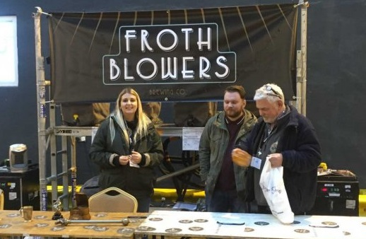

In early January Camra invited me to attend their Great British (Winter) Beer Festival which this year and the following two years is to be held in Birmingham. I replied to say that as the owner of Birmingham’s biggest real ale brewery, I had expected our beers to feature at such an event. They responded by hurriedly offering to add us to the list and buy six of our beers if we would pay for our own stand – and run it. When we delivered the beers we found our stand was between Thornbridge’s bar and Davenport’s bar – all three of us being late additions. Furthermore, we were in the unheated overspill ex-bus-garage bit of Bingley Hall and not the heated, carpeted bit. To the right of the stand can be seen a cooler they obviously thought we would need – for beer standing for a week in an ambient temperature of 5 to 10 degrees! We brought in a heater on Tuesday for us and the beer and by Friday night things were tolerable. We sold out on Saturday morning. For us, running it as a ‘family’ experience, the week was a good one. Ben, the assistant brewer, and Kate (pictured here) did much of the work, but Will came up from London on Tuesday and served or networked until Friday morning. Emma, being 20, was prepared to take off warm clothing and play the beer-barista for many hours. Even Kamil – our man-with-a-van - and his wife put in a session. Thanks to them – and all helpers!

Birthday Bash and Brum Trudge
On Tuesday, 17th March, I will be in the Wellington, Bennetts Hill, B2 5SN, from 5 p.m. to 8 p.m. for a celebratory tipple with my nearest and dearest, and anyone else wishing to join me in a libation. At 8.30 p.m. I hope to be in Mother India, Boldmere, with a few dozen poppadoms in front of me – as a warm up for the Dansak to follow.

On Saturday, 21st March, on or after 11 p.m. I will be in the Froth Blowers Brewery with a group of Amber Valley drinkers and anyone else who wishes to join us. At around 1 p.m. I hope to lead a ‘trudge’: say, Bartons Arms to the Wellington (at 4 p.m.) More details later. D. L. W.

