FRIENDS OF THE FROTH BLOWERS
Newsletter No. 56 Autumn 2019
15th Annual Gathering
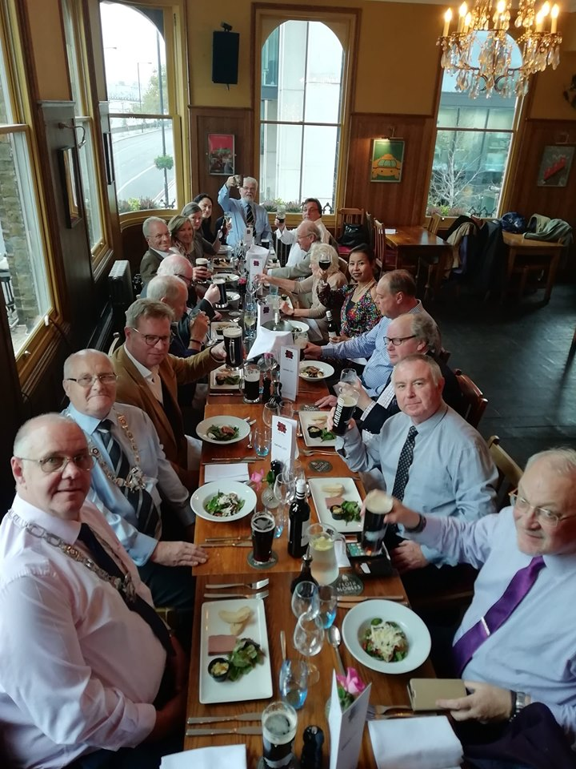
On Friday night we, the citizens of Birmingham, were advised that merely by living there we would be at “risk of death” – by drowning, we were told. The night was, indeed, wet, as was the walk to the Brewery made by Brian and Ian, judging by their moistly glistening faces and damp clothing. I was blamed for this immersion, as they expect all such events organised by me to be accompanied by “Woody Weather” (i.e. sunshine all day). I can only apologise but add that it stopped raining while they walked from the car to the pub – a journey that turned out to be unnecessary as, not finding my £20 parking permit under the relevant resident’s door-mat, I subsequently moved the car right outside the pub for the duration, without penalty.
With such an auspicious start – free parking in London – it is satisfying to be able to say that the Rose rose to the occasion. From almost every point-of-view it ticked the boxes (even the fact that it was previously unvisited by local FOFB’s): it is accessible; it has views across the Thames; although Greene King’s, the beer, I was told, was drinkable; the wine was potable (and the helpful staff even found seven glasses of port); the food was as good as any I have had in a ‘gastro-pub’ type of establishment (far better than most, in fact); and the room was ideal for our sort of gathering. (Sadly, I forgot to lead the company in a rendition of the Anthem as I am sure its acoustics would have been flattering to our seventeen-part harmony). I also forgot to fine people, but one or two generous Friends did not forget our charitable beginnings, including – on our way home - Mick the Hat of the Hat Vat, Stoke Lyne (a visit to whose hostelry – the Peyton Arms - should be at the top of any list of 100 hundred things to do before you turn into a pumpkin) so the Acorns Hospice of Birmingham will be in receipt of the day’s generosity as part of the Brewery’s annual gift. Many thanks for this – and your company!

The Downing Connection
I was talking to ‘Dr. John’ about the reason for the ‘Downing’ in Sir Alfred’s name so, following from his explanation, I looked up the Downing Baronetage and found the following:
Sir George Downing had the house that became 10 Downing Street built for him in the mid-17C and his eponymous grandson left enough money for the building of Downing College in 1800 - despite a lengthy and expensive court case challenging the provisions of his will. If there was a direct family link between Sir Alfred’s family and the Downing family, then it was through a “Captain of the Guards” mentioned by Samuel Pepys in his Diary who may have been one, John Downing. It is supposed that he shared the same grandparents as Sir George - who was described by Pepys as a “perfidious rogue” and that “all the world took notice of him for a most ungrateful villain.” A miserly, scheming turncoat, he was responsible for the deaths of his former Puritan colleagues but he was, also, a very skilful financier and diplomat – a fact recognised by Cromwell and Charles II (who made him a baronet). Different branches of the families tracing their line back to the 1st Baronet have added ‘Downing’ to their children’s given names: however, those with connections to Cambridge University – as with Fripp’s grandfather – may have been thinking of the 3rd Baronet and his endowment.
In my ‘middle-period’ cricketing days the then Master of Downing, John Butterfield, was also the President of the Cambridge University Cricket Club (and, later, Vice-Chancellor of the University). After an Old Boys of Cambridge (Quidnuncs) v the Old Boys of Oxford (Harlequins) match in about 1980 he invited players and partners for dinner in Downing College – and, having obviously taken a shine to Joyce, insisted she sat between me and him. It transpired that he had been born in Stechford, less than a mile from where we lived at the time and where his father had made Levis bikes. Having hobnobbed with him for a few hours, we were pleased that, when ennobled, he chose to be referred to as ‘Lord Butterfield of Stechford.’
As for lords and ladies definitely associated with the A O F B, many of Fripp’s aristocratic ex-patients gave their time, money – and, sometimes, their grounds – in aid of the charity: some, no doubt, paid their 5/- membership. King George V had known him both as his Surgeon in Ordinary and through Fripp’s friendship with his elder brother and his father; he corresponded with him directly in the Boer War. His son – later Edward VIII – is thought to have accepted ‘honorary’ membership of the Order. In the late-1920’s, he was on many committees – medical, sporting and charitable – which included lords and ladies ‘doing their bit’ for the country. Sporting ones, such as Lord Lonsdale, are known to have assisted Fripp in his many charitable endeavours.
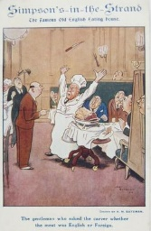
In honour of Lord Oliver of Burgess Hill, I include a copy of the wonderful menu he brought to our feast – with an arrow pointing to the man-in-black, identifying Fred Heck himself – what a find! This (unauthorised) copy is of an old postcard.
Froth Blowers Brewing Company
The Company is still trading but selling has been hard work for the past six months. We hope that Christmas and some sort of post-Election optimism persuades people to part with their money more willingly. The product remains high-quality and true to Bert’s beliefs – even if we do slip a few American hops into our paler beers.
17th March 1940
On the above auspicious date - a Sunday, St. Patrick’s Day, and in the Year of the Dragon – in Loveday Street Hospital (by St Chad’s Cathedral, Birmingham), Dave the Chainless was born. Should I survive to the 21st March, I intend to hold a froth-blowing celebration close to my birthplace – see you there!

Lord Oliver of Burgess Hill’s Simpson’s Menu

Signed by the 3 Fred’s, Fred Heck (Manager of Simpson’s), Fred Pocock (Joint Grand Scrounger and Overseas Grand Scrounger) and Fred Desborough (Joint Grand Scrounger) with a dedication from A.O.F.B. founder Bert Temple No 0.

