FRIENDS OF THE FROTH BLOWERS
Newsletter No. 55 Summer 2019

Old Age and Alcohol
For years I have given this combined excuse for my inability to remember what I was intending to do next. However, as far as functioning brain-cells are concerned, we are informed, a life-time of alcoholic indulgence (with the occasional over-indulgence) does not reduce their number. I, therefore, can only blame senility for being behind in my seasons in recent quarterlies, leading to last minute arrangements – and rearrangements - of previously advertised events. It may, of course, be that I was always short of the requisite number of functioning cells.

Plaque-wetting at the Swan 2019
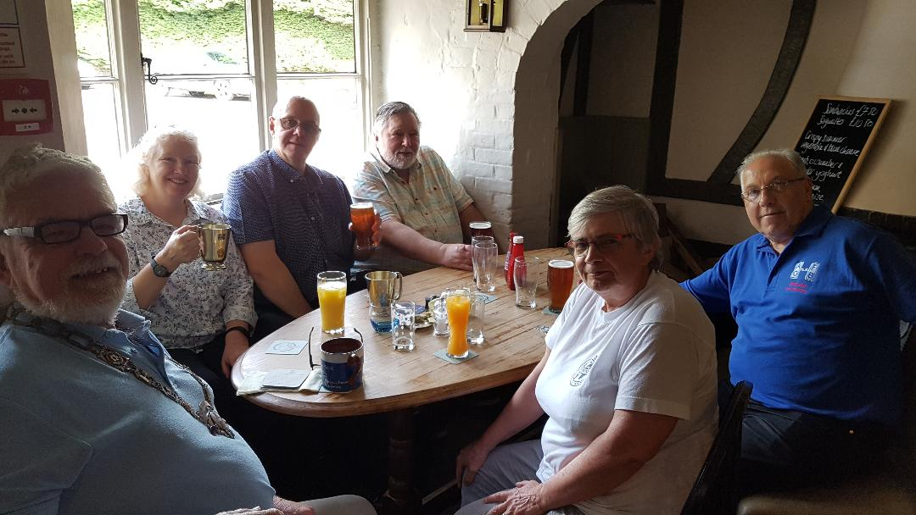
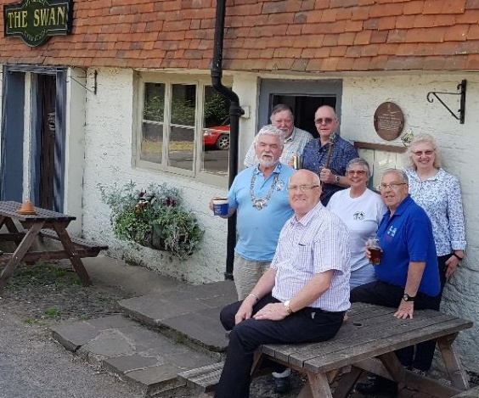
Having messed around with the date to avoid the bank-holiday week-end, I was pleased that five Friends could join me in Fittleworth in early-June: Hannah and Heather from the Wallingford Vat (or, perhaps, as Hannah is the Froth Blowers’ accountant, the VAT Vat); Jim the Larger from the Hat Vat; and Ian, Brian and Chris from the former Holly Lane Vat.
These photographs are courtesy of Brian – and a friendly member-of-staff who learnt how to point the camera in the right direction and press the relevant button. The Swan has changed tenants four times since we first went there in 2006. The last lot seem to have taken what was left of the AOFB memorabilia and all of my ‘permanent loans.’ The present incumbents seem to know what they are doing but I have no doubt Enterprise Inns will ensure that they will be forced to move on sooner rather than later, having relieved them of their life-savings.

The Fifteenth Annual Reunion

The set menu from The Rose, Albert Embankment, SE1 7TL is overleaf. Look on therosepublondon.co.uk for other details. We need a minimum of £600 for a group booking (e.g. 12 @ £50 - £32.95 + drinks) – pay on the day.
I will confirm the booking on this basis – let me know definite (liable to pay!) names and numbers a.s.a.p.: 07525 100644 finwood40@btinternet.com
FOFB LUNCH
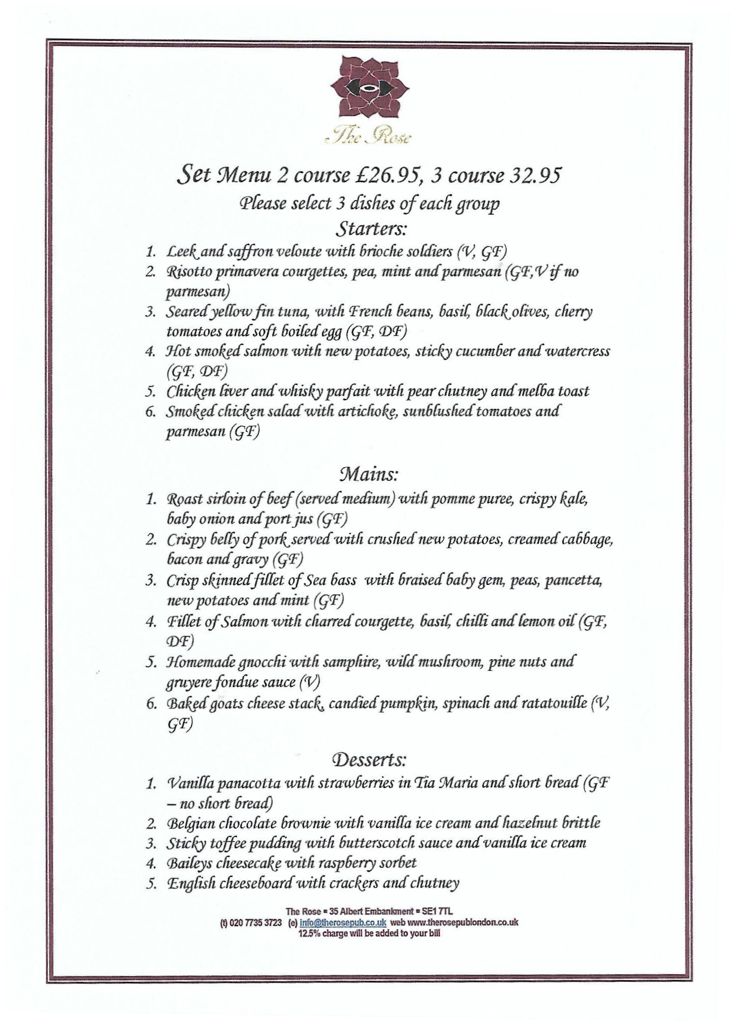
The Rose: Saturday 26th October: 12:15 for 1300 hrs: carriages at 15:15 hrs.
Choose by number: I am going for S5/M1/D1 (two courses if you prefer)

