FRIENDS OF THE FROTH BLOWERS

Newsletter No.54 frothblowers.co.uk Spring 2019

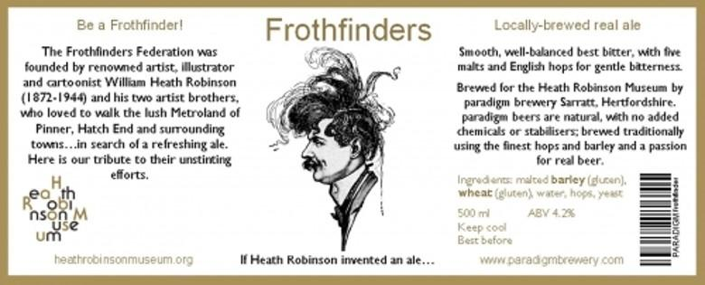
The Froth-finders Federation

On September 15th, 1920, the people of Barnstaple and others flocked to the traditional Toast and Ale Function in the Guildhall of that ancient town. With every local dignitary in attendance, and in a hall decked out with bunting, ferns and asters, “the Mayor presided at the table head and ladled out from a huge punch-bowl the famous spiced ale, prepared by the Senior Beadle, Mr. E. B. Stowell, from an old recipe, and which was of excellent quality, and practically everybody sampled the brew, the silver tankards and cups, together with glasses of the beverage, being handed round with toast, cheese and biscuits, by the assistants.” The reporter added, “There was toothsome fairing for the ladies.”
In proposing “Success to Barnstaple Fair and Agriculture,” Captain William Beare Incledon-Webber of Braunston remarked that nothing except plague and civil war had stopped the celebration since the time of King Athelstan (in the 10thC) and “he did not think that they meant to stop it for Mr. Smillie and his coal strike.” He continued (significantly) that they had “hospitality to please either party, whether they belonged to the Pussyfoot Brigade or to what were known as the Froth-finders Federation.” (The American Abolitionist, “Pussyfoot” Johnson, had toured Britain in late-1919).
According to a recent article, Heath Robinson and his two brothers wandered the highways and bye-ways around their homes in Pinner on ale-tasting expeditions – as members of their own “Loyal Federation of Froth-finders.” Other articles say that the Crown in Stanmore and the Queen’s Head in Pinner were places that they and their friends liked to slake their thirsts. The above advertisement appears to be the bottle-label of the local Paradigm Brewery’s “Frothfinders” beer, brewed for the Heath Robinson Museum in 2017.
My guess would be that their “Loyal Federation” had been formalised soon after the Great War had ended but that, like Bert Temple, their use of the phrases “finding froth” or “blowing froth” dated from their early drinking days of the 1900 to 1914 period. That the people of Barnstable recognised the reference shows that the idea had reached beyond Pinner although the brothers do not seem to have illustrated their Federation’s quirks in a manner that might have spread the nature of its charms rapidly – unlike Ye Ancient Order of Froth Blowers, with its eye-catching cartoons by Stampa … and by Heath Robinson himself.
Of interest to we members of the latter-day “Friends of the Froth Blowers” is the fact that the Loyal Federation of Froth-finders obviously pre-dates the AOFB and would have been known to Bert himself. I would be wishful to think that the two groups joined in each other’s functions in the late-1920’s.
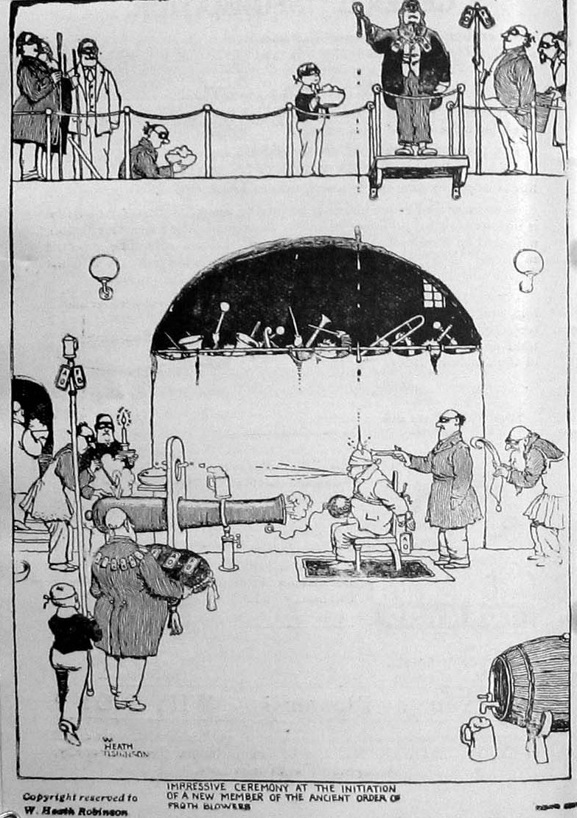
YE ANCIENT ORDER OF FROTH BLOWERS

As there is little doubt that Bert Temple and his surgeon-friend, Sir Alfred Fripp, knew all about the mysteries of the various fraternities – in particular, the Freemasons – this initiation ceremony would have delighted them … and those not invited (or not wishing) to join in their exclusive activities.

Change of plan (What again! You say)
I propose to visit the Swan at Fittleworth for lunch on Saturday 1st June, 2019 (not Bank Holiday Saturday, 26th May). I will be there shortly after midday. R.S.V.P. … perhaps?
David L. Woodhead (Dave the Chain) finwood40@btinternet.com

