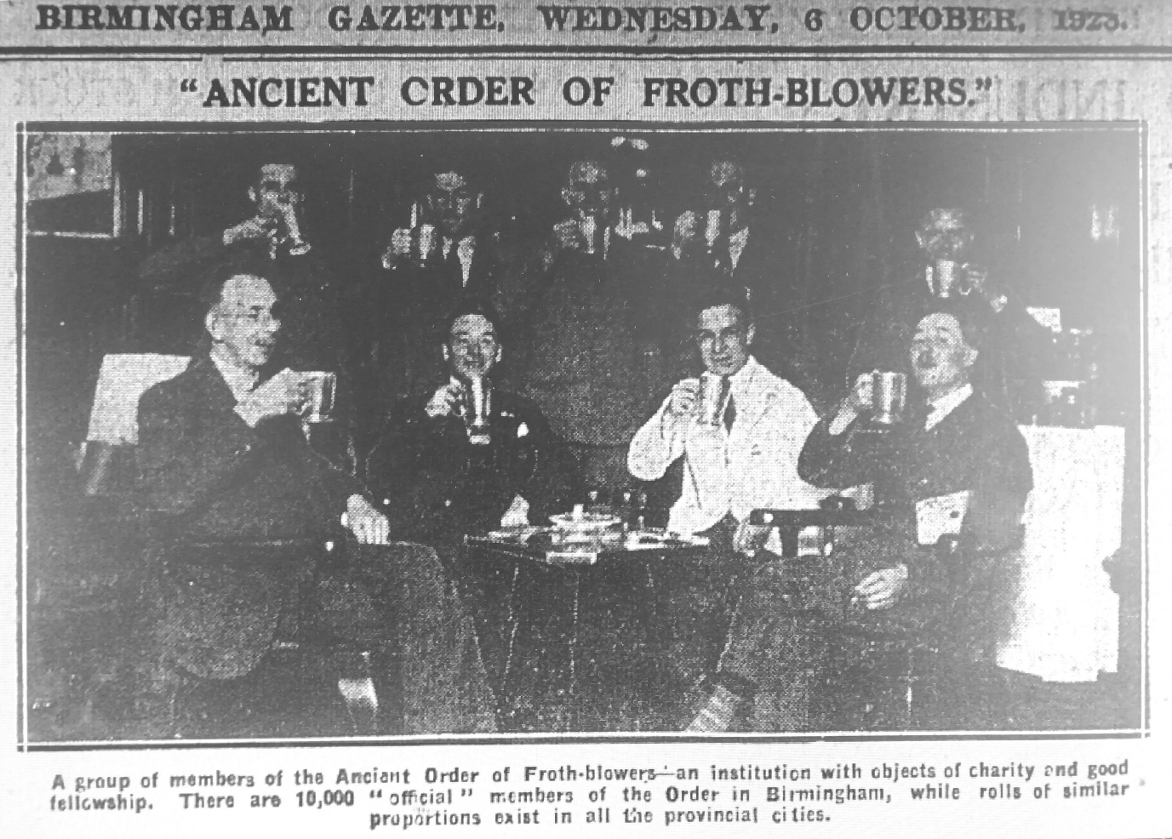
FRIENDS OF THE FROTH BLOWERS
NEWSLETTER NO. 53 WINTER 2019
Over ninety years have passed since these Birmingham gentlemen were raising their tankards to drink the health of Bert Temple and Sir Alfred Fripp. Among their number were ‘Hal’ Turner and his father (a Director of Turner & Simpson).

With apologies to Janine Wiedel, whose copyrighted photographs these are, I give you a portrait of ‘Hal’ taken by her for her book “Vulcan’s Forge” (a copy of which I hope to buy). They are of him and the Turner & Simpson’s works in the 1970’s. I am guessing that the portrait by which he is standing is of his eponymous father. Their home in the 1911 Census, when ‘Hal’ was a child, was in Highbury Road on the Streetly village edge of Sutton Park, as exclusive then as it is now. Janine Wiedel’s links to ‘Turner and Simpson’ include the ‘Birmingham Medal Company’ which suggests that ‘Hal’ merged it with the parent firm after he took over.

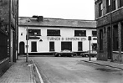

Some interesting Outlets for Froth Blowers’ Beers.

Our website (www.frothblowersbrewing.com) contains a list of some of our more regular customers, all of whom have their own virtues – other than selling our beer – but here are a few that it is worth taking a detour to find, even if an FBBC beer is not on offer:

White Horse at Hedgerley (by Junction 2 of the M40) – a gem which every ‘proper pub’ aficionado should have visited: if not, go now.
Land of Liberty, Peace and Plenty, Heronsgate (by Junction 17 of the M25) – not as “idyllic” as the White Horse but equally surprising in its arboreal setting, so close to the motorway.
Queens Head at Newton, south of Cambridge – Adnams from the barrel + a guest (not often one of ours) and dripping on toast for lunch in one or other of its eclectically-furnished rooms.
Green Man, Leighton Bromswold (by Junction 17 of the A14) – an easy-to-find survivor from the days when every village had a pub like it.
Frothblowers, Werrington (north Peterborough) – award-winning micropub.
Marlpool Brewery Tap (behind the Queens Head on the Heanor to Ilkeston road) – open Friday to Sunday, selling its own beers and a few others from pump and cask: not to be missed!
Dewdrop, Ilkeston (by the re-opened railway station) – good beer-selection in an unaltered ‘Station Hotel’ sort of pub.
Quiet Woman, Earl Sterndale (south of Buxton) – incredibly basic farmers’ pub which might take our beers soon. A month ago it had Owd Roger on handpump! The Roebuck in the next village (Crowdecote) does take our beers.
Barley Mow, Kirk Ireton (by Wirksworth) – in transition in that Mary, the landlady, is too senile now to handle the money, but still one of the great, old rural pubs of Great Britain.
Black Lion, Consall Forge (by Leek) – took our beers once or twice, but having to cross a river, a canal and a railway-line to deliver casks makes it hazardous: an amazing site, though.
Bhurtpore, Aston (north-west of Junction 16 of the M6) – a fine beer-festival type of pub.
Royal Oak, Ellerdine Heath (north of Telford) – The Tiddly is justifiably famous locally for its basic homeliness and beer-quality.
Three Kings, Hanley Castle (near Upton-on-Severn) – neither the pub nor the characterful landlady has been touched for donkeys’ years: the gem of all the gems!
Ship, Ashleworth Quay (west of Tewkesbury) – another ‘timewarp’ pub in an idyllic setting: this time by a one-time crossing of the River Severn.
Enough is enough: fortunately a few of the pubs of my youth have changed less than me – and I have been rewarded for my persistence by the recent micropub revolution (some of which are run by people who know what they are doing).

St. Patrick’s Day
I have shared the snake-remover’s day with him for the past 79 years. This year, as last, the proposed Brum Trudge (on the 16th) did not take place – or if it did your Chairman was not present: instead, he was driving from Birmingham to Bedford to Henlow and back to deliver six beers, and then driving to the bucolic King’s Head at Bledington (with two more casks) and on to the Peyton Arms for a libation with the denizens of North Oxfordshire. The Hat Vat is closing for two weeks so that Mick can recover from his hernia operation without the temptation to lift anything more than a glass to his lips … in some other publican’s hostelry.

Events
I intend to take lunch (buy it, in fact) at the Swan at Fittleworth on the 25th May – even if I am on my own.
Also, (s.v – Skoda willing) I shall arrange lunch at a suitable London venue for the 26th, October.
Suggestions, please!

finwood40@btinternet.com

