FRIENDS OF THE FROTH BLOWERS
FOFB Newsletter No. 52 Autumn 2018
I thought when writing Newsletter No. 51 that I was catching up with the seasons – obviously not!
Some Good: Some Bad
Most of the news items I included in “The Zestful Gollopers” were gleaned from the many pages of the Sporting Times that Ian and I had copied and studied some years ago. Ian’s website has many more items from newspapers published in Britain and the States (mainly) at the time. Some of these below may or may not be found in his almost exhaustive collection.
9th September, 1926: Coventry Evening Telegraph
“The Ancient Order of Froth Blowers (is) an organisation headed by Sir William Orpen, Sir Guy Chetwynd, Sir John Milbanke, and Henry Ainley, the actor. One looks for G. K. Chesterton’s name in this gay company: in spirit, if not in fact, such a lover of good brown ale must surely belong to the Order.”
Chesterton was famous for, among other things, writing, “The rolling English drunkard made the rolling English road.” It seems that the Coventry reporter was not aware that it was first published not as The Rolling English Road but as A Song of Temperance Reform. It was published in 1913 and – after such wanderings as the “night we went to Birmingham by way of Beachy Head” - ends with the idea that by giving up drink we would:
“walk with clearer eyes and ears this path that wandereth
And see undrugged in evening light the decent inn of death;
For there is good news yet to hear and fine things to be seen,
Before we go to Paradise by way of Kensal Green.” (By this he meant Kensal Green Cemetery)
There is every possibility that the other gentlemen, while not ‘heading’ the AOFB, were Froth Blowers of some stature as all would have been known to Fripp for many years. Orpen was a successful artist with portraits of many wealthy patrons to his name, Chetwynd was the son of one of Fripp’s high society patients, Ainsley was a top actor-friend of his, and Milbanke – and his remarkable ‘Sheila’ – were the toast of the town in the mid-1920’s. If you really wished to demonstrate the need to read a newspaper article as if it was fiction then Chesterton wrote “nutbrown ale” (not “good brown ale”) and only as a reason for making Father Brown say to Lady Mounteagle that an Indian’s skin should not make us prejudicial when it was the “same beautiful colour.”
18th December, 1926: Bath Chronicle and Weekly Gazette
“Contrary to general opinion there are no drinking tests, and one does not have to be a three bottle (no tankard) man to be eligible for the Order.”
“A three bottle (no tankard) man” is not a phrase familiar to me: one assumes it meant a man who was so keen to drink that he eschewed a drinking-vessel and drank three barley wines at a sitting.
23 December, 1926: Daily Herald
“All Britain’s froth blowers were yesterday excitedly discussing the news. There had been a great brewery fusion. Bass and Worthington had joined forces, and everybody was wondering if the answer was going to be a cocktail.”
It is well to remember that at the time these two old Burton breweries were renowned for their bottled beers, in particular, Worthington White Shield and Bass Pale Ale. They did not merge after the ‘merger’ until much later.
26th February, 1927: Folkestone, Hythe, Sandgate and Cheriton Herald
A daily paper this week contained the following announcement:-
“Exactly two minutes after he had been born a baby was enrolled a member of the Ancient Order of Froth Blowers yesterday. The enrolment was made by a doctor, himself a Tornado of the Order, who had taken with him a bracelet, the insignia of the Angelic Order of Fairy Belles, in case the newly-born child happened to be a girl.”
This quotation, or something similar, appears elsewhere in our annals, but is still an amusing side-light on history – a bit like Yorkshiremen domiciled outside Yorkshire who took their pregnant wives back ‘home’ in case the child was a boy and would not be able to play for Yorkshire if, in those days, he was not born in Yorkshire.
4th March 1927: from the report of an AOFB meeting at the Angel Hotel, Northampton
Thus, for “the absence of one link the Froth Blower shall sing the Blowers’ anthem tune by himself without nourishment, and the Blowers present shall preserve contemptuous silence.”
This is the sort of whimsy that caused thousands of people to join the Order.
14th May, 1927: The Leeds Mercury
There was only one “gentleman” present, the Rev. Sam Rowley, … who is a teetotaller. (He) announced that while there is no frothblowing at Central Hall (his church), he invited the Blowers to hear his point of view on Sunday afternoon.
That Sam Rowley should be allowed to attend a prestigious AOFB meeting in order to invite Blowers to his anti-AOFB discussion shows a degree of tolerance not in the make-up of Sam and other detractors – as with the extract below.
11th June, 1927: The Leeds Mercury
The Reverend W. R. Wilkinson of Chesterfield, addressing the Primitive Methodist Conference:
“I notice the King’s Physician prides himself on being the leader of the fellowship. He might find something better to do than lead men who are only unanimous about drink, and whose singing is
always hoarse.”
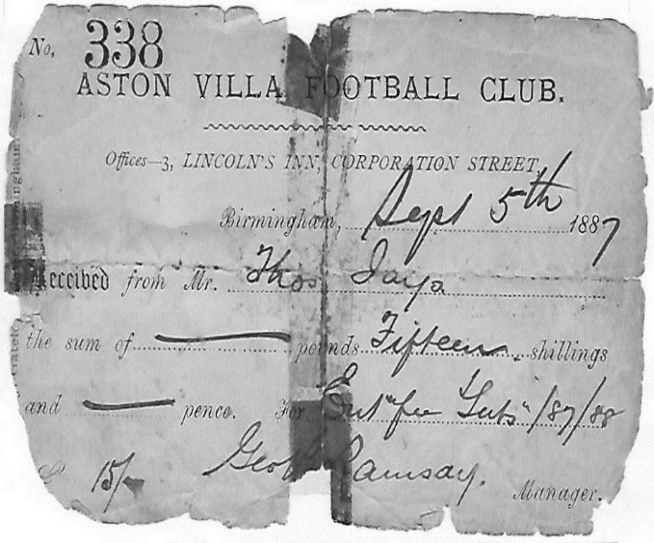
To attack their singing seems somewhat irrelevant but, no doubt, Primitive Methodists were proud of their own particular style of community singing.
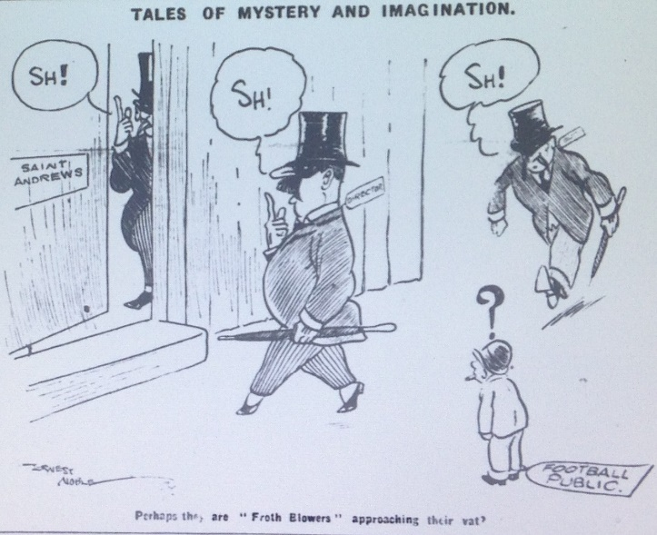
Birmingham Daily Gazette
At some point in 1927 Birmingham City F.C. decided to replace their coach and the secrecy (in the St. Andrews’ boardroom) surrounding his replacement was likened by the Birmingham Daily Gazette to a freemason-like Vat meeting of the AOFB. Plus ça change …, as they say! Forty years earlier my great grandfather had paid 15/- to George Ramsay of Aston Villa F. C. for the privilege of watching a handful of fixtures during the first season of a new league. I hope he got his money’s worth!
Froth Blowers Brewing Company
November was our best month of sales since we started. We have had to accept the lower prices of Wetherspoon’s and M & B in order to increase our sales potential, but they will remain a small element of our customer-base. Merry Christmas & A Happy New Year! finwood40@btinternet.com

