FRIENDS OF THE FROTH BLOWERS
NEWSLETTER No. 51 SUMMER 2018

As you can see I am gradually catching up with the seasons.

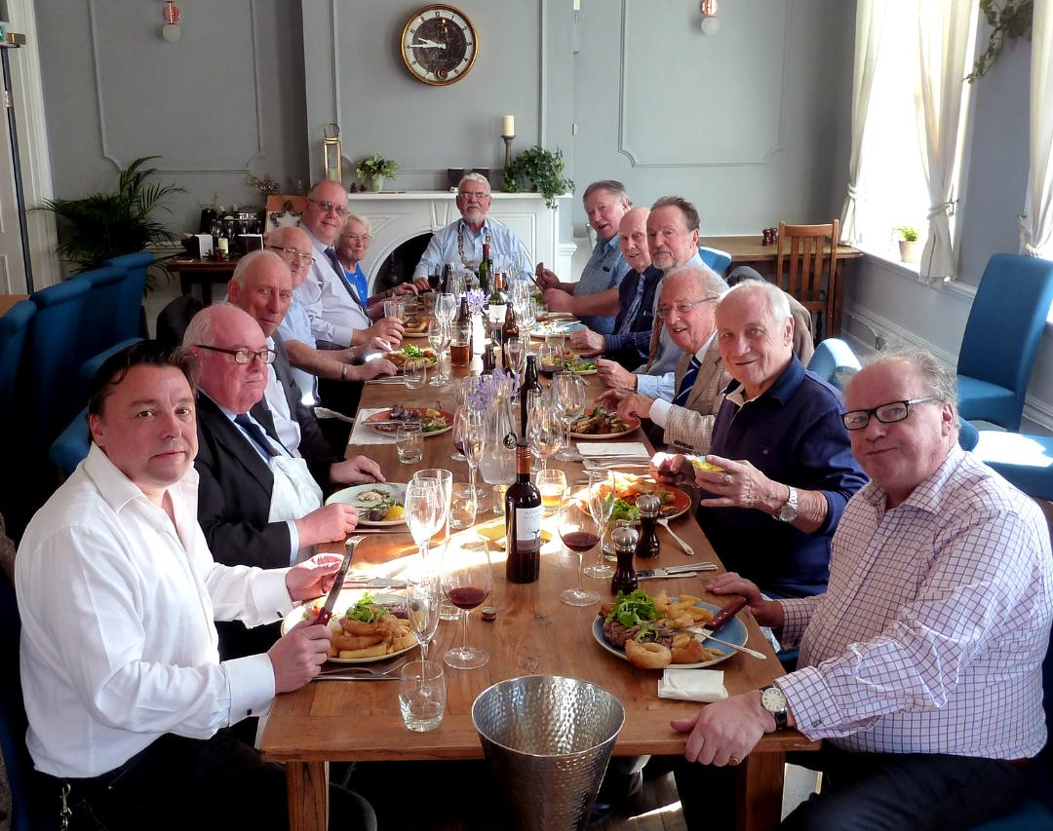
A HUNDRED MEN AND A GIRL! (Well, twelve and Jill)
Nobody ordered Curate’s Egg because the menu was somewhat limited - but we did get a version, nevertheless! This less-than-eulogistic start to my record of the 14th Annual Gathering of the Friends of the Froth Blowers held at the Coopers Arms, Chelsea, is not to say that the thirteen diners were unhappy or cursed by the presence of a Judas in our midst: if such a person was present then it was the fourteenth – the sublimely untroubled waiter who, when asked for port to go with the cheese, declared that the hostelry did not possess any. (We were told on leaving that, of course, it did – no less than three). To iterate further failings would give the impression we had a miserable time. In fact, it would have had to have been truly awful to dampen the enthusiasm of so select a group of FOFB’s – which it wasn’t. A few wines and beers at the bar – or, in some cases, en route – created the mellow mood of camaraderie typical of previous meetings. As can be seen, the upper room suited our purpose admirably: in my case a meal of seared scallops, rare-ish beef and a not-so-far-from-Eton mess washed down with a nearly-drinkable wine caused me to break into song. I was adeptly joined by a massed choir of eleven basses and a soprano in a fine rendition of the Anthem. Furthermore, £109 was collected in a tankard-cum-oast-box for the Acorns Children’s Hospice, Birmingham.
Thank you, Blowers! Happy Christmas – and see you next year, if not before!

Collectibles
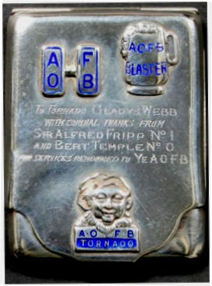
At the first gathering of the FOFB - in 2005 – FOFB Paul, now a cider-seller in Borough Market, brought a case full of artefacts to the Frothblowers Arms in Salisbury. These included a chain-of-office and a piffle-snonker: it was some years before I became the proud owner of such rarities. However, Paul later claimed that I had caused prices to rise because of the success, however limited, of the FOFB – particularly by the publication of books and articles on the subject. Looking at prices on eBay now, I would probably have to agree – sorry, Paul! (Perhaps Webmaster Ian will shoulder some of the blame!) Whatever-the-case, this case was sold at auction (not eBay) for £252 in 2007 – a snip!

Spreading the Word
I am just now looking back at early responses to Ian’s first website. The first five people to ‘Comment’ – Ian, Brian, Chris, me and Hannah – are still integral to the FOFB (Hannah being the accountant to the Froth Blowers Brewing Company from its inception, and previously – and concurrently for a time – accountant to the Ancient Order of Froth Blowers Girl Guide and Boy Scout Charity Ltd). A few months on, the late David Oxford wrote (from Australia), “I have Bert Temple’s silver tankard No. 0. It was given to my father in 1952 by the Gentle Zephyr.” The tankard now resides in North London. Shortly after this Richard Temple wrote, “Bert Temple was my great uncle.” Richard attended a number of gatherings a few years ago. Of course, Jill – Sir Alfred’s granddaughter – and John, her husband, attended the first Salisbury gathering and most of the intervening ones, including last week’s. Her cousin, Rex, and his late-wife, Caroline, attended a number of functions – as have other family members.
Given Bert’s somewhat aggressive attitude to America at the time – “pussyfoot hornswogglers from overseas “ - it is good to read how many modern Americans appreciate the AOFB - and Ian’s website. I particularly liked the comment by Charles De Vogel on 28th July, 2017, which reads more like an autobiography than a short appreciation – including, ”I wish to note in passing That I did NOT vote for the uncultured ignoramus currently befouling the White House.” Give the website’s Visitors’ Books a – first or second – look.

Froth Blower Brewing Company
With the departure of Louis, the Company looks even more like a family firm: as well as Neil, Andrew and myself, there is Emma doing 20 hrs @ week, Connor doing casual work and Sam making himself useful in the school holidays and at week-ends. Salesman Will is happy to be considered ‘family’ by us, too. The presentation bottle of Ned’s Wonder was much appreciated by those that drank it at the Coopers Arms: our cask-conditioned ale is even better and can be supped at the Brave Sir Robin, Tapping the Admiral, the Pineapple and one-or-two other North London pubs – and dozens closer to home, of course.

2019 Events (Movable feasts, some might say)

Saturday 16th of March: meet at 11.30 in the Wellington for a nearly-79th Birthday Trudge.
Saturday 25th May: Plaque-wetting at the Swan, Fittleworth - 12.30 p.m.
Saturday 26th October: FOFB Annual Reunion – lunch in London somewhere! D.L.W.

