FRIENDS OF THE FROTH BLOWERS
Newsletter No. 50 Spring 2018
Not Exactly Spring!
I feel an apology is owed by me to all regular readers of these Newsletters and, indeed, all regular attendees of events as neither has been evident in the last six months. I could blame the weather: it has either been too wet and miserable to think of southern jaunts or too hot and debilitating to do more than lie in the lounger and stretch out a hand for the glass that cools. However, this would be a poor excuse for not arranging outings and no excuse for not putting finger to keyboard (except for lack of ‘copy’). The fact is the older I get the more I seem to find ‘essential’ things to do.
Of course, running a brewery is a full-time job: the theory was that in getting young F.O.F.B. Will Hunt to work with us as a Director I would be able to take a back seat. In fact, ideas – of various merit – tumble out of his head and are turned into reality so rapidly that I find myself getting to the Brewery at 8 a.m., and then working in the office or delivering beer until tea-time or beyond and, on returning home, collapsing in front of the telly. Whinge! Whinge!

ANNUAL REUNION
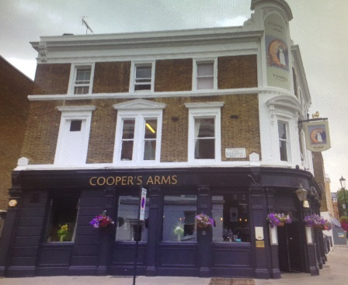
Saturday, 13th October, 2018 – Coopers Arms, Flood Street, SW3 5TB - 12:15-15:15
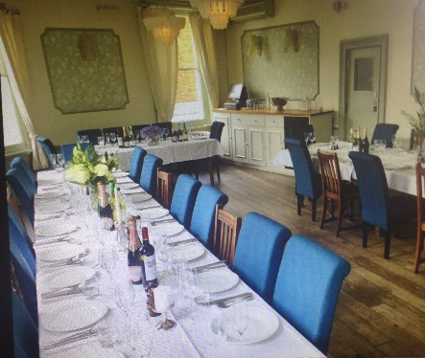
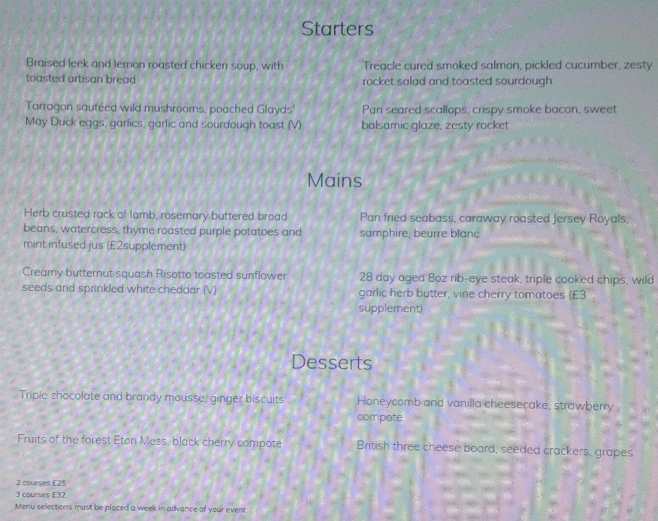
As Simpson’s-in-the-Strand want over £100 @ head to serve food to us in a private room, I have approached the Coopers Arms in Chelsea instead. I am prepared to risk the £100 booking fee immediately but their price is another £400 minimum-spend: so, for example, 20 lunchers would be liable for £25 each minimum. Unfortunately, the 20th October was not available so I apologise to those FOFB’s who have cleared it on their diaries! I, also, have to admit that the 20th was less convenient for me! (See pub website for ‘Private Party’ menu).
Given that 10 people might happily have £50-worth of food and drink on the day, I will only cancel if fewer than this number tell me that they can make it – by the end of the month, say.
r.s.v.p. a.s.a.p. Dave the Pain 07525 100644 finwood40@btinternet.com

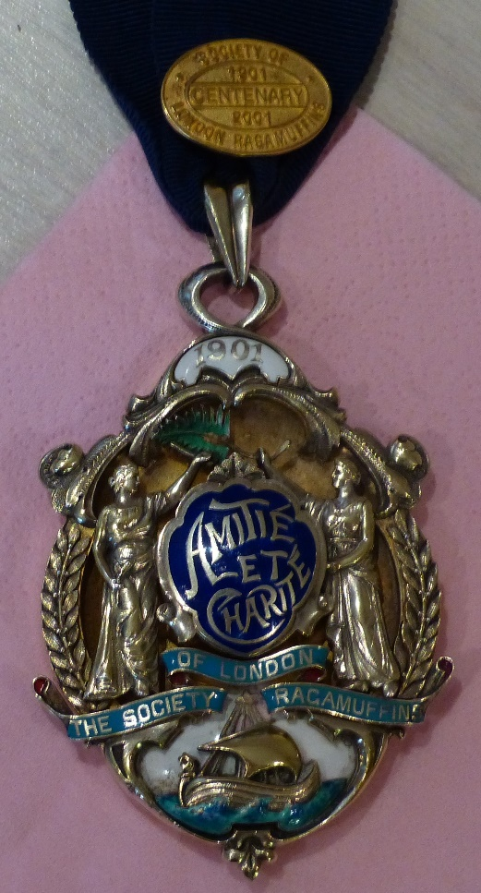
Jeff Jarman: SOLR, FOFB
The Society of London Ragamuffins Jeff in typical mode
I am well aware that others of our Friends have died in the recent past without a eulogy from me – and I doubt that Jeff would have wanted one – but, as I have known him and his family since 1992 and met his mother, Rose, and older brother, Rod, in 1944, before Jeff was born, I cannot let his passing go by without a word or two about him. He was brought up close enough to the old Arsenal ground to make it difficult not to be a supporter – which he was for the best part of his seventy years, even when living abroad. In fact Joyce and I met him, Eileen, Hannah and Laura in Singapore because my mother had kept in touch with Rose who told us that Rod’s brother, Jeff, was working for Shell there. In fact, he was more than just another Shell employee; he was “a Titan of tanker chartering, inspirational leader, coach and devoted family man” as one of his colleagues wrote. He was obviously a great colleague but he was an even greater husband, father and friend: capable, caring and generous. It was a pleasure to be in his company, and an extra pleasure to me that, by chance, he and I linked two old London-based charities together: the Society of London Ragamuffins and Ye Ancient Order of Froth Blowers. My only regret is not having been able to spend more time in his company.

The Brewery
The Froth Blowers Brewing Company, while still not having to pay Corporation Tax, is becoming more widely known – thanks to Andrew’s excellent beer, Neil’s interpersonal skills and Will’s energy. We now have a charity link with Acorns Children’s Hospice and are sponsoring Birmingham Moseley’s Women’s Rugby team.
D L Woodhead - September 2018

