FRIENDS OF THE FROTH BLOWERS
Newsletter No. 49 Winter 2018
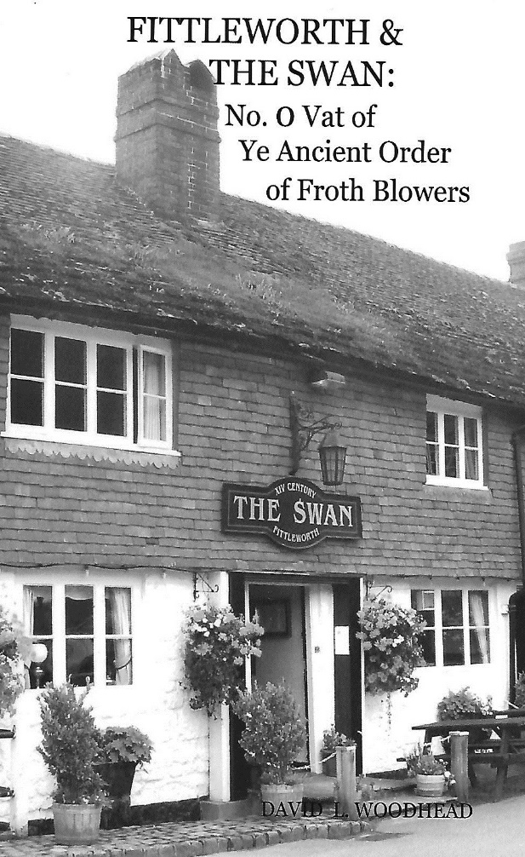
Another Booklet
I have a collection of dozens of postcards, photos and prints of Fittleworth so I decided to write a – mainly pictorial – history of The Swan and its surroundings in the period circa 1860 to 1960, but including a section on the Friends of the Froth Blowers from 2006 onwards.
I always order ten copies of any book for family and friends to read so that they can act as unofficial proof-readers. Should any FOFB wish to have a copy then a payment of £5 and an address will secure them one.
I begin with acknowledgements and then explain how I became interested in the A.O.F.B., followed by an account of their part in the Swan’s story. After this I use the various pictorial records to show the attraction of Fittleworth to all sorts of people. I finish with the visits made by the Friends of the Froth Blowers and a mention of the Brewery, with my use of Bert’s whimsies to when naming the beers.
However, I will record an extract here - part of a newspaper report of the time that throws light on the relationship between Monsoon Oliver and Bert Temple:
from The Observer and West Sussex Recorder, 16th March 1927
Bert Temple’s “Home From Home”
“The Swan” has a special interest for members of the Ancient Order of Froth Blowers. Mr. Oliver is a great friend of the founder of the movement, Mr. Bert Temple, who regards the place as a home from home, and he has now risen to the rank of Monsoon. The vat is the first to be established in the country. Prominent Blowers and Fairy Belles are frequent visitors …
A month earlier the correspondent had written
Where Bert Temple Can Be Met
Every local “Frothblower” is familiar with the name of the now famous founder of the “Ancient Order,” but how many have yet met him personally? It is not generally known that almost every Sunday Bert Temple can be found at a place of refreshment only half-an-hour’s motor-run from Chichester, namely The Swan Hotel at Fittleworth …
After a serious operation performed by Sir Alfred Fripp, Mr. Bert Temple came to stay at the Swan Hotel, and there with Mr. Oliver discussed the possibility of raising a raising a little money for the charities of Sir Alfred Fripp was interested in, as a mark of appreciation … Thus the great Order was launched.
A taster!
Earlier Publications
Most of you know that I have written short – and not so short – books on various subjects, not always inspired by Froth Blowing. A few of them have been spin-offs from my fascination with the life and times of Sir Alfred Fripp, such as one on his major part in the reform of the Royal Army Medical Corps.
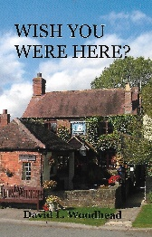
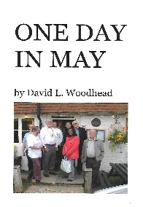
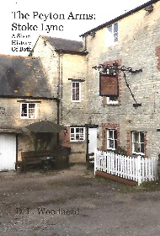
Another is on the parallel lives of Fripp and Sir Frederick Treves and yet another on the life of his famous colleague at Guy’s Hospital, Sir Edwin Cooper Perry. I have nearly finished a full account of Fripp himself. Of those below I should say that by “Craft” I meant only that they were the new breweries producing ‘real ale’ in 2010, that Wish You Were Here? is of 100, mainly rural, ‘gems’ (with another 100 nearby pairings) and One Day In May was of a specific record of one plaque-wetting outing from Birmingham to Fittleworth and back.
Ned’s Wonder
Froth Blowers Brewing Company have joined forces with the 80’s Stourbridge-based amalgamated band, Ned’s Atomic Wonder Stuff, and produced a 4.1% beer named Ned’s Wonder. 5,500 bottles will be on sale at their various O2 venues for their UK Tour in March. Some has been put in casks for our regular customers to purchase.
For those of you who drink in London, the Pineapple, Rose & Crown and Southampton Arms in Kentish Town sell our beers as does the Gatehouse in Highgate, the Bell in Walthamstow – and one or two others, including the Hole in the Wall in Lambeth. That wonderful pub off Junction 2 of the M40 – the White Horse at Hedgerley – stocks our beers, too.
Werrington Vat
Over the first week-end of March, Steve Williams will be hosting a 55th Birthday bash at the Frothblowers, Werrington – now the in-place in Peterborough for the discerning drinker (No.1 bus will take you there).
Froth Blowers at Sussex Vats
Bob Oliver continues to keep the flag flying in Sussex whether on ‘official’ occasions or merely ‘blowing the froth.’ As I understand it an official meeting will take place on Wednesday evening at the Brewers Arms in Lewes, starting at 6.30 p.m.
The Brum Trudge to Warwick: Saturday, Match 17th
In my last post I suggested a bus-trip from the Wellington. However, of the few places that serve our beer all the time – the Wellington itself, the Broomfield in Coventry and the Pickled Crab in Warwick – the latter is the only one to serve food: fine-dining, in fact.
Apart from the Pickled Crab, Warwick has four or five other good drinking hostelries within easy walking distance of each other (we don’t have to trudge from Birmingham).
London (Marylebone) to Leamington Spa : Leamington Spa to Warwick (Central, not Parkway) is inexpensive (c. £15 return) and reasonably frequent (10.40- 12:12.01/12.33 (10 mins).
Trudge: Warwick Station – Wild Boar (Slaughterhouse tap - leave 1.15) – Punch Bowl leave (2 p.m.) – Rigsby’s Cellar Bar (leave 2.45) – Old Post Office (leave 3.30) – Pickled Crab (leave 5.30) – Station.
Should anyone wish to come to Birmingham and be driven to Warwick and back this could be arranged (11 a. m. in Wellington, Bennetts Hill) contact: 07525 100644
I need to know numbers for food at the Pickled Crab – 4 p.m. to 5.30 p.m. – a shared platter of fruits de mer would be on offer (c. £20 x 2) but simpler shellfish, fish and other delights, too.
The 14th Annual Gathering: 20th October, 2018
If Simpson’s-in-the-Strand are prepared to give us a reasonable rate for a room this year, I would still prefer to meet there. Of course, I was not originally intending to make this venue the annual one but it is ‘traditional’ and it is central. I’ll keep you posted. D.L.W.

