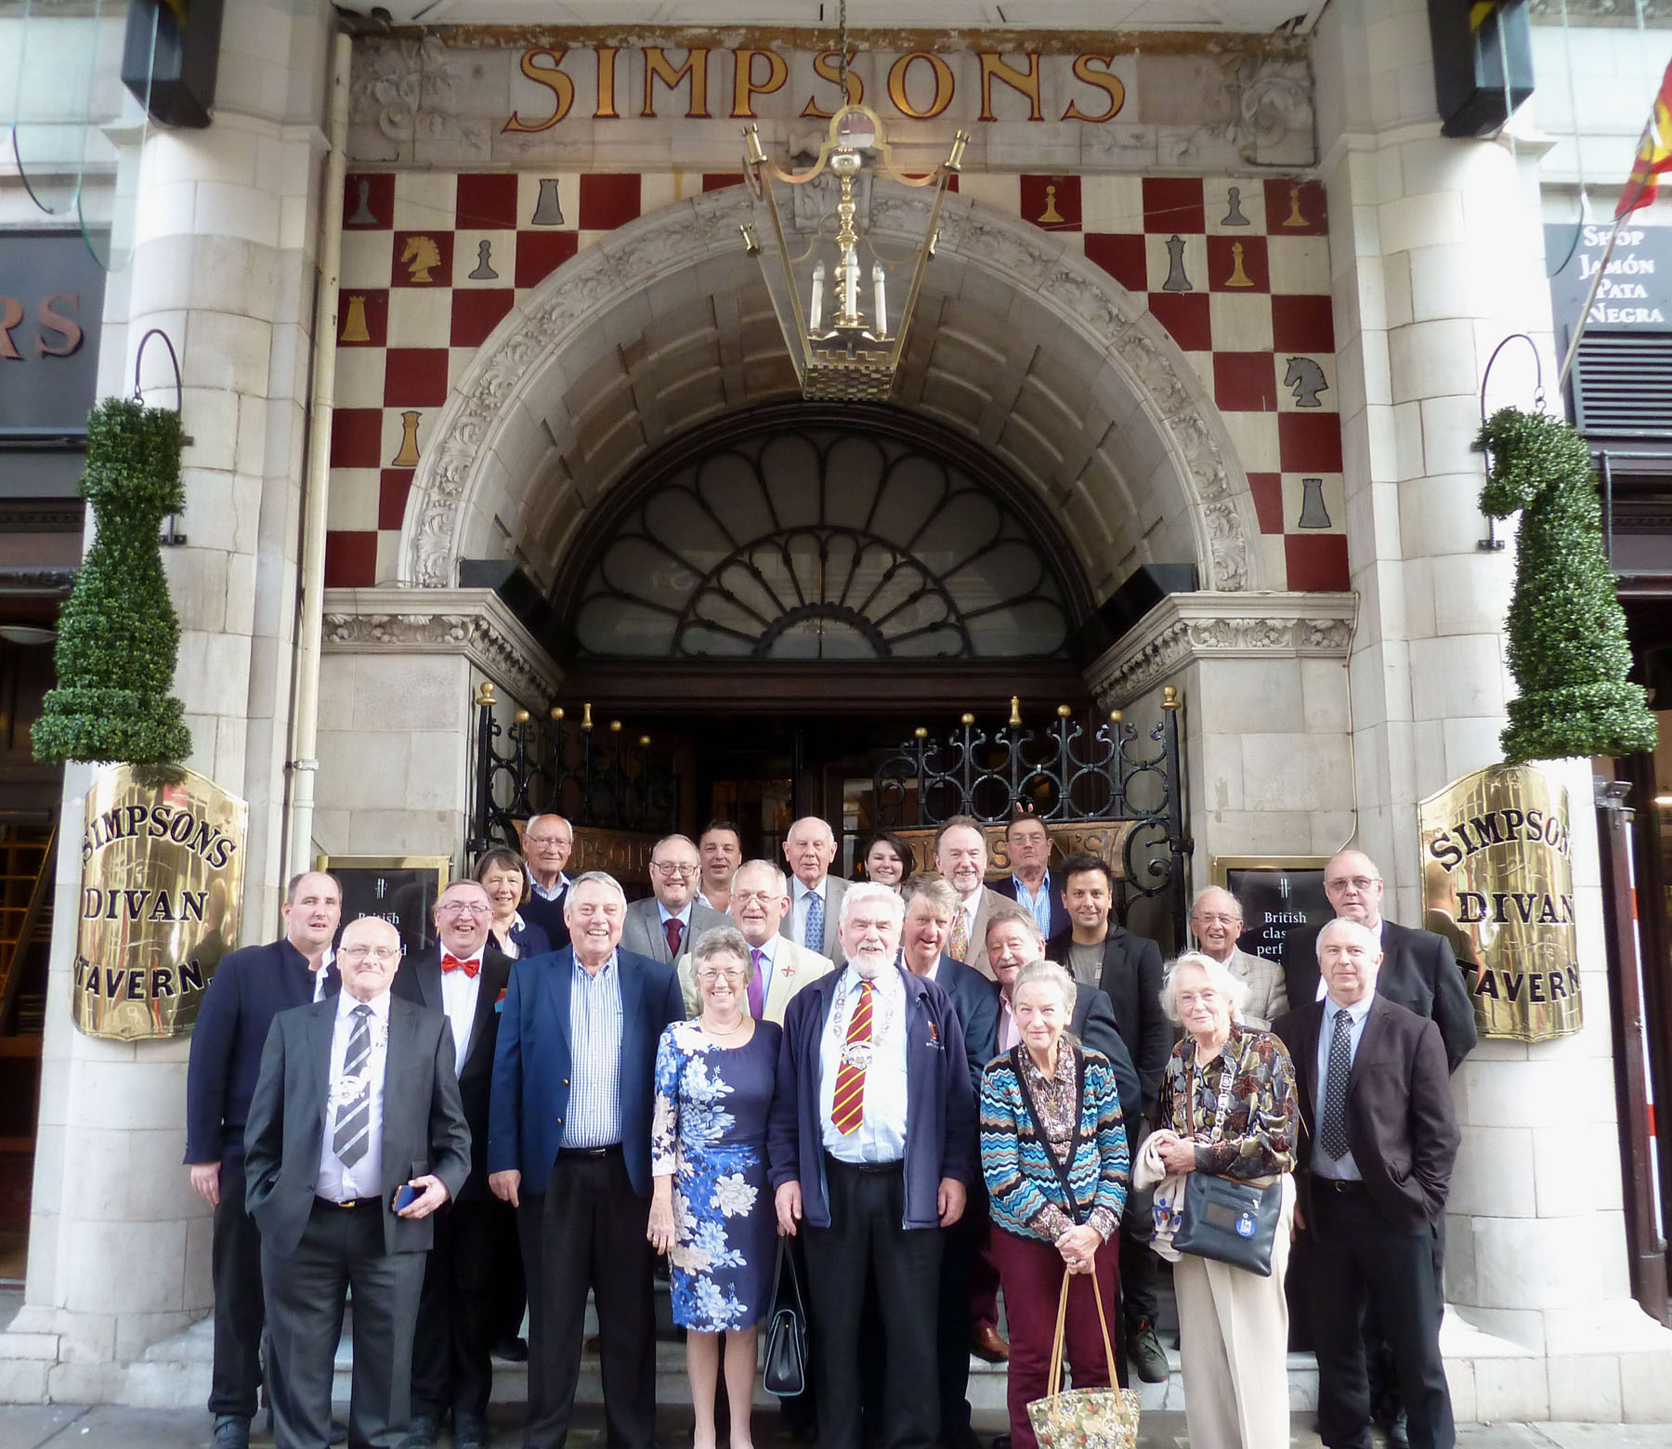
FRIENDS OF THE FROTH BLOWERS
NEWSLETTER No. 48 AUTUMN 2017
The More We Are Together …
We seem happy enough. I certainly was at this point; and not just because I had had a couple of G & T’s and a glass or two of wine. I was just relieved that twenty Blowers and five Fairy Belles had turned up to fill the twenty-six places I thought had finally booked. I would particularly like to thank Ian for booking separately and for Brian, John and Steve for joining him – even if it was a fait accompli for the beer-baristas of Werrington. Of course, those pictured (or partially obscured) deserve my thanks, too, for risking possible disappointment and financial pain had the new owners ruined the traditional ‘Simpson’s experience’ - and apologies to those put off by the hourly change of plans!
Fortunately, there is nothing like a few drinks in a bar with friends to make the world seem a less worrying place; so, by the time we descended from the Knights Bar to the Grand Divan we were ready to take a less jaundiced view of foreign interference in a British icon. I would say that the actual fare was as good as ever - the beef being particularly tender and succulent, I thought. It was just a pity that, although each table seemed happily engaged in eating, drinking and being merry, we were too spread out for corporate conviviality.
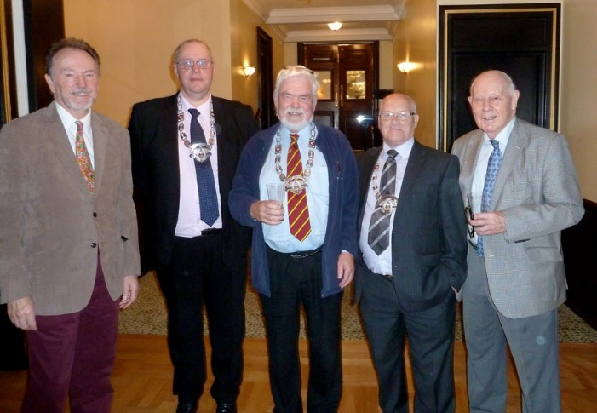
I cannot fault the staff for their service: good-humoured and attentive. They are particularly to be thanked for stopping the roar of London’s traffic – or at least a few pedestrians on The Strand – while they took this particularly pleasing record of afternoon out together.
John was busy with his camera in the Bar and managed to be in this one, he and Ivan flanking the Birmingham Chain Gang
I apologise for not joining the ‘youngsters’ in the Nell Gwynne but a pint or four of Hooky was calling me at the Peyton Arms – and very good it was, too!
Here’s to the next time!
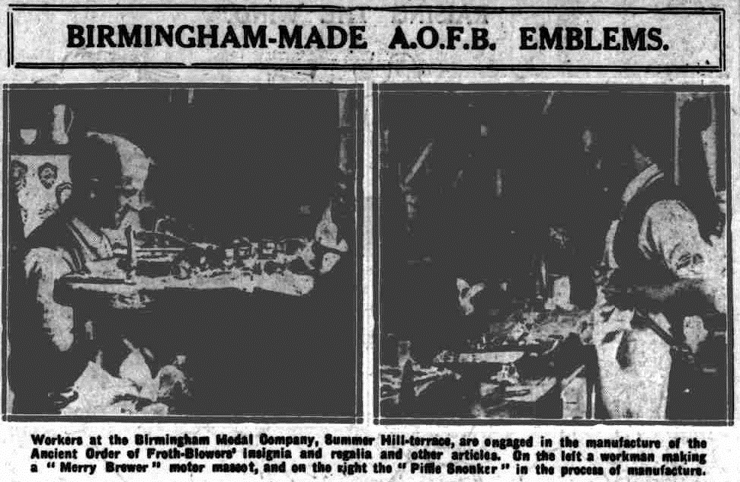
Ninety Years Ago
Ian discovered an article on the Ancient Order of Froth Blowers at the time of the major Vat meeting in Birmingham that included a photograph of the event and this of two workers actually making a “merry” – not “jolly” – brewer and a piffle snonker.

2018 Events
17th March, my 78th birthday: a 12-seater “Auto Outing For Blowers,” starting from the Wellington, B2 5SN, at 11 – my treat, first ten ‘definites’ only: return by 6 p.m.
13th May - Plaque-wetting: Swan, Fittleworth – 12.30 p.m.
20th October - Annual Reunion: t.b.a.

