FRIENDS OF THE FROTH BLOWERS
NEWSLETTER NO. 47 SUMMMER 2017

NEWS
This has been a quiet year for the Friends of the Froth Blowers – possibly because a number of the stalwarts have been busy doing other things. I, having employed Will the Son of Wizzard to sell beer for the Brewery, have found myself rushing round the country dropping and picking up casks; Steve the Pub History Man, now Steve the Frothblowers Micro-pub Man as well, only has time to go on holiday every other week; Ian has been busy downsizing; and Hannah and Heather’s marriage kept them away from for a plaque-wetting that never happened. Even Simpson’s threw a spanner in the works by refurbishing the Grand Divan just when I wanted to book tables. I will try to get back on track next year.

The Froth Blowers Brewing Company
Will has increased our sales by around 30% since joining us: and anyone who wants a top-class singer-guitarist and a cask of top-class Piffle Snonker should hire him as soon as possible. We have a number of outlets in north London, the Pineapple in Kentish Town and the Gatehouse in Highgate being two regulars; otherwise, we have enthusiastic supporters in the Wellington in Birmingham, the Broomfield in Coventry, the Plough in Worcester and the Scruffy Dog in Sutton-in-Ashfield. Many others re-order frequently – especially in and around Derby, such as the not-to-be-missed Barley Mow in Kirk Ireton.

Vats
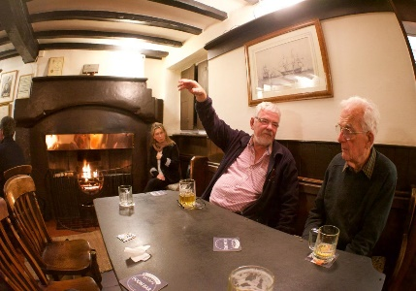
The Sussex Vat continues its activities, both formal and informal, thanks to the energy and enthusiasm of Bob. There may be a new Vat in San Luis Obispo, California, if Charles the “Clamper” has his way (view the FOFB website Visitors’ Book). The Singapore Vat has lost two of its core members, Scott and Eriko, by their move to British Columbia, but Blaster Dave keeps the flag flying with gusto. He and his wife spent four days with me last week on a whistle-stop tour of major oaks, castles and various hostelries.

12th Annual Reunion of the Friends Of the Froth Blowers
Overleaf is the menu available to all those special Friends who are able and willing to join me in the Knights Bar of Simpson’s-in-the-Strand from noon on Saturday, 21st October, 2017, the meal to take place in the newly-refurbished Grand Divan at around 1300 hrs.
Please let me know A.S.A.P. of your desire to attend, with names of guests.
Pay as you go.

