FRIENDS OF THE FROTH BLOWERS
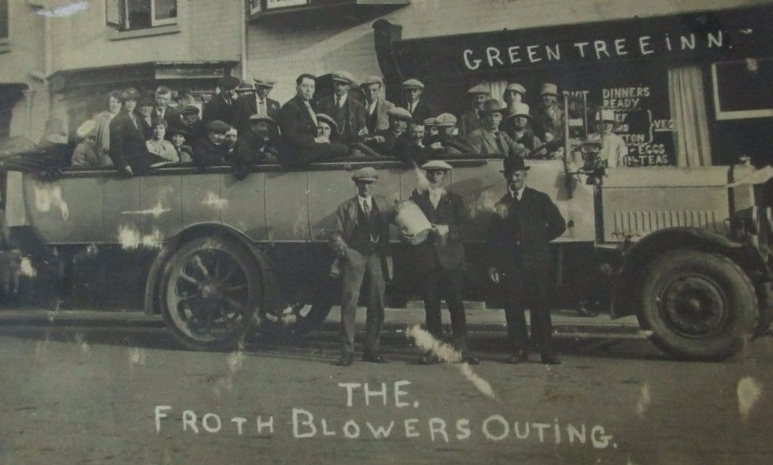
NEWSLETTER NO. 46 SPRING 2017

FOFB Outings
The only Green Tree I know is the one in Bath but this looks fun wherever it was. Sadly your Chairman has been unable to arrange an outing such as this in recent months – even one in a car holding a maximum of five people. Furthermore, I have postponed the Plaque-wetting at the Swan in Fittleworth on two or three occasions so far this year. If nothing else crops up I aim to take lunch there on Saturday 22nd July: I will keep Ian the Webmaster posted, so look on the FOFB site nearer the day for an update.
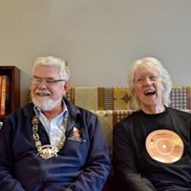
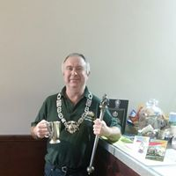
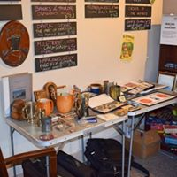
One outing that did take place was to Werrington: if you remember this is where FOFB Steve and friend, John (who is an honorary FOFB whether he likes it or nor), have spent productive time and money transforming a place for fake tans into a place to take fans - of real ale and cider. Members of the Birmingham Vat – with their artefacts - met up with those of the Tewkesbury Vat at the Werrington Vat to spread the word and drink Froth Blowers beer.

The Froth Blowers Brewing Company
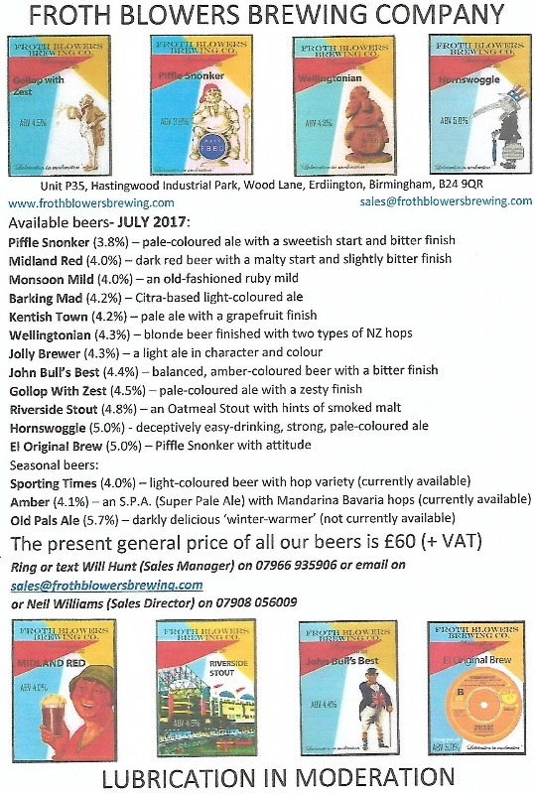
I make no apologies for using this space dedicated to Friends in order to advertise the products of the eponymous brewery. Those of you who have been FOFB’s for four years or more will have been in at its birth in October, 2013, and its conception a year before that. We have now moved the smaller kit along-side the larger one, so now we have the capability of brewing anything from a ten-firkin-brew to a seventy-firkin one (and we still have the two-firkin kit we practised on way back in 2012).
In order to increase sales, Will Hunt – of Ye Ancient Order of Froth Blowers Band (and Bill’s son) – has agreed to work for us in the capacity of Sales Manager. He has already increased our trade and has had set up a new, improved website: www.frothblowersbrewing.com.
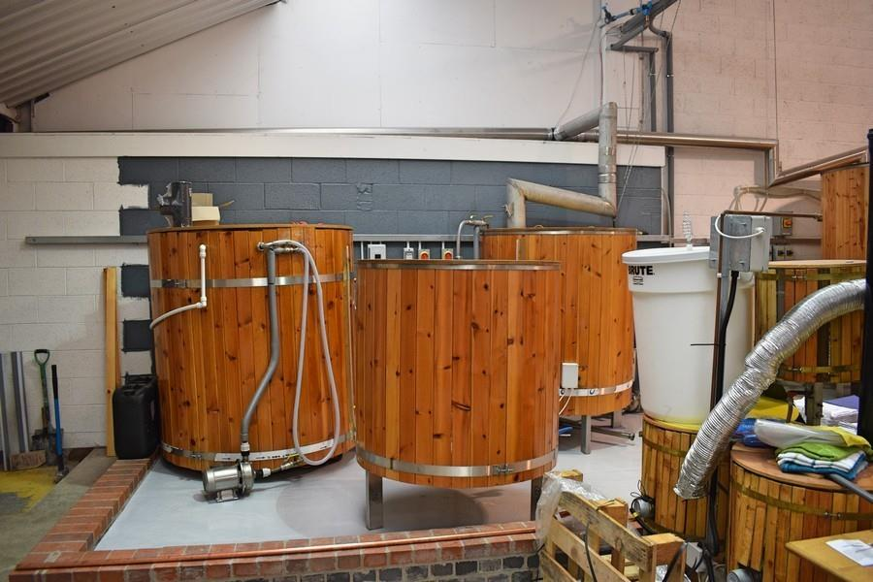
His friends own pubs in London – particularly in the Kentish Town area – and our beers are to be found in their pubs regularly (see “stockist” list on the website). Added to this AVS Wines & Beers of Gravesend have had three deliveries of our beers to distribute in the London area – and have already suggested to CAMRA that they take three 18’s of our Piffle Snonker for the GBBF in August: we are keeping our fingers crossed while awaiting to see if we get a firm order. Some of our customers have become major fans of our beers in particular, Adrian Stone of the Alestones Micropub, Tardebigge (near Bromsgrove). He is expanding the pub into the next unit which he is going to call Froth Blowers Hall. So, now there is a Tardebigge Vat.
Any FOFB wishing to visit the Brewery – with its small AOFB museum and large carved Jolly Brewer – may do so merely by getting in touch with me through the website or my email: finwood40@btinternet.com.
Members of the Cambridge University Cricket Club Vat (the Pat Vat) are taking on the other place at Lord’s today. This is a 50-over match. I wish them luck!
Tipplefair
This will take place at the Peterborough Beer Festival on Saturday, 26th August, where Steve the pub historian/Frothblower barman/husband of the honourably First Class Debbie will be in charge (slightly over-the-top phrase). As Debbie’s degree is in Sociology she will be able to explain to him why Lev-Strauss is not waltzing in jeans.
Events
Saturday, 22nd July: I shall take lunch at the Swan, Fittleworth. I hope you can join me. (Room for three in my car).
Saturday 21st October: 12th Annual Reunion at Simpson’s-in-the-Strand. All those wishing to attend this majestic function get in touch with me – preferably by email or mobile which is 07525 100644. Dave the Chain

