FRIENDS OF THE FROTH BLOWERS
NEWSLETTER No. 45 WINTER 2017
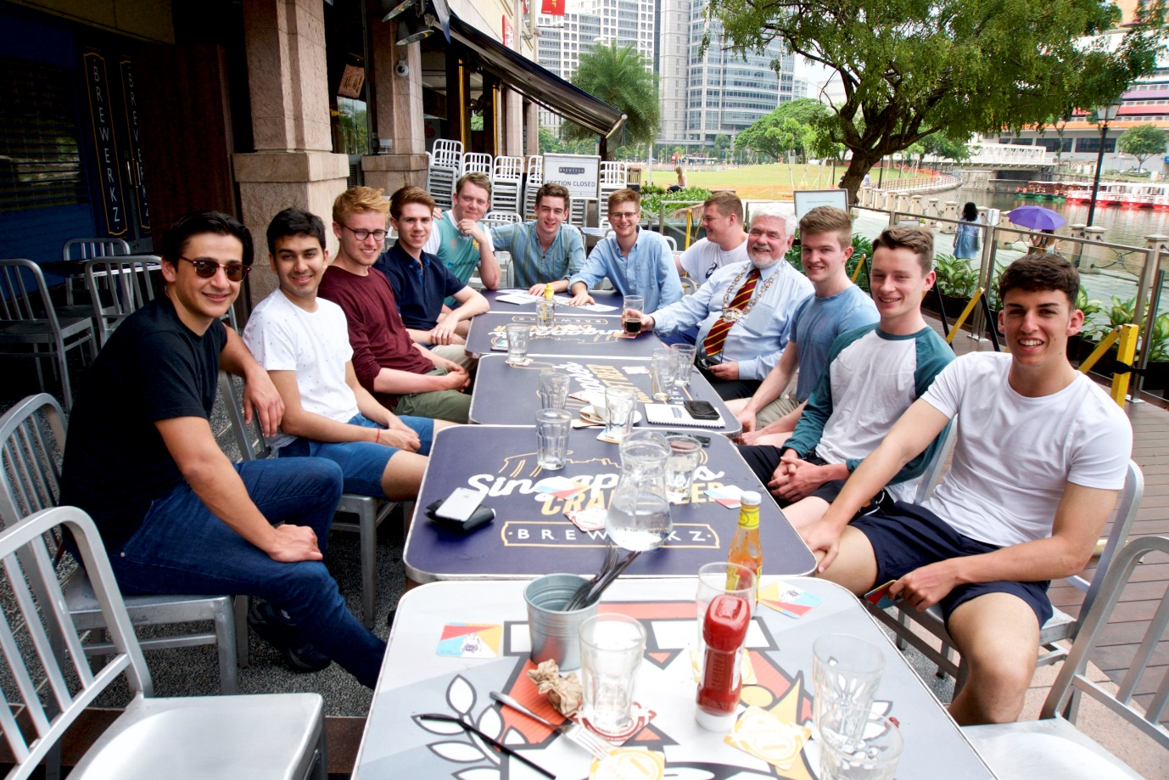
The More We Are Together The Merrier We’ll Be!

The Cambridge Vat
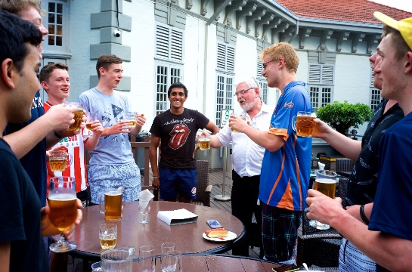
The initial gathering of members of the Sing Vat and fourteen members of the touring party was at the Brewerkz brewpub, opposite Clarke Quay - where the night before most of those pictured (myself excepted) had been unable to sink into the depths of the debauchery they had had in mind due to a lack of hell-holes open at two o’clock on a Friday morning. Despite this failure to sin in Singapore, a number of tourists were conspicuous by their absence at breakfast the following morning regardless of its generous 10.30 deadline. Most did manage to attend the 1.30 p.m. lunch on the north bank of the Singapore River – maybe, because it was provided free-of-charge by the management. As my friend, Dave the Senior Blower, is seeking to enrol 100 members - and, thus, become the only modern-day Tornado – their names have been forever inscribed in the pages of the Sing Vat; but I see no reason why they should not have dual nationality. Although the gentlemen assembled on the roof of the Singapore Cricket Club have been officially inducted into the Sing Vat, it would seem appropriate for them to be regarded as the founder members of a Cambridge Vat (or, if we take their cuff-link-holding captain to be the Senior Blower, the Pat Vat). It is particularly heartening to record that their renditions of the Anthem, after a rather too mellifluous start, became more acceptable on the second day when familiarity and moderate lubrication achieved the suitable degree of raucous freedom of expression so typical of an Englishman – and the occasional odd Irishman. The least said about the cricket the better!

Pre-Cantabrigian Times
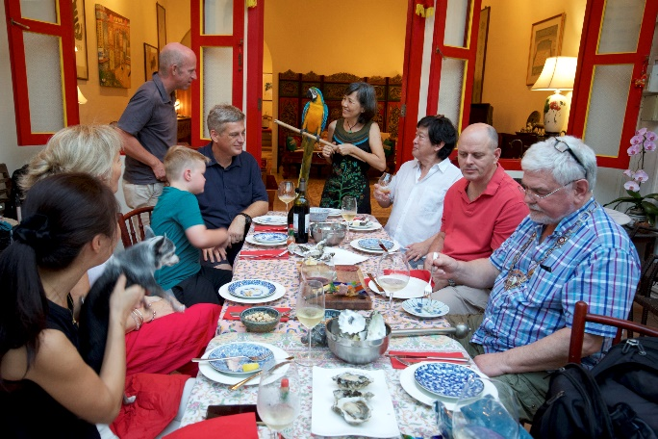
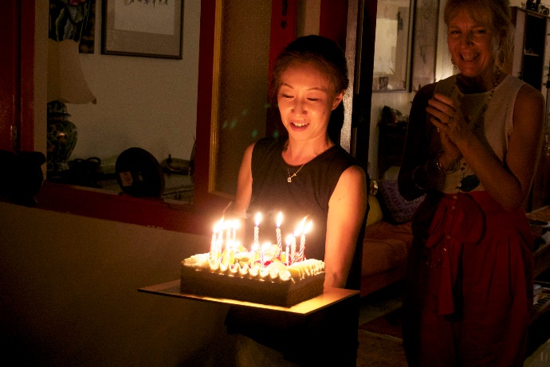
I arrived in Singapore on Friday, 17th March. Those who have taken part in a Brum Trudge may know that this is the day on which I was born, consequently Kim and Tang put on a party supper for me a few hours after my arrival.
I am pretty sure there were not 77 candles on the cake so this Blower was able to rise to the challenge and extinguish their flames: I wish to do the same again a few more times.
This party was followed up the next day by a fish-head-curry one at Ted and Felicity’s. What friendly Friends!
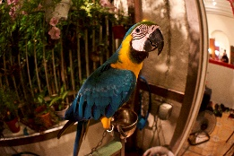
More generosity was to follow as I was invited, while they were on holiday, to live in Kim and Tang’s house, ostensibly to look after the dog, Charcoal, and the birds - in particular, the Macau. In fact, Fay – the home-help – was in charge of these duties. However, a dramatic incident occurred when she was working elsewhere. A day or two after I had moved in, I heard a crash from below and when I reached the kitchen, I found the water-bowl and its metal holder on the floor, water everywhere and the Macau hanging upside down. Its tail feathers were pointing in different directions and its claws were firmly gripped on its chain. It was only after I had received a flesh wound from its beak that I reached for a tea-towel, gripped its neck, untangled its feet and sorry-looking tail from the chain, and restored it to its perch. Although in shock, we – the bird and I – survived the ordeal; but I don’t think it regarded me as its saviour.
By the end of the summer a Canadian Vat should have been established on the banks of Lake Okanaga in British Columbia. When their friends have selected a house big enough to offer them accommodation, Scott and Eriko will move there – possibly, to Peachland. Good luck to you both!

Home Affairs
The Brewery seems to have survived my absence, even to the extent of being able to have produced a brew in the re-sited 6BBL plant. Both kits are now side-by-side in Unit P35. Increased sales and decreased rates might make us truly profitable in the coming months: so far, we have only been able to ‘survive.’
It would help our sales if readers would visit hostelries known to serve our beers -particularly, The Pickled Crab Restaurant and Bar, Smith Street, Warwick, and The Frothblowers, Werrington, Peterborough, in both of which we have a financial interest.
The purchase of the Ancient Order of Froth Blowers’ vinyl record would also help.
On the 6th May, there will be an FOFB gathering at Werrington and on the 27th May the rearranged Plaque-wetting will take place at Fittleworth. DLW

