FRIENDS OF THE FROTH BLOWERS
NEWSLETTER No. 44 AUTUMN 2016
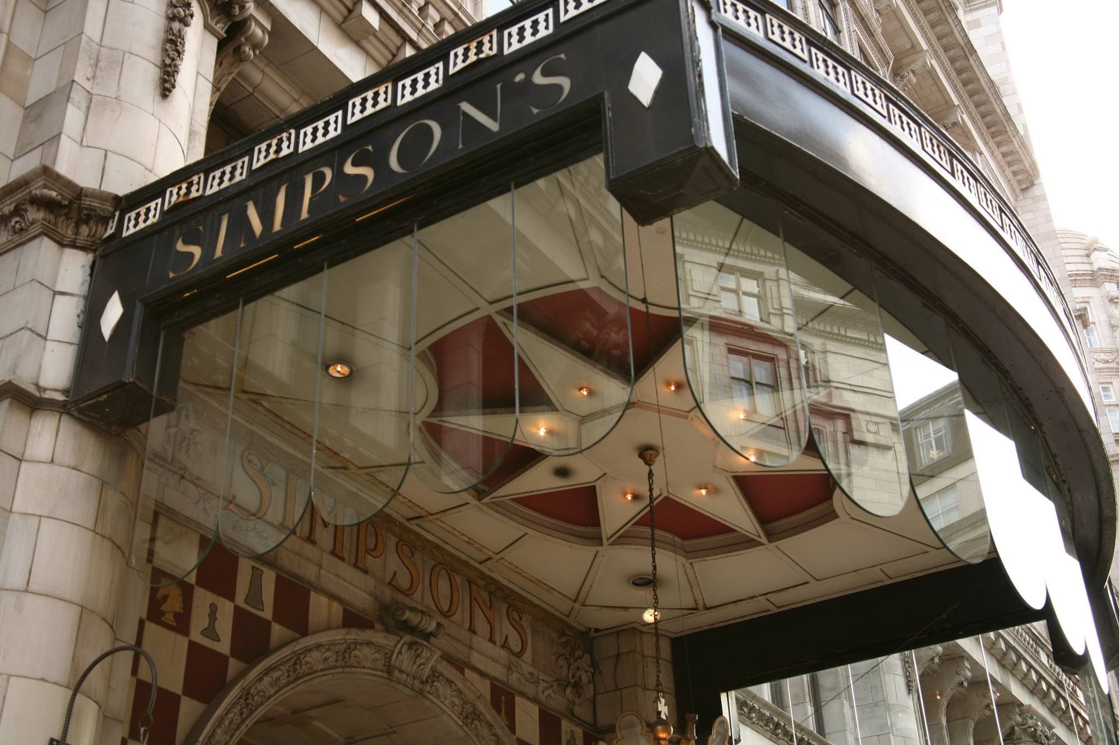
12th Annual Gathering
13th Annual Gathering 2017
Given that “at my back I always hear Time’s winged chariot hurrying near” (well, not “always”) it might be prudential to consider a similar meeting in October next year (especially as Simpson’s itself might be hearing Time’s winged bull-dozer by then). Those that “think themselves accursed they were not here” can keep, let us say, Saturday 21st October 2017 – four days before that of St. Crispin - free for a similar get-together: I expect to see those not accursed (and not overtaken by Time, including myself) next year as a matter of course, of course. My thanks to Jill, John (and family members), Rex and Caroline, and all who helped to make the 11th Annual Reunion (and, therefore, 12th Annual Gathering) of the Friends of the Froth Blowers such a memorable one.
Matters Arising
Frothblowers Micro-pub
As I reported in the last newsletter, in the Knights Bar (Birmingham has scrapped apostrophes so as a Brummie I am trying to get rid of them, too) FOFB Steve told us of his intention to open a micropub on the north edge of Peterborough called “Frothblowers.” It is his intention to order beer from the Froth Blowers Brewing Company on a regular basis and I, for one, am happy to deliver it. Within a few weeks of this letter, it should be trading – fingers crossed.
El Original Brew
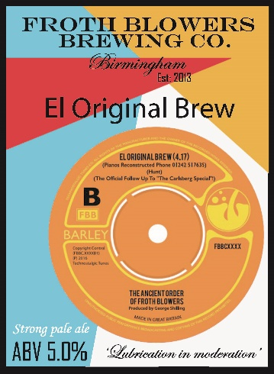
And again, FOFB Bill and FOFB Will told us that they were to be known, for the purposes of releasing a memorial vinyl EP, as The Ancient Order of Froth Blowers. The two sides are in the ELO/Wizzard style of the 1970’s – the Kentish Town Song is immediately downloadable but El Original Brew is on sale as a limited edition (500) one-off. Google “The Ancient Order of Froth Blowers Double B-Side” for instant access to the site.
We, the Brewery, are sponsoring the production of the disc and artefacts and since the music has already won plaudits I am sure this symbiotic relationship will suit us both. Will’s friends have taken a few casks of our beers with names based on the two titles and a few more have been sold in Cheltenham and Tewkesbury (where Bill and Fairy Belle Dawn live). Beer in Kentish Town is a new venture for us, although AVS Beers and Wines in Gravesend have distributed about twenty here and there.
The Grove Vat
Finally, another attendee of the Gathering - FOFB Steve from Tunbridge Wells – took four beers for his pub a few weeks ago (and every now-and-then will, I hope, take a few more). As far as I can tell, they hit the spot for most of his regulars.
The Sing Vat
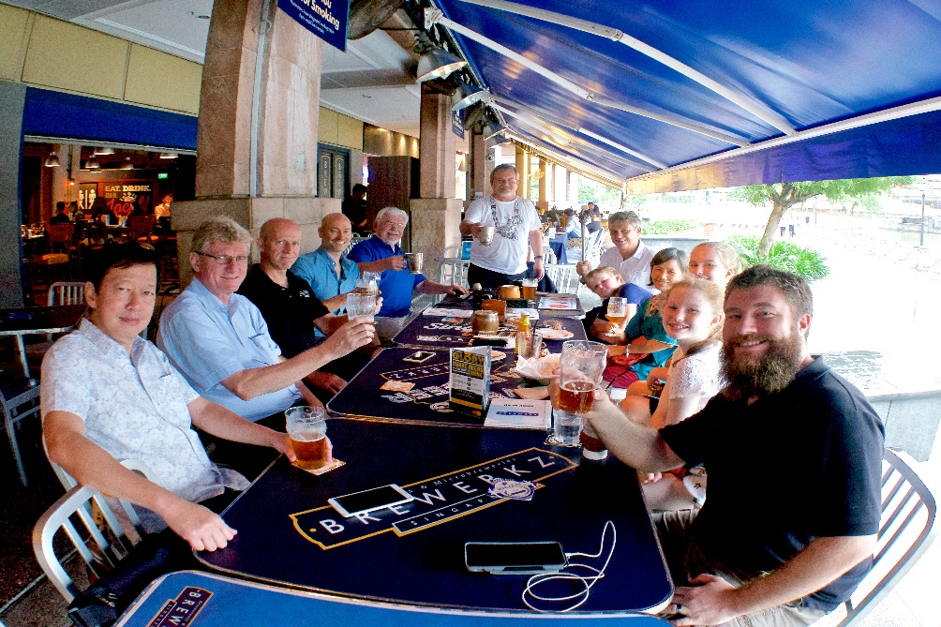
At the end of November I treated myself to a trip to Singapore, knowing that FOFB Scott and his wife, Fairy Belle Eriko, will be leaving for life in Western Canada next year. The picture is a record of the Vat meet-ing called by Blaster Dave (standing), the Senior Blower of the Sing Vat. On the left at the front is Tang, the Vice-Gargler. Close to $200 (Sing) was raised for Oxfam (Canada). I had already presented Blaster Dave with an Oast Box. He responded by presenting me with his recently-acquired but treasured possession, a copy of Ye Froth Blowers’ Annual. As this was at his and Debbie’s Thanksgiving Party the next day, it is particularly appropriate that I should give thanks in this letter. Dave – what a friend! What a Friend, too!
I hope to return in a couple of months time.
Events
My 77th Birthday falls on a Friday next year: so I hope that members will find time to celebrate the fact that I will be one day into my 78th year on Saturday, 18th March, 2017. Meet at 11 a.m for 12 noon at the Wellington, Bennetts Hill.
Plaque-wetting: on Saturday 6th May, 2017, at the Swan, Fittleworth: 12.15 p.m.
12th Annual Reunion: on Saturday, 21st October, 2017, Simpson’s-in-the-Strand: 12.15 p.m.
Chairman Dave, Wearer of the Chain, Holder of the Piffle Snonker & Custodian of the Annual.
finwood40@btinternet.com MERRY CHRISTMAS & A HAPPY NEW YEAR!

