FRIENDS OF THE FROTH BLOWERS
NEWSLETTER No. 43 SUMMER 2016
A.O.F.B. – NINETY YEARS ON!
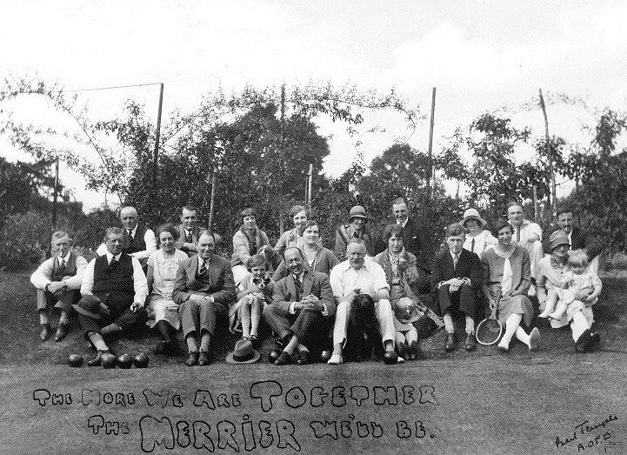
On 15th October, 1926, most of the people in this photograph attended the “Inaugural Dinner of the ‘Pink-Un’ Vat” in the Knight’s Room of Simpson’s-in-the-Strand. The drinks consisted of “Ye Foaming Ale from Ye Cask.” It has to be supposed that at some time roast beef was consumed and the gentlemen were allowed to light their ‘Froth Blower’ cigarettes so that “beer, beef and baccy” could take their rightful place in an evening of such importance. A delighted Sir Alfred Fripp, having already received £2000 from members’ fees and collections, was presented with a cheque for a further £1000 on the night by Bert Temple. “It was indeed a memorable evening and one which will long dwell in the memories of all present.”
F.O.F.B. – ELEVEN YEARS OLD!
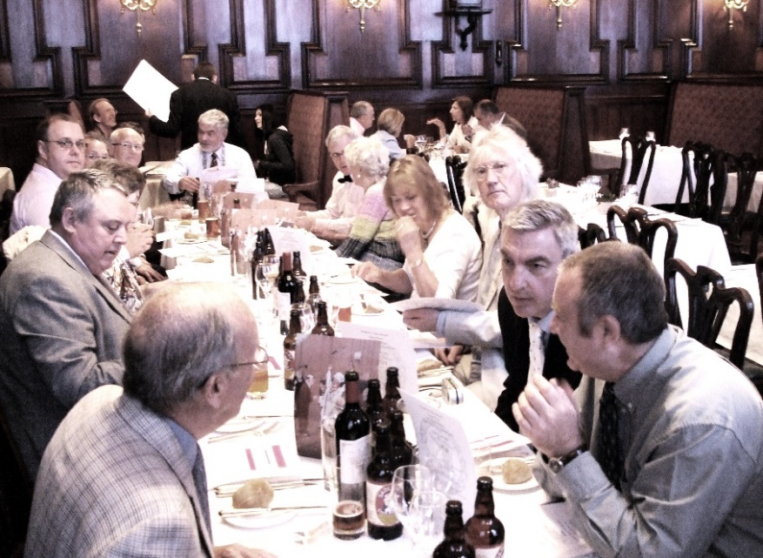
I could have put a photo of our first gathering, which ten FOFB’s attended in the short-lived Frothblowers’ Arms in Salisbury, if I had found it. John, Jill, Steve and I were there and are here. This is the 2009 group, over half of whom are here today. Many of those who were here two years’ ago have, also, returned. Jeff (on the left) and his wife, Eileen, wished to join us but decided her mother’s 100th birthday should take precedence.
So, welcome to you all, old and new - if we have a first-timer – old and not-so-old, otherwise!
LUBRICATION IN MODERATION, BLOWERS!
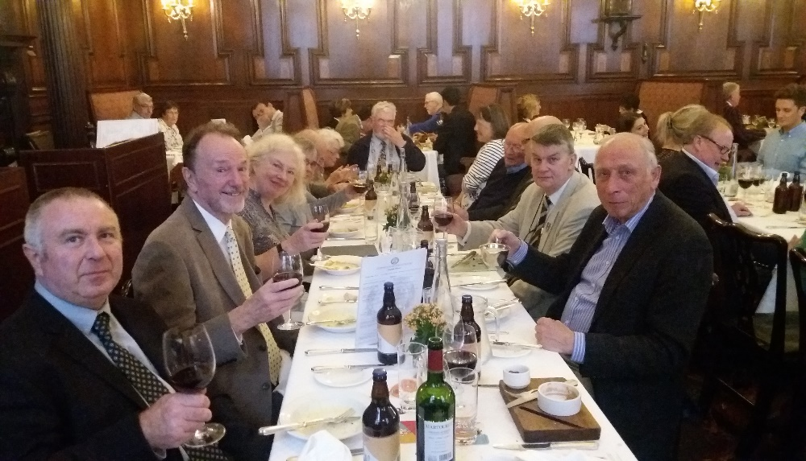
This year’s Gathering was a particularly con-vivial affair, spoilt only by this class-conscious report. However, do not take it to heart, you people of the OTHER TABLE, as the top person of the top table appears to be picking his nose!
Old and young-at- heart
THE BOTTOM OF TOP TABLE! left their habitual grumpi-
(OR HOW TO WIN FRIENDS AND INFLUENCE PEOPLE) ness at the door, fought
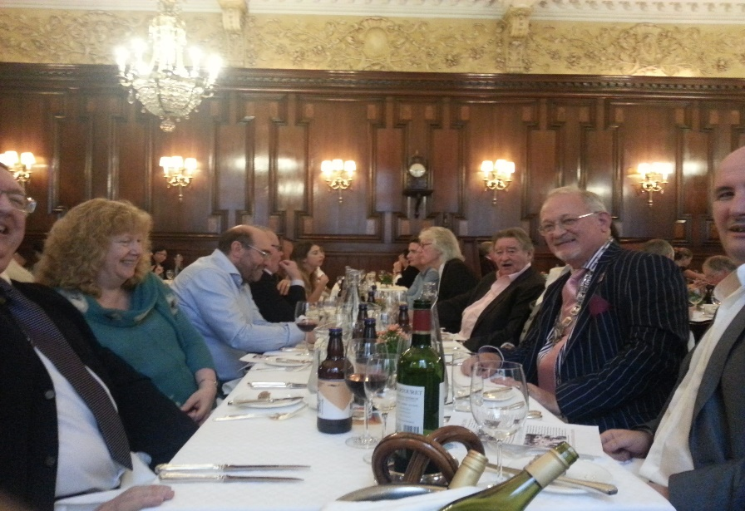
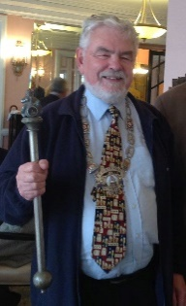
decorously for places at the groaning board, did not beef about the beef or whine about the wine, and even spoke to one another without a trace of geographical condescension. That all had imbibed a sufficiency – including ye fine bottle of Froth Blowers’ Ale – was demonstrated by the roof-rousing rendition of “The More We Are Together,” never, I doubt, sung so closely to the tune by any modern Blowers; this suggests that the presence of a number of Fairy Belles added the angelically choral element so vital for community singing. Border rivalries were forgotten as the Men of Kent from the not-to-be-missed Grove Vat sang in unison with the Gentlemen – and Lady – of the vibrant Sussex Vat; and those from north of the Watford gap refined their speech so that they could be understood by those less fortunately situated. All-in-all, another day to remember in the annals of the F.O.F.B.
Specific Announcements
Steve the PHS Secretary told us that he is close to signing a lease for a property at the north edge of Peterborough which he – with a little help from me – is going to turn into a micropub: The Froth Blowers.
THE BOTTOM OF THE BOTTOM TABLE!
Bill, a member of Wizzard with Roy Wood in the 70’s, is producing a limited edition (500 EP’s) of two works written by him and his son, in ELO style, to commemorate 40 years since he started with the band – and with the ELO. The band is performing as Ye Ancient Order of Froth Blowers. It is hoped that a profit will be made for disbursing to charity, so get your orders in!
Dates to Remember: None as yet, but Simpson’s (if it is still open) in a year’s time looks good.

