FRIENDS OF THE FROTH BLOWERS
NEWSLETTER No. 42 SPRING 2016

Regular readers might think that early June is a bit late for a ‘Spring’ edition but I can claim that this season should run from the equinox to the solstice – and, in any case, the general daily temperature scarcely reminds one of the fine summers of our youth.
The Froth Blowers Brewing Company
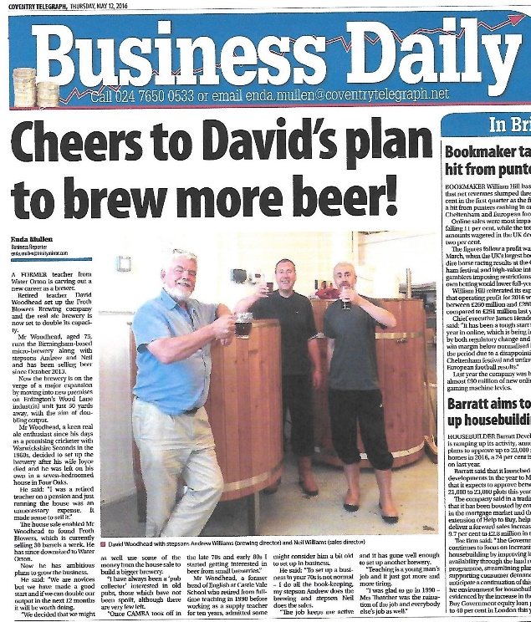
The move from the 6BBL brewery (capable of brewing around 24 firkins of 4% beer in one batch) to the 18BBL brewery in a Unit close to the original one has proved less than smooth. Having solved the problem of getting a floor with good, even drainage – by paying extra for one – we had no sooner completed our first brew than a fire raged overnight in a Unit two away from ours. If the wind had not been in the other direction, our new brewery – uninsured for such an eventuality – might have been destroyed, too. The whole area was sealed off for a week and, with the risk of asbestos contamination (still possible), our second brew occurred over a month after the first.
As temperature control, especially while mashing the grain and fermenting the wort, is critical, getting a brew three times the quantity as that produced on the smaller kit to behave in the same way has proved difficult. However, fingers crossed, we are getting there.
The Woodhead Williams Wander
This year the Brum Trudge was a no-goer (except that FOFB Bill, from Tewkesbury, took a bus-load of his local CAMRA group to visit a rather disparate collection of Birmingham pubs – the Bartons Arms and the Inn-On-The-Green being the principal ones). Instead, as no other FOFB’s were forthcoming, I picked up Mr. Peterborough Williams from the Lord Hop in Nuneaton and proceeded by a circuitous route to Rugby. Our first call was to the Pestle & Mortar in Hinckley where we had a happy encounter with Dr. Muggleton, F.O.F.B., author of many articles on beer, including a whole chapter of “Biographies of Drink: A Case Study Approach to our Historical Relationship with Alcohol” – entitled “‘Lubrication in Moderation’: Culturally Locating Ye Ancient Order of Froth Blowers” (downloadable). From there we managed to find the Elbow Room, an even newer – both historically and architecturally – Hinckley micropub. Both establishments gave the impression that they were there to stay.
At Wood Farm Brewery & Tap, just off the A5 near Willey, we stopped for a ‘pie and a pint’: the pie was tasty but the pint was so badly tasteless that I fed the patio foliage with it. So, our ‘Mug-A-Rugger-Trudge’ did not start as early as originally intended. It was worth the wait, however.
Having parked the car for the duration next to the Alexander Arms, we bought a couple of Atomic Brewery ales (I think) and sat in the garden supping at leisure. We found, in this order, the permanent beer festival that is the Merchants Inn, the curious micropub, The Rugby Tap, the old-fashioned Raglan Arms and the home of Atomic Ales, the Victoria. With things to do in the evening, I deposited Steve back in Nuneaton and headed home.
The Singapore Vat Visits Europe
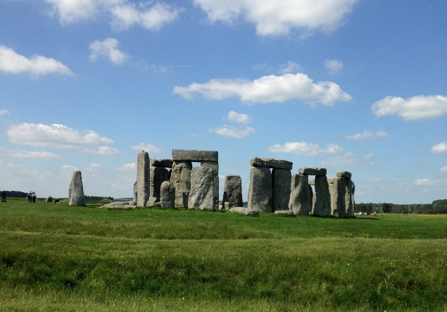
A month ago four members of the FOFB Singapore Vat – Scott, Eriko, Michael and Adele – visited England. We started our get-together by drinking beer at the George in Borough High Street and the following day ate Sunday lunch at Simpson’s-in-the-Strand. However, the plan was for me to drive them around Dorset and Devon before visiting the Cotswolds en route to Birmingham and, finally, Heathrow. So, on Monday I drove straight to the Stonehenge Vat – and was impressed by a commercial set-up that enabled the experience to be as enjoyable as possible in the circumstances. The weather helped. We then drove to Lulworth, drank beer at the Castle Inn, ate and slept well and explored the area next morning – including walking down to Durdle Door.
We drove into Devon and across Dartmoor in the afternoon - with the obligatory stop for refreshment – before reaching our rather isolated and basic resting-place on the edge of the moor with views towards Plymouth. Fish-and-chips eaten out of the paper while leaning against a church wall were followed by a pint in Cornwall, on the quayside at Saltash.
A long and somewhat wet drive through Devon and Somerset took us to Bath, where a pint in the unspoilt Star Inn and tea across the road in a church café sustained us for the rest of the drive. A pint or two of Oakham’s JHB and some Thai food at the Bartons Arms in Birmingham rounded off a long and tiring day.
On Thursday, after eating a Devon cream tea for breakfast in a canal-boat and watching two others negotiate locks in the heart of the city, we visited the Froth Blowers Brewery. However, as the main purpose of the day was to spend Scott and Eriko’s last evening in Mick the Hat’s, we set off for Stoke Lyne, with a whistle-stop tour of Warwick on the way. Four hours in the Peyton Arms, wrapped in cotton-wool by Mick, meant that we slept well that night.
The next day we said our goodbyes, having thoroughly enjoyed our trip – and each other’s company - while, metaphorically at least, blowing froth off a few pints of beer in exotic (and less exotic) bits of England.
Fittleworth
I realise I have left little room for the Annual Plaque-Wetting ceremony, but three FOFB’s from Brum and four from Burgess Hill had a pleasant lunch and short sing-song – despite some drama with the clutch of my (borrowed) son’s car: and the s-u-n shone, of course!
SIMPSON’S-IN-THE-STRAND
Sat. 8th October: 12.15 p.m. (Cost c. £50)
R.S.V.P. finwood40@btinternet.com

