FRIENDS OF THE FROTH BLOWERS
newsletter No. 36 autumn 2014

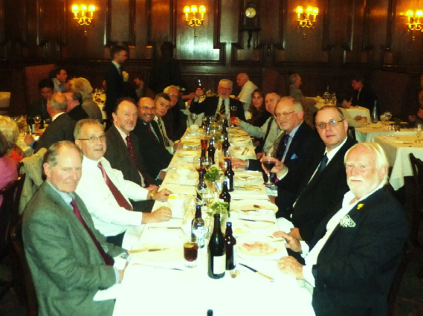 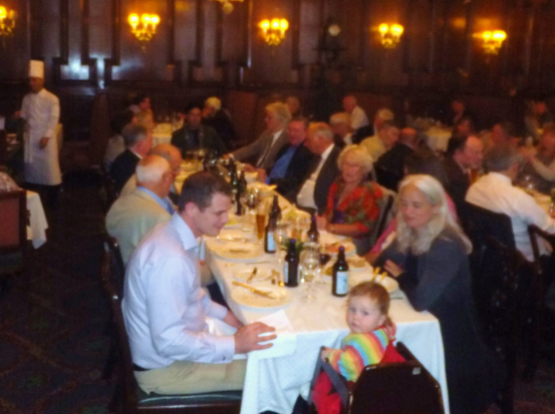 10th Gathering of the Friends of the Froth Blowers
HISTORIC F.O.F.B. FUNCTION
9th Reunion Lunch of the Friends of the Froth Blowers at
Simpson’s-in-the Strand on Saturday 13th September, 2014
* * * * * * * * * * * * *

“Its best friends could not have wished for a bigger, better or more cheery” gathering than that the

F.O.F.B. held, for the second time in five years, at Simpson’s-in-the-Strand. Those present - in

best bib and tucker - numbered twenty Blowers, six Belles and a baby who, while in no way one of

the ‘Wee Waifs’, seemed (generally) happy to represent them. I would like to thank Jill and John, Rex, Caroline and family for their support at this and other lunches: their direct link to the A.O.F.B. helps to make sense of the F.O.F.B.
Two other people I would like to thank for their attendance are Gordon and Jennifer. I am so glad that they were able to fit the F.O.F.B. Gathering into their schedule before returning to America. I hope they did not find us too sedate on the day – as we can make more noise – but I know that their congeniality accorded with ours.
Another thing that delighted me was the number of ‘first-timers’ present – about a third of our number. I hope that they become regulars.
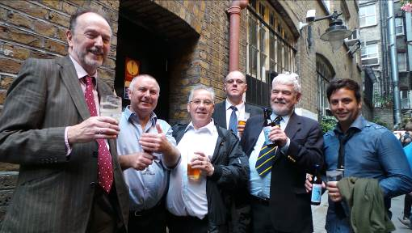
One final name I would like to single out is that of Nicholas (despite not having had much time to talk to him on the day). He had had published a well-informed article about the A.O.F.B. before I had finished my first short book (“Of Fripp and Froth Blowers”) on the subject, and was kind enough to read my proof copy, give sensible advice and the encouragement I needed to see it through to completion.
However, next time I book an F.O.F.B. lunch at Simpson’s I am not going to try to arrange things with the management as they try to throw spanners in the works at every opportunity whereas the Saturday staff, when the officers are all at home, agree to everything without demur. If the management, based at the Savoy, had had their way, I would have had to pay hundreds of pounds to book the Bishop’s Room and pay corkage on my own bottled beer. In the event, the staff, in their usual pleasant and helpful manner, went out of their way to make the event as relaxing and stress-free as possible.
Thanks to them and all who attended! I think I can call the 9th Reunion a memorable do.
Postscript
Six Froth Blowers were lured to a rendezvous
behind the nearby Harp pub in order to have a clandestine beer with the Editor of the Pub History Society’s publications. Keeping in the shadows, he managed to take this mug-shot of the gang.
Froth Blowers Brewing Company
I am pleased to report that the Brewery has had a very successful first year: we are still solvent and our beers are proving popular. Our first brew, Piffle Snonker, is likely to be on sale at the main Birmingham real-ale pub, the Wellington, as a regular - at least up to Christmas – and in kilderkins (firkins are heavy enough). The life-size Jolly Brewer has been added to our portfolio:
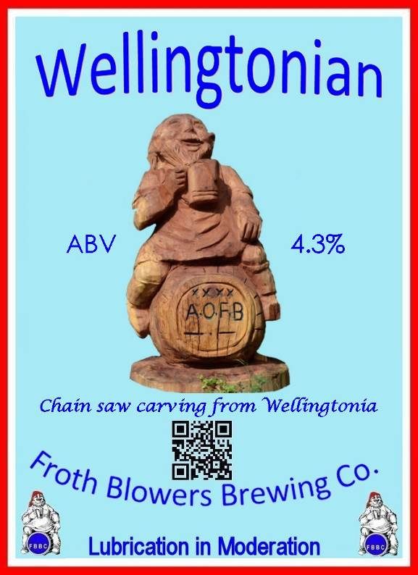
We sold 22 firkins in seven days: now we will have to brew some more and add it to Piffle Snonker, Gollop With Zest and Hornswoggle.
Pub History Society A.G.M.
The P.H.S. continues to provide the F.O.F.B. with space in its journal and time at its A.G.M. I arrived at this year’s meeting after my usual, but unintentional, tour of the area round the Hoop & Grapes. Edible food washed down by indifferently-kept beer was followed by a rapid appointment of officers led by Chairman, Dr. Darts (aka Patrick Chaplin, PhD). Messers (sic) Hoyle, Murray and Woodhead educated the masses for about an hour, a photo was taken and we all went home.
5th Brum Trudge: Saturday 1st Nov., 2014
Eight Blowers and two Fairy Belles foregathered in the Post Office Vaults at noon and made their way to the Old Contemptibles and on to the Metro tram nearby. This dropped us by the Black Eagle in Hockley, whence a fifteen minute trudge took us to the New Bingley Hall and the Birmingham Beer Festival. At this point your scribe was not feeling himself – or anyone else – but managed half-a-pint, two samosas and lamb curry and chips. An hour later, we ambled to the Red Lion in the Jewellery Quarter where one barman was at least one too few for the task, so we gave it a miss and walked up to the Rose Villa Tavern, a mish-mash of old tiling and a hundred years of D-I-Y ‘updating.’ Hurrying past the site of one of the Birmingham Medal Company’s addresses, and past the Queen’s Arms, to the Wellington, the company settled down to a final session before trains to Kent, Sussex (the following day) and Peterborough bore four of The Ten to their homes.
Froth-Blowers-at-Sussex-Vats
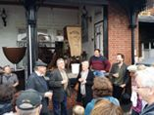
Two enthusiasts from Burgess Hill, Bob and Simon, have established the first proper Vat (i.e meeting regularly) since Richard set up his own variety in Shrivenham some years ago. If you Google frothblowers.co.uk you get the ‘mother’ Vat run by Ian in Birmingham; if you Google frothblowers.org you get Bob and Simon’s pages.
Grove Vat
I paid a visit to Steve at the Grove in Tunbridge Wells where his regulars called him from a self-inflicted bed of pain not only to greet me and my Ragamuffin friend, Jeff, but to solve my Facebook mugging by his professional expertise in matters of this kind. He has since held an F.O.F.B.-style fund-raising event at his ‘proper’ pub.

Singapore Vat
This Vat is in the capable hands of Dave the Unchained who sells our books by the dozen and chairs our meetings with photographic aplomb. A certain wedding curtailed our Froth Blowing celebrations last month. If you want to see a bumbling Chairman in action go to Youtube (Scott and Eriko).

2015 Events to follow – in 2015. Happy Christmas!
Dave the Chain

