FRIENDS OF THE FROTH BLOWERS
NEWSLETTER NO. 31 SUMMER 2013
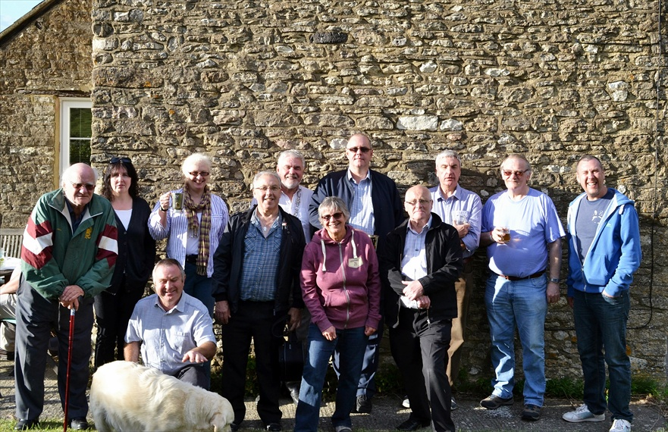
WOODY WEATHER STRIKES AGAIN!

8th Annual Reunion
As you can see from this picture, taken by my 11-yr-old grandson, ten FOFB’s – plus my son and daughter-in-law (honorary FOFB’s in view of their status as brewer and assistant at the Froth Blowers Brewery) – stood backs-to- the-wall in the garden of 1 The Street, Stoke Lyne, to record their attendance at the 8th Reunion and ninth annual gathering of the Friends of the Froth Blowers. It was particularly gratifying to meet Tony (2nd from the right at the back), the grandson of Bert’s only sister, Marion. It seems, from Tony’s account, that she was a close friend of Elizabeth Bowes-Lyon (the ‘Queen Mother’) – but not a friend of her own mother, from whom she detached herself at an early age.
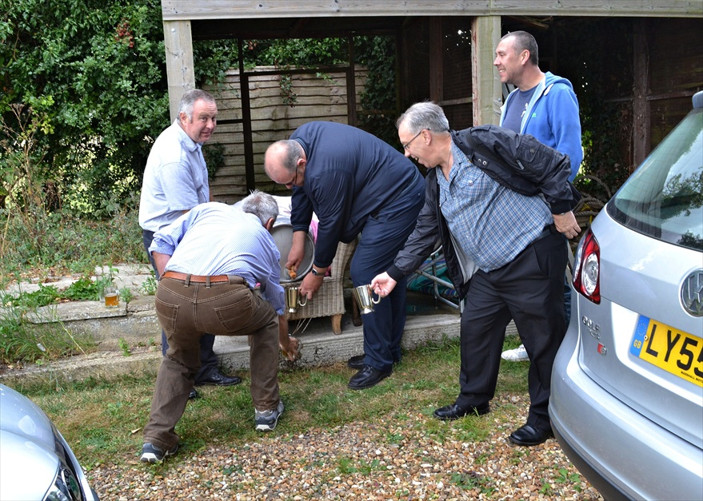
The first two hours of the meeting were spent in the Peyton Arms where Mick the Hat and his wife, Jean, treated us with the sort of old world courtesy not often found in hostelries nowadays – and not always found in the Peyton Arms if those entering their ‘house’ show a boorish disregard for the niceties of the host/visitor relationship. After that, with the weather cool but sunny, we enjoyed a leisurely afternoon eating from the B-B-Q and drinking from the barrel: burgers and sausage from the one and a trial version of Pifflesnonker from the other.
Most of the FOFB’s had to return home in the late afternoon, but Steve had already erected his tent in the garden and Tony and Chris had booked a bed; so, at 6 p.m. we four found ourselves in the Peyton Arms again. Fortunately, as I had to catch a plane to Singapore the next day, Mick always closes early at the week-end so two hours later we were in the cottage and mostly in bed (or tent) by ten. Add granddaughter (Casey), grandson (Sammy), local (Jim the Larger), plus Mick and Jean, seventeen (+ dog) were present.
At The Singapore Vat
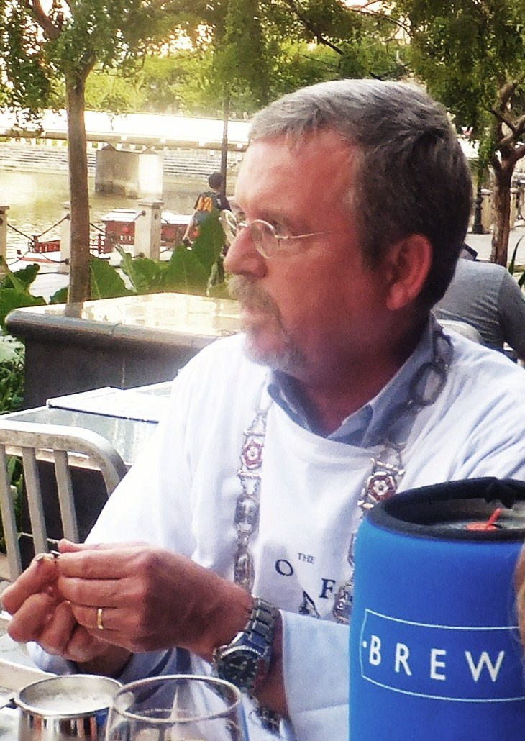
Blaster Dave: Chairman for the Night
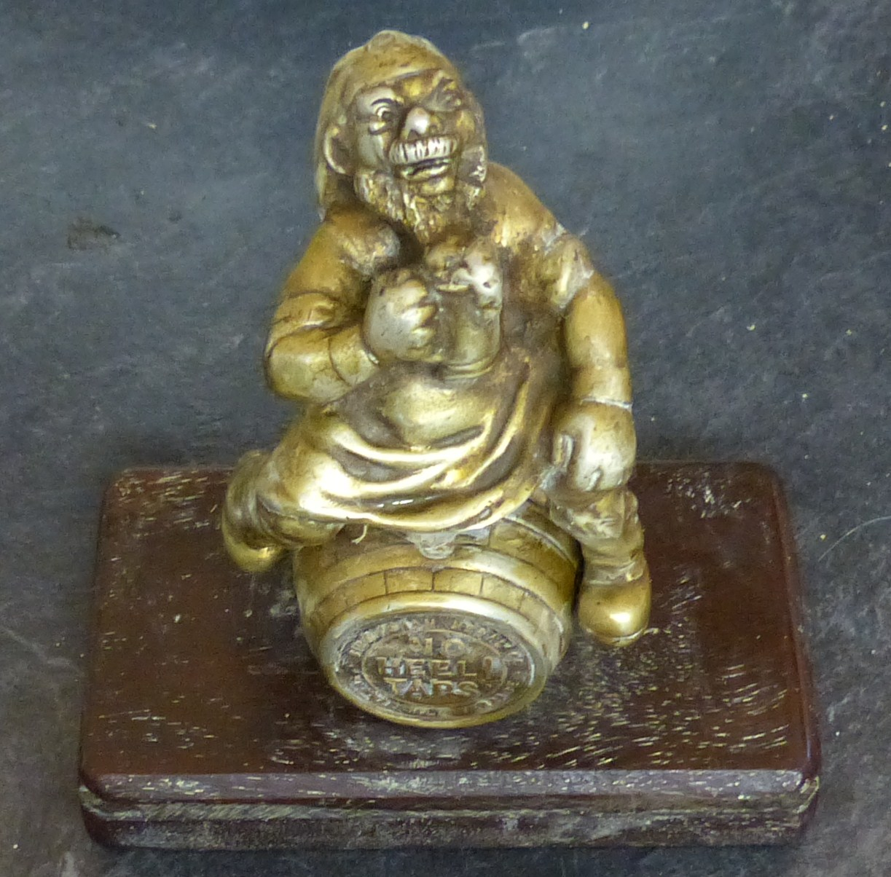
As Dave was able to identify forty Blowers, Fairy Belles and Bow-Wows who had been present at a Vat meeting at Brewerkz, Singa-pore, it seemed appropriate that he should be ‘elevated to the Beerage’: so, on Thursday 12th September, 2013, at a meeting of sixteen Vat members, I declaimed the words from ‘Copy of a BLASTER’s Screed’, starting with “And be damned …” and ending with “assume the title of BLASTER.” Thus was he ennobled.
Of those present, half were soon to leave for foreign climes – England, Texas, Switzerland and Brunei. It was particularly pleasing to catch up with Greg and Corrinne, the Texas contingent, as we had had a few memorable (or partially memorable) celebrations in the previous decade.
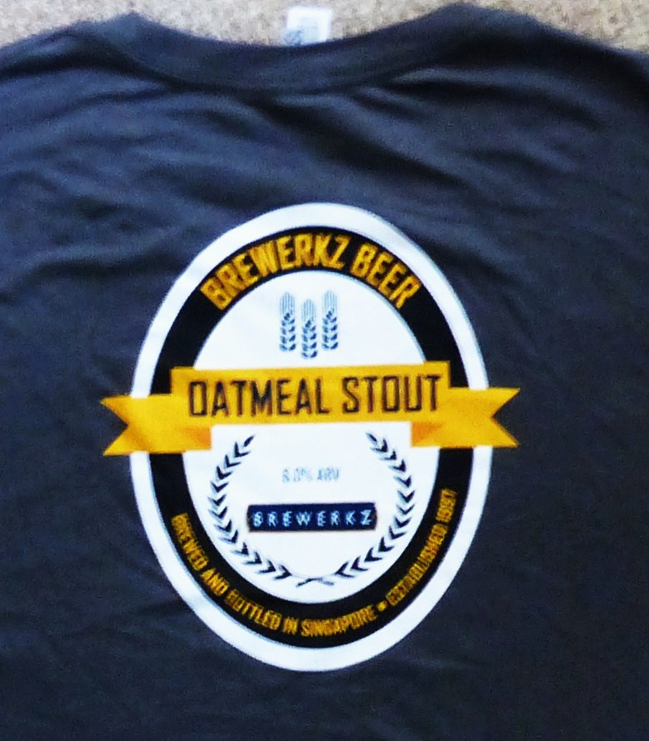
Calling on the services of Tang, the Sub-Assistant Vice-Gargler, and Ted, the Grand Oversees Scrounger, we were able to screw fines from members for spilling the beer brewed by Scott, the Not-So-Jolly Brewer, and Kim, his Fairy Belle Assistant Brewster, for not bringing a Bow-Wow member, for being late, for being early and for being there at all. The moreish qualities of Scott’s 6% Oatmeal Stout means that I am unable to recall the amount of money sent by him to Canada’s branch of Oxfam, but I think it was well in excess of £100. (At this point I think I should record that an ad hoc collection from Stoke Lyne Pifflesnonk quaffers raised £42.50. I will inform readers of its recipient in the Autumn issue).
Birmingham Jewellery Quarter Museum
I have been in touch with the manager of the above public amenity and am hoping to persuade him – with a little monetary encouragement – to put on a display of the more ‘jewelled’ artefacts of the Birmingham Medal Company. I await his response. (He might respond favourably if anyone has/knows of 1st World War artefacts produced in the Jewellery Quarter for the War effort).
Artefacts
I do not know how many of you collect artefacts of the Order but I do know that we Birmingham FOFB’s have a good selection of them. I have recently bought this Jolly Brewer mascot, a beer glass with the inscription FROTHBLOWER on it, and a tankard inscribed “A. O. F. B.” and “L.W. SMITH, ESQ. PRESENTED BY SIR NEIL BURN.” We are lucky that some of the real ephemera have survived, but more lasting things – neckties, for example - remain to be found.
Events
Andrew and I are being super-cautious about selling a beer under the Froth Blower name that we are not 100% happy with. However, a ‘Launch Day’ is close. I will keep you posted.
Next September (13th?) I hope to hold the 90th Anniversary lunch at Simpson’s-in-the-Strand.

