FRIENDS OF THE FROTH BLOWERS
Newsletter No. 29 Winter 2012

The Froth Blowers Brewing Company

A few months ago I registered this com-

pany with the intention of going com-

mercial about now. As I am trying to downsize my life by renting a smaller pro-

perty (next to the Hat Vat), the problem of selling one property and renting another

while setting up a brewery – for my step-sons to operate - has proved too involved to achieve either at the projected time.

However, watch this space: my revised launch-date is St. Patrick’s name-day and my 73rd Birthday (if the traumas facing me do not finish me off before then).
The Hat Vat
The Hat Vat, tied to the characterful Hook Norton Brewery, is run by one of Britain’s most characterful landlords, Michael Wes-
ton, ‘Mick the Hat’. He is licensee of one of Britain’s most characterful pubs, the Peyton Arms. He has collected a pot-pourri of the most characterful regulars; and he serves one of the most charac-terful and traditional beers of Britain - Hook Norton Bitter, or plain ‘Hooky’ – served in that most characterful of ways, straight out of the barrel. I hope to be in
 – for long week-ends - in the New Year.
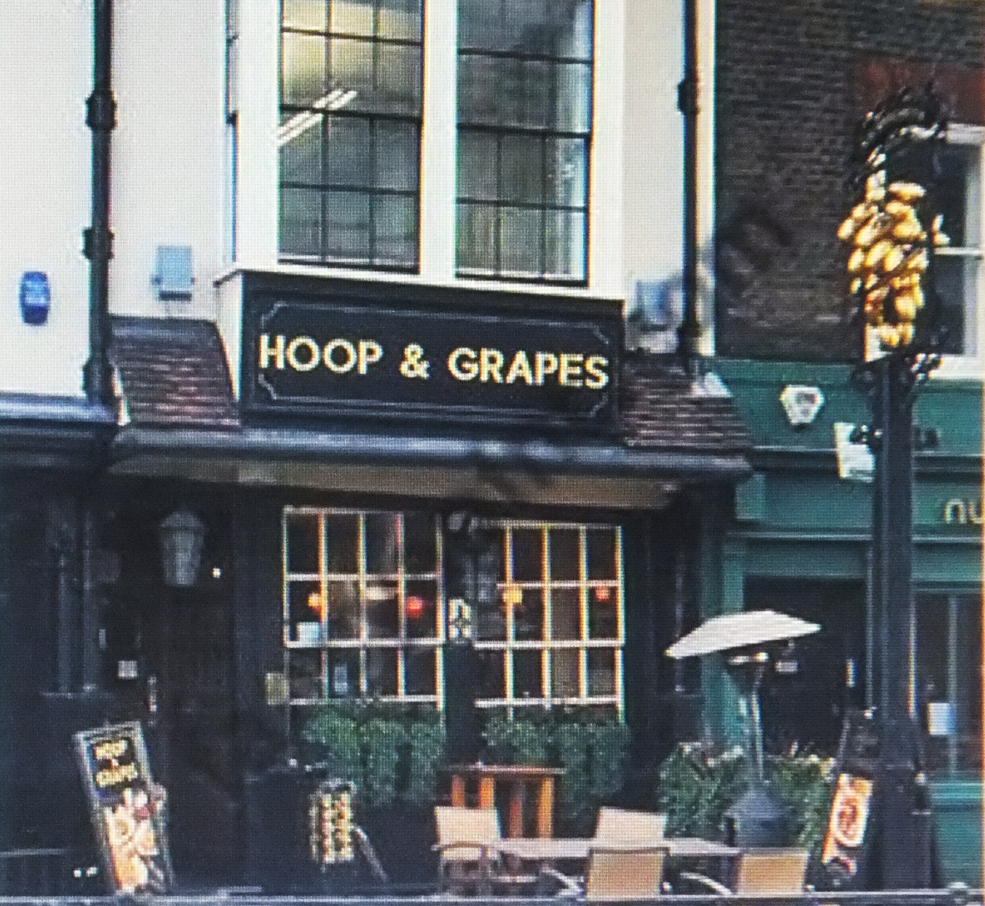
The Pub History Society
The A. G. M. of what could be called our ‘parent company’ was held at the Hoop & Grapes in Farringdon Street. The Secretary manages to find pubs selling beer of so little interest – in this case Shepherd Neame’s – that I am not tempted to lubri-cate immoderately, allowing me to drive straight to the Hat Vat for an early-even-ing libation on the way home; thus making the day out worthwhile!
I jest: the turn-out was gratifyingly numer-ous, being in double figures, and the contributions, outside the necessary bur-eaucracy attendant upon an AGM, were most interesting - the two main contribu-tions being about the preservation of mid-to-late 20thC pub architecture, and an illustrated talk (after the meeting) by Alan Greenwood entitled “The Brewers and the Theatre Licence.” I would like to congratulate PHS/FOFB member Trevor (the Tankard) Moore on his professional handling of the proceedings – and on his innovative ideas for the future.
The Peterborough Beer Festival
As all real ale cognoscenti know, the most civilised, large Beer Festival takes place in Peterborough on the banks of the River Nene. Here, in late-September, senior members of the Pub History Society, with some local Camra dignitaries, were said to be running the annual Tipplefair. It, there-fore, seemed the ideal occasion on which to visit the Festival for the first time.
It was good to catch up with one or two FOFB’s I had not seen for a while, and to sell a ‘Zestful Golloper’ or two. I even bought a couple of pewter pots from Trevor the Tankard before heading off for that beautifully-sited brew-pub, the Ex-eter Arms in Barrowden, Rutland.
The Singapore Vat
In November I left cold and wet Britain for hot and wet Singapore. I had no other purpose for visiting than to be reunited with friends – and enjoy a few carefully-crafted beers at Brewerkz, the home of the Singapore Vat. I did spend a morning watching Assistant-Brewer Kim brew a
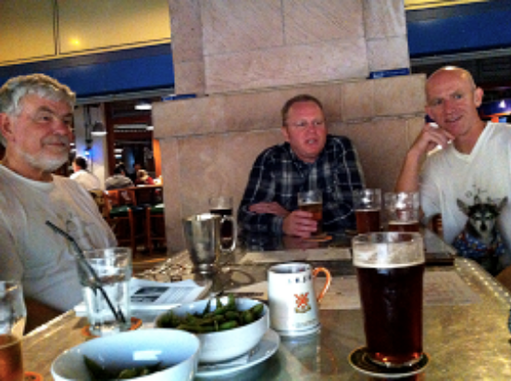thousand-or-so litres of beer in the on-site brewery at Riverside Point, while Master-Brewer Scott was busy at Brewerkz’ sec-ond brewery, built because of the ever-increasing demand for their products.
A number of the Singapore Froth Blowers were out-of-town on the Friday selected for the Vat Meeting but we had enough not only to be quorate but inchoate – or, at least, vague enough for me to be imprecise in my recollection of the evening’s events. I think a hundred or two dollars was collected for Canadian Oxfam – but don’t quote me.

The Independent Order of Good Templars
As a group of people totally opposed to
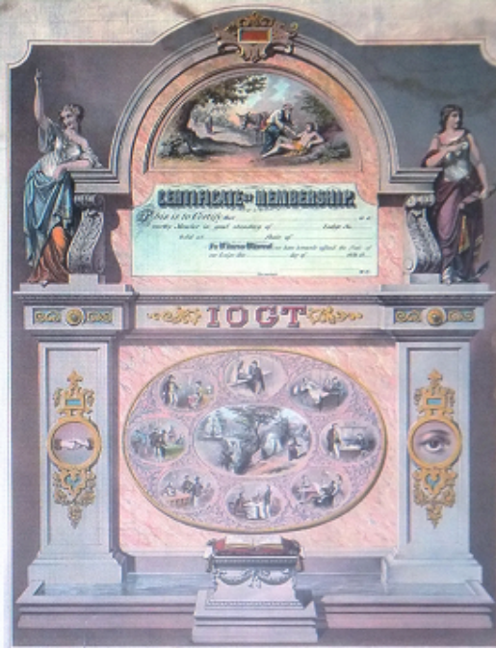
the jollifications associated with Froth Blowing, I was slightly surprised to find that the British version was imported from America by one Joseph Malins and, in 1868, started as ‘Columbia Number 1, at Morton’s Chapel, Cregoe Street, Birming-ham. Malins died in January, 1926, thus missing most of the ‘action’.

2013 Some dates (otherwise, t.b.a.)

Sun. 17th March: ‘Froth Blowers’ launch
Sat. 4th May: Swan, Fittleworth
Sat. 28th September: Annual Reunion

