FRIENDS OF THE FROTH BLOWERS
NEWSLETTER No. 26 SPRING 2012

The Prologue
Whan that Aprille with his shoures soote
The droghte of Marche hath perced to the roote …
Than longen folk to goon on pilgrimages.
Well, the sweet showers of April have, at long last, pierced the drought of March and this pilgrim has set off ‘the holy blisful’ nectar ‘for to seke’ – on more than one occasion since I last put finger to keyboard for my FOFB ramblings.
Third Brum Trudge
My 72nd Birthday (I don’t look a day older than 71) happened to be on a Saturday this year and, as it has always coincided with St. Patrick’s Day, a dual celebration was the obvious idea. On the stroke of mid-day, the first reveller arrived at the latest pub to be realised (i.e. ‘real ale-ised’) by Nigel Barker
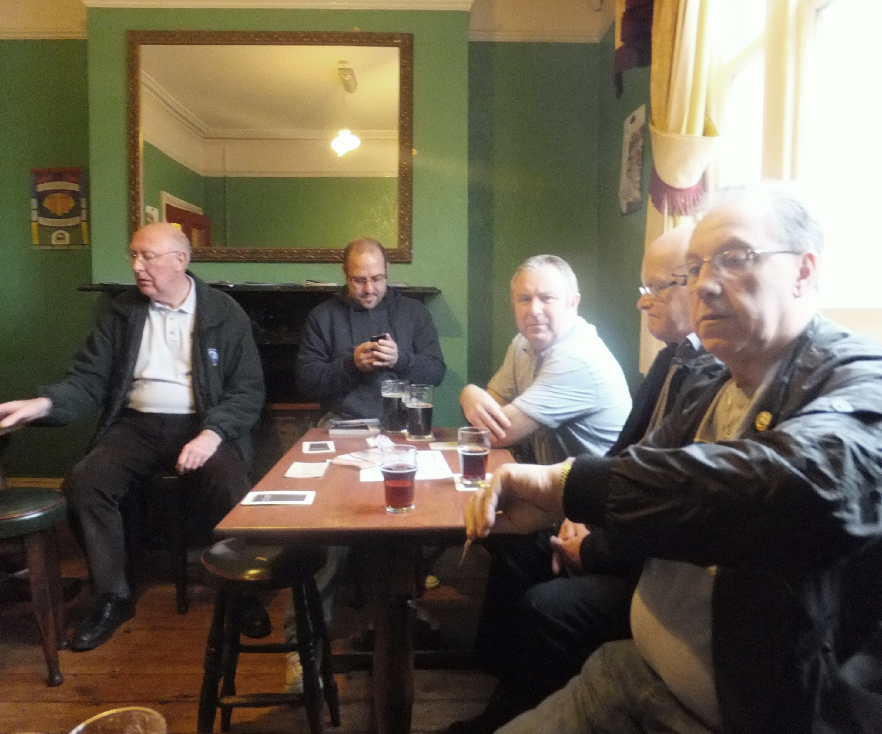
and associates, the Post Office Vaults. This time he has added a portfolio of bottled beers of the world - for those with more money than discriminating sense. An hour later the out-of-town PHS/FOFB members, having braved the vicissitudes of cross-country rail-travel - and the obligatory glass of St. Patrick’s green beer - set off with the Birmingham four (DLW, Ian, Brian & Chris) to sample the delights of Old Brum (at one point we crossed the River Rea close to the point where it is thought the first settlement was established). The Old Fox does include beers from Backyard and Slaters Breweries as something like regular guests so, although it is not totally reliable for fussy beer-bores like me, it is worth a visit as every other hostelry in the area is weird, but less than wonderful.
The next stop was at Eddy’s (the Lamp Tavern). Having survived a near-death attack in the riots last year, he is back to full health and bonhomie. There is always a locally-crafted mild and one of the bitterest of light-coloured ales, Stanney Bitter from Stanway
Brewery, plus two or three others, quite often from Yorkshire. Then, ten minutes brisk walk took us over the subterranean River Rea and
on to the Spotted Dog. This is a most enthusiastically run pub, on the top edge of
‘Irish’ Digbeth, with a serious rugby following among its regulars; by 2 o’clock on St. Patrick’s Day – with Ireland playing England (and Birmingham City at home half-a-mile away) – the place was heaving. However, they do have one consistently good real ale, Castle Rock’s Harvest Pale; and a jovial clientele. The next pub, the Crown, proved to me – again - that the only reason for going to it is that it is Central Birmingham’s oldest pub, being genuinely14thC.
We split up here for different food outlets and reconvened at the ever-popular White Swan in Bradford Street – so full it was difficult to appreciate its Victorian charm. The small back room at the near-by Anchor was empty so we were able to give a rendition of “The More We Are Together” without disturbing its Irish revellers who were, by now, drowning their sorrows after a drubbing by the English. Then, my son and I left for a birthday curry with the rest of the family, nearer home.
Thanks to all who attended.

Time to go home!

The Society of London Ragamuffins

Some months ago I was invited by my good friend, Jeff (of the Kent Vat), to give a short talk about the Ancient Order of Froth Blowers to the Ragamuffins - on the occasion of their Annual ‘Ladies Night’ Dinner (as the Society’s current Social Secretary, its organisation was Jeff’s responsibility).
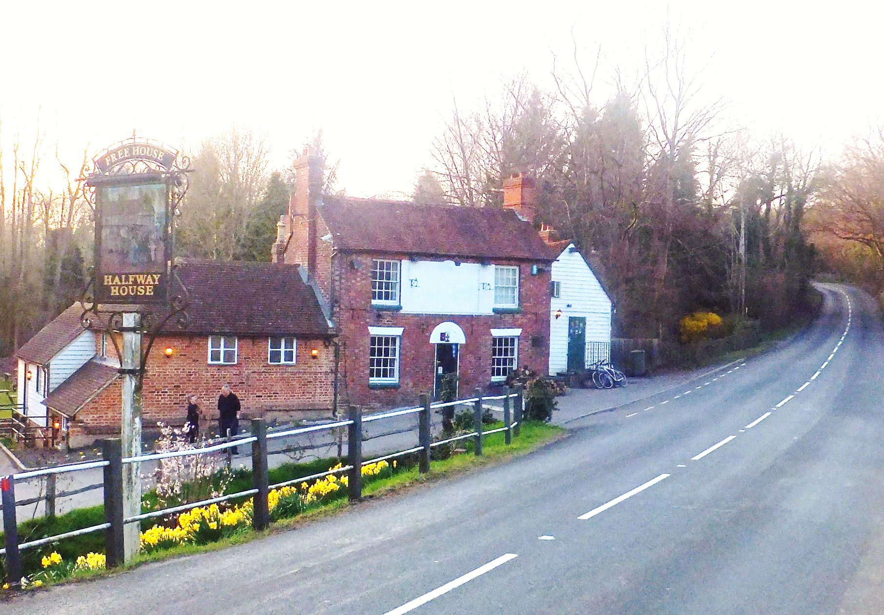
The Society, after a few years of ad hoc meetings, was founded in 1901 to ‘rescue’ chosen street urchins deemed worthy - and in dire need - of their help. The Society’s motto is “Amitiè et Charitiè”. It was this connection of Friendship with Charity that prompted Jeff to invite me to speak about the AOFB’s ‘Froth of Friendship’ history.
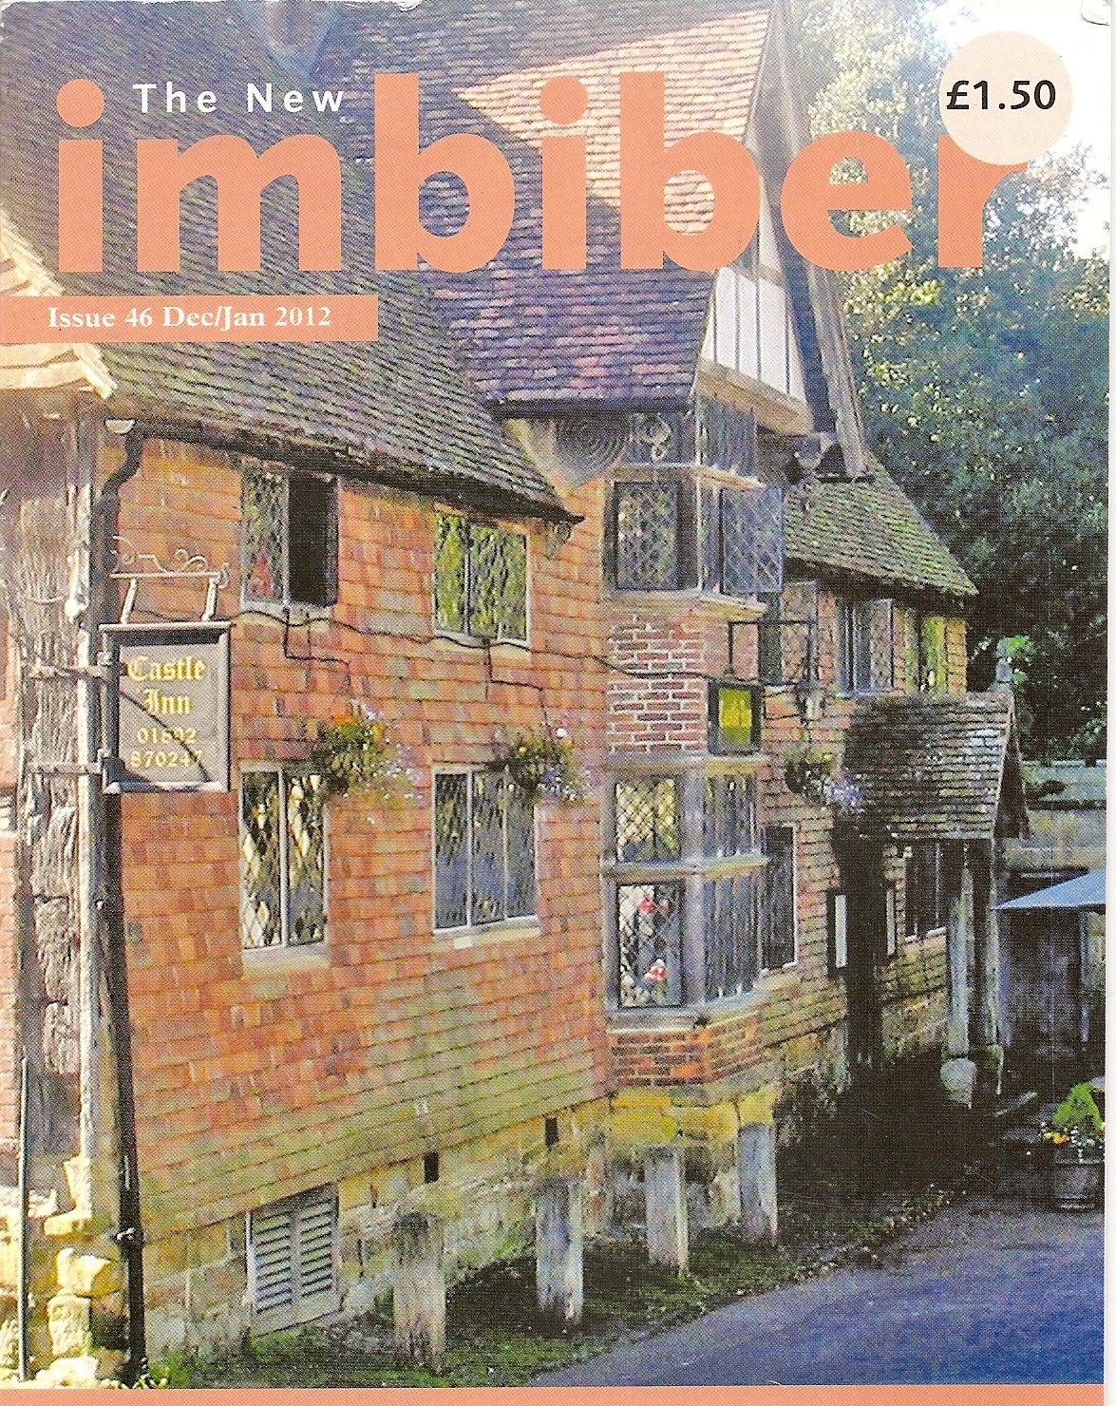
I drove down to Tonbridge on the day before the Dinner so that I could reacquaint myself with the many fine pubs in that area – and even finer breweries, especially Larkins of Chiddingstone. By 11.30 a.m. I was enjoying a glass of Larkins Traditional in the Castle Inn, a few yards from the Brewery.
I am able to use this picture of the pub because I took it; it goes with my article on West Kent pubs.
For lunch, Jeff, Eileen and I returned to the Coopers Arms, hidden in the back-streets of Crowborough, where I had previously had sprats; now, I had ox-liver, mashed potatoes and onion gravy – delicious!
An obligatory visit to see Steve at the Grove (Kent Vat) in Tunbridge Wells proved just as delightful – especially as Steve would not take the money we proffered. My round next, Steve!
Finally, for those who like a choice of a whole range of beers, the Halfway House at Brenchley is excellent. The food, too, Jeff has reported recently, is of a high standard.
I cannot repeat my ‘speech’ to the Ragamuffins at the University Club in the City as it was largely off-the-cuff. Suffice it to say that it was short and reasonably sweet. The members and their ladies were surprised by the meteoric success and short life of the AOFB compared with the slow financial growth of the Ragamuffins over more than a century.
I am unlikely to catch up with FOFB David Rowe of the Flintshire Vat in the matter of after-dinner speeches about the Froth Blowers, but I do not mind trying – if the hospitality of the hosts is comparable with that of the Society of London Ragamuffins.
Research
I spent two sessions finding more about Fripp in Kings College Archive (by Simpson’s-in-the-Strand – more roast beef!) and London Metropolitan Archive. In the evening, Mr. Murray and I celebrated St. George’s Day.
Dates
Sat. 26th May: 12:15 hrs – Swan, Fittleworth Plaque-wetting r.s.v.p.
Sat. 8th Sept.: 12:05 hrs – Red Lion, Brightwell-cum-Sotwell r.s.v.p.

