FRIENDS OF THE FROTH BLOWERS
Newsletter no. 23 summer 2011

Joyce

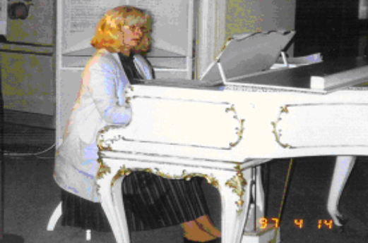
Joyce playing Dvorak’s piano in Prague
I think that most FOFB’s who met my wife know that she died a month ago. She was a good enough pianist to have an obituary notice published in The Scotsman on the 30th of July. She would have been pleased to be remem-bered in the country of her birth.
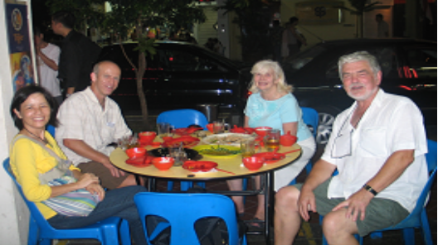
Joyce was, also, a not-too-long-suffering glass widow: I did my best to get to pubs of my highly-selective choice as often as I could, but her frequent and protracted stints as a music examiner in South-East Asia took me away from these to lands of alcopop. Fortunately, one of them – Singapore – opened a ‘beers-of-the-world’ brewpub, Brewerkz, where we became great friends with the brewer, his assistant and the in-crowd, leading to the well-established Singapore Vat.
With Scott, the brewer, and Kim, his assistant brewer

In fact, your self-appointed Chairman owes his interest in the Froth Blowers to his wife as she
found his first copy of Bert’s booklet tucked
away on a shelf of a second-hand bookshop in
Ironbridge.

Since then some of my more treasured possessions – such as a motor-mascot and a chain-of-office – have been presents from her. Ten years after the gift of the booklet, costing about £1.50, Joyce attended the first meeting of the Friends of the Froth Blowers in September 2005. In the last six years she has attended meetings in Salisbury, at the Swan, Fittleworth, and at Brewerkz, Singapore, but work has prevented more regular attendance. I know she will be missed by FOFB’s who have met her, because they have told me so.

Froth Blowing 2011
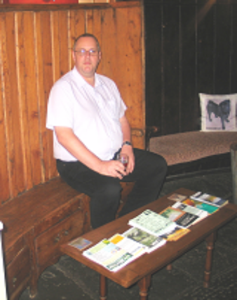
Yesterday myself-your indefatigable Chairman, Ian - the less-than-fatigable Webmaster, Jim the Elder and TweedleB (as opposed to TweedleC) faced the hazards of a pub tour on your behalf. First, we visited the Hook Norton brewery - as a photo-opportunity only – and its ‘tap’, the Pear Tree. Next, we drove the four miles to Which-ford and the fine brew-pub, the Norman Knight.After lubricating in moderation a-gain we set off for the brew-pub, the Crown
in Lechlade, where Jim the elder had
to have a half of Old Lech. Ian the parfait knight

Continuing to the vicarage in nearby Shrivenham we were happy to find Richard, the vicar, had returned from early Tiffin.

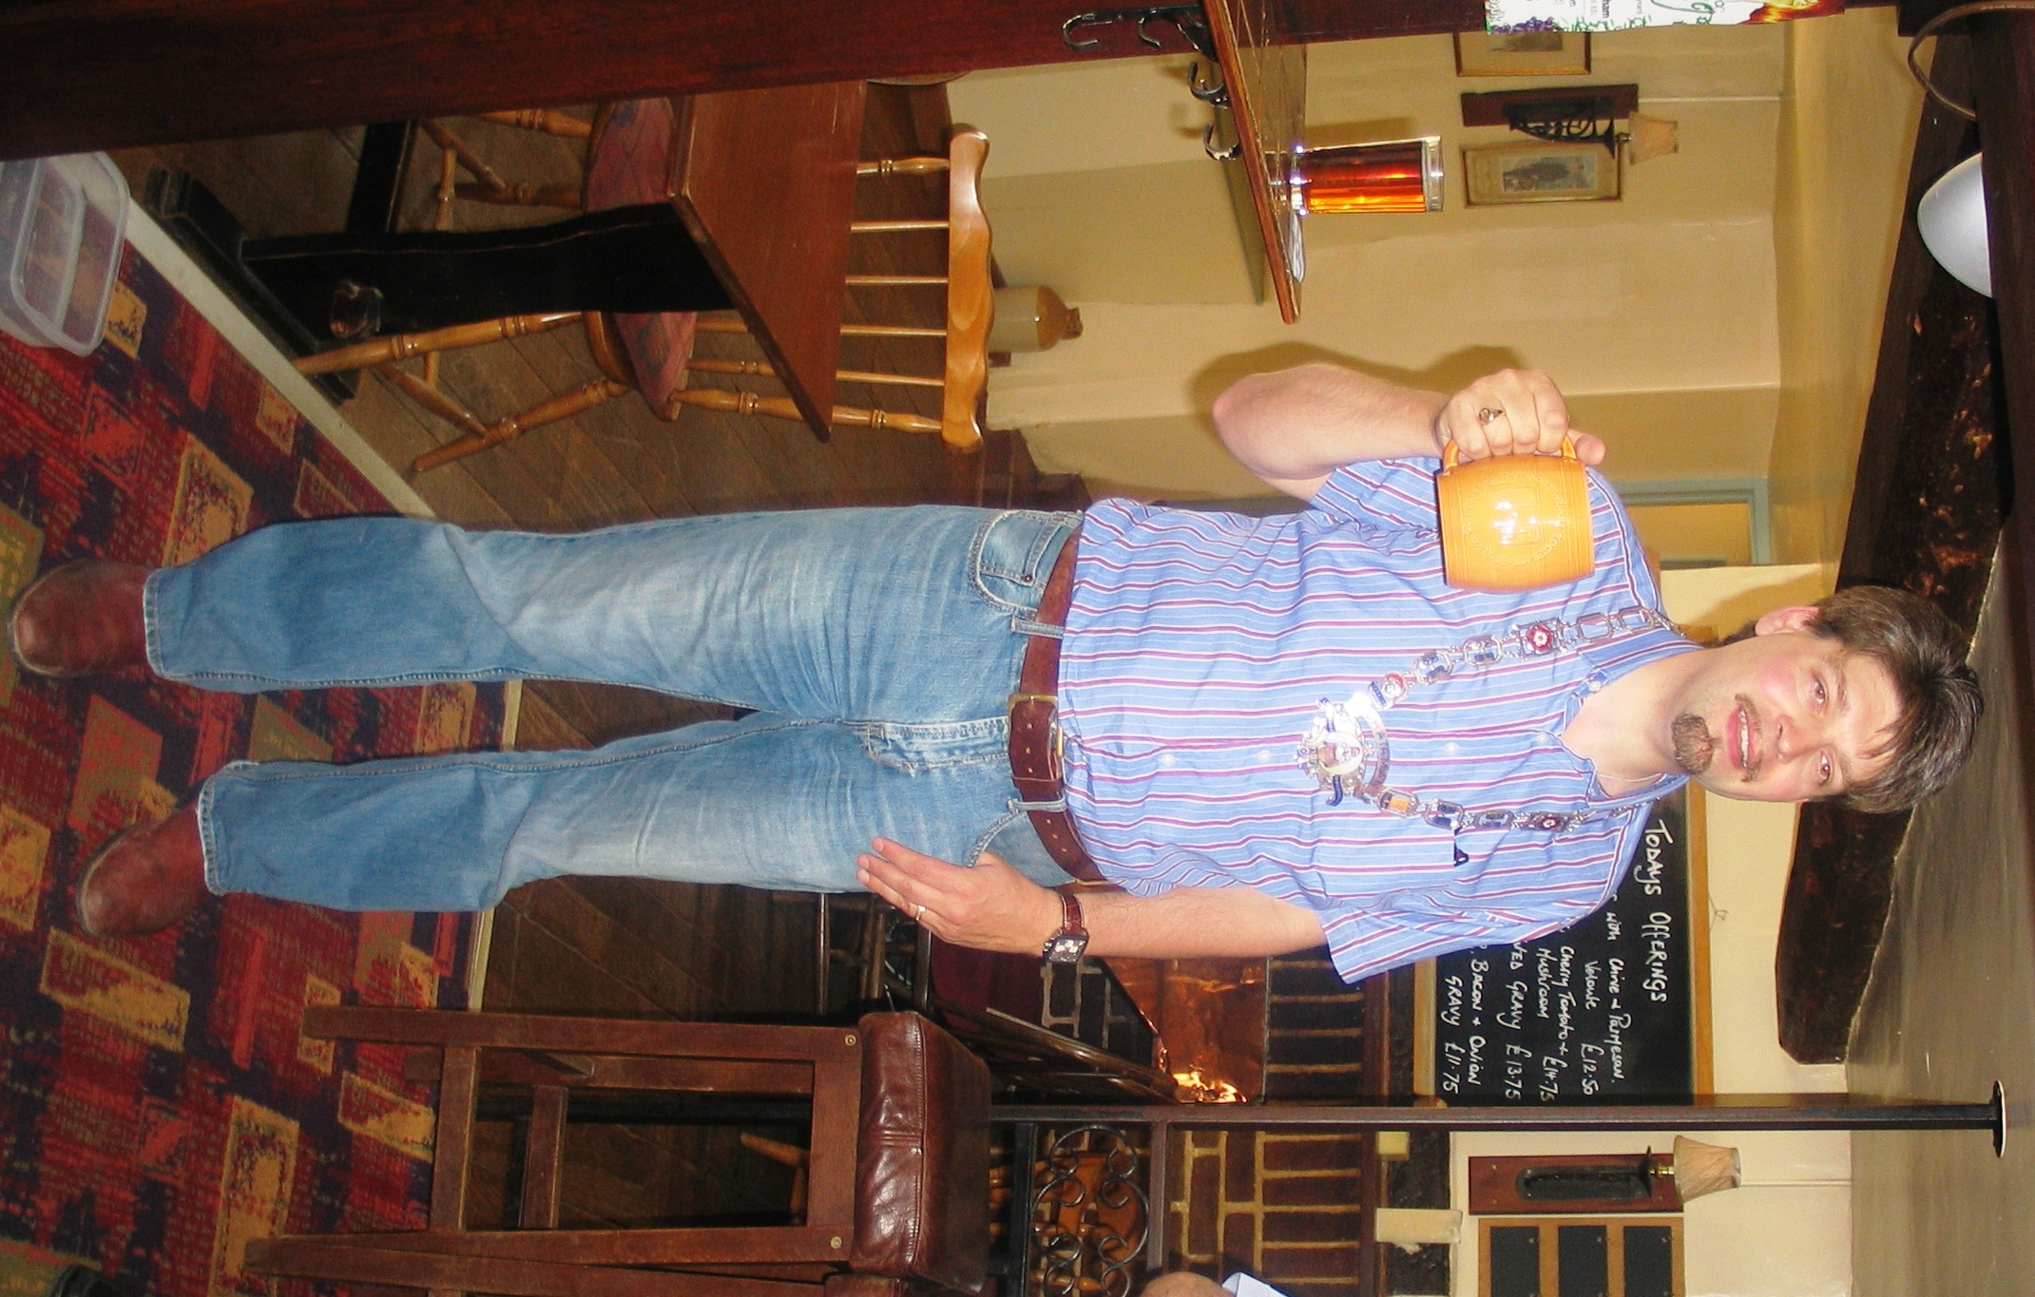
As Senior Blower – nay, Blaster – of the Shrivenham Vat he was happy to fill our glasses at the Prince of Wales, receive a pair of cuff-links, be photographed in the chain of office and assure as that his Vat was in fine fettle, meeting usually in the Crown – fifty yards from where we were lunching. Froth Blowing events take place on the second Thursday of each month (except August) should you be inclined to visit.
We left Shrivenham fully shrived in the froth of friendship, and made our way to the National Trust village of Coleshill. Here we found a brew-pub, the Radnor Arms, and we felt it would be churlish not to sample its gravity-fed ales. Tearing the Elder away from his lady-friend, we set off for Brightwell-cum-Sotwell. Somehow, the car seemed to deviate to the Woodman at Fernham for beer from the barrel again. A second surprising deviation took us to the wonderful North Star at Steventon, so it was approaching 18:30hrs when we reached our destination, the Red Lion – in the village where one of the AOFB’s Auto Outing For Bairns took place over eighty years ago, an event celebrated by the villagers in more recent times. Having introduced ourselves to the friendly Geordie landlady, we immediately fell into conversation with two elderly regulars who knew some of the Froth Blower story and the words of the Anthem, which the gentleman had recently been singing with his local choir. Exchanging details, we agreed to hold the FOFB annual lunch at the Red Lion on the second Saturday of October.
Mr. Rodda, the songster, was able to direct us to Blackstone House, where the ‘Bairns’ had been entertained all those years ago. As the owner was not at home, we photographed his house and left for pastures new – that is, the Peyton Arms at Stoke Lyne. Here we received the traditional ‘Hat’ welcome, including cheese snacks, a medicinal gin and tonic for Ian, port for the cheese – all on the house. What a man!
Events Diary
Saturday 17th September – lunchtime onwards:
The Blue Bell, Halkyn, stands on the hillside above the A55 and the town of Flint. It has been a fine watering-hole for many years and is energetically run now. A Birmingham contingent of FOFB’s will be there on the day so we hope that others will join us – especially those from the North West who have complained that all our meetings are in the South. 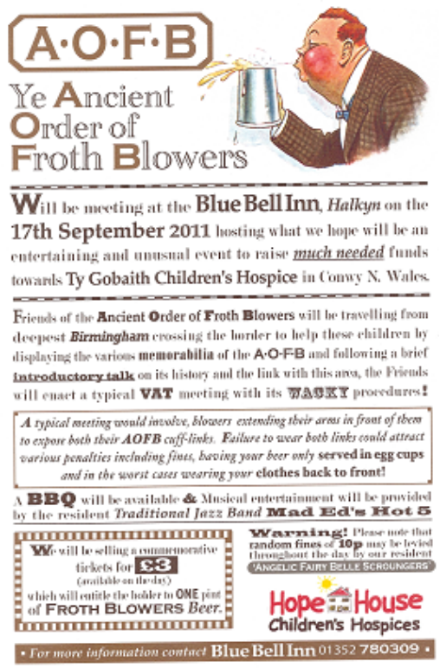

R. S. V. P. to me if you are likely to be there.
Saturday 8th October – 12:30hrs for 13:00hrs
Sixth Annual Reunion of the F.O.F.B.:
Red Lion, Brightwell-cum-Sotwell, Oxon. – two miles West of Wallingford.
Talk – Lunch – Artefacts – Froth Blowing – Anthem Singing – Fines for Charity – and…
LUBRICATION IN MODERATION
R. S. V. P. - a.s.a.p.
P.S. The Secretary of the Pub History Society is to speak about Dorothy Roper and the AOFB in October – hopefully not on the 8th.
DLW (0121 308 1515) finwood40@btinternet.com

